# Trends in MMR and MMR Research

## Measuring MMR in LMICs

Measuring maternal mortality: a systematic review of methods used to obtain estimates of the maternal mortality ratio (MMR) in low- and middle-income countries

<https://academic.oup.com/bmb/article/121/1/121/2926155#google_vignette>

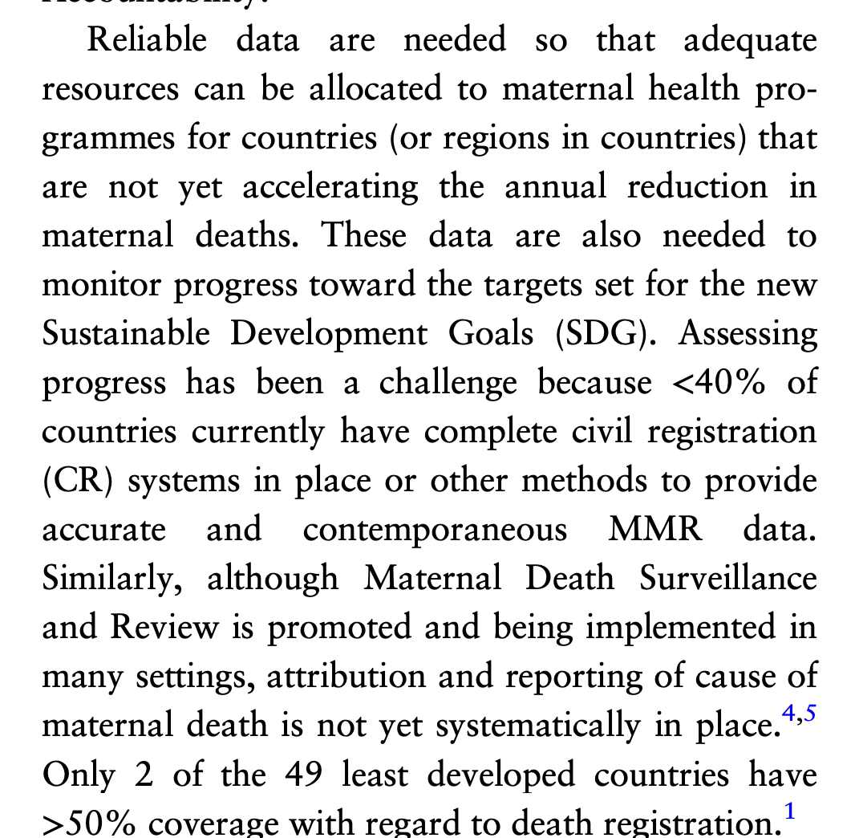

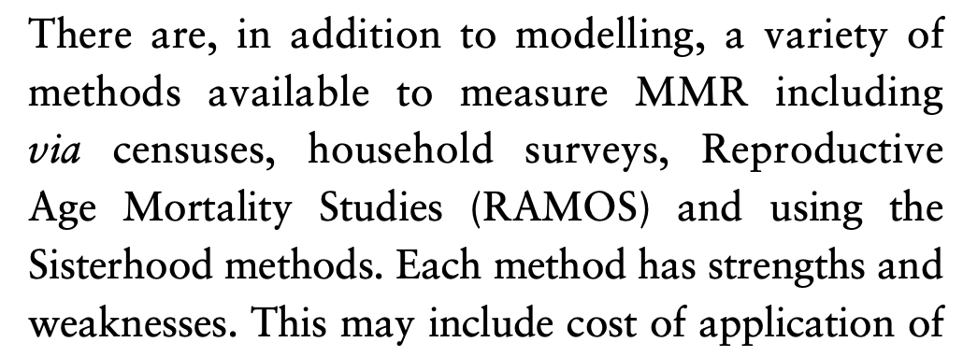 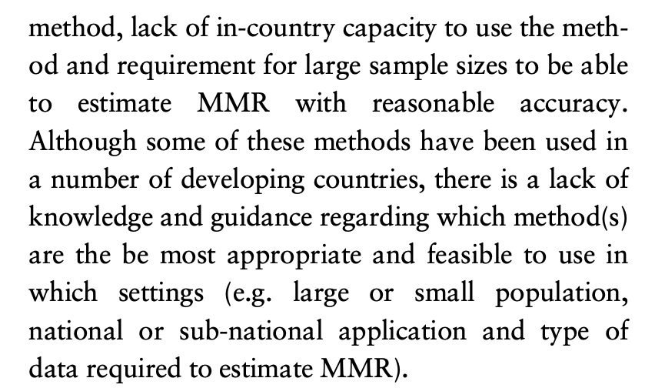

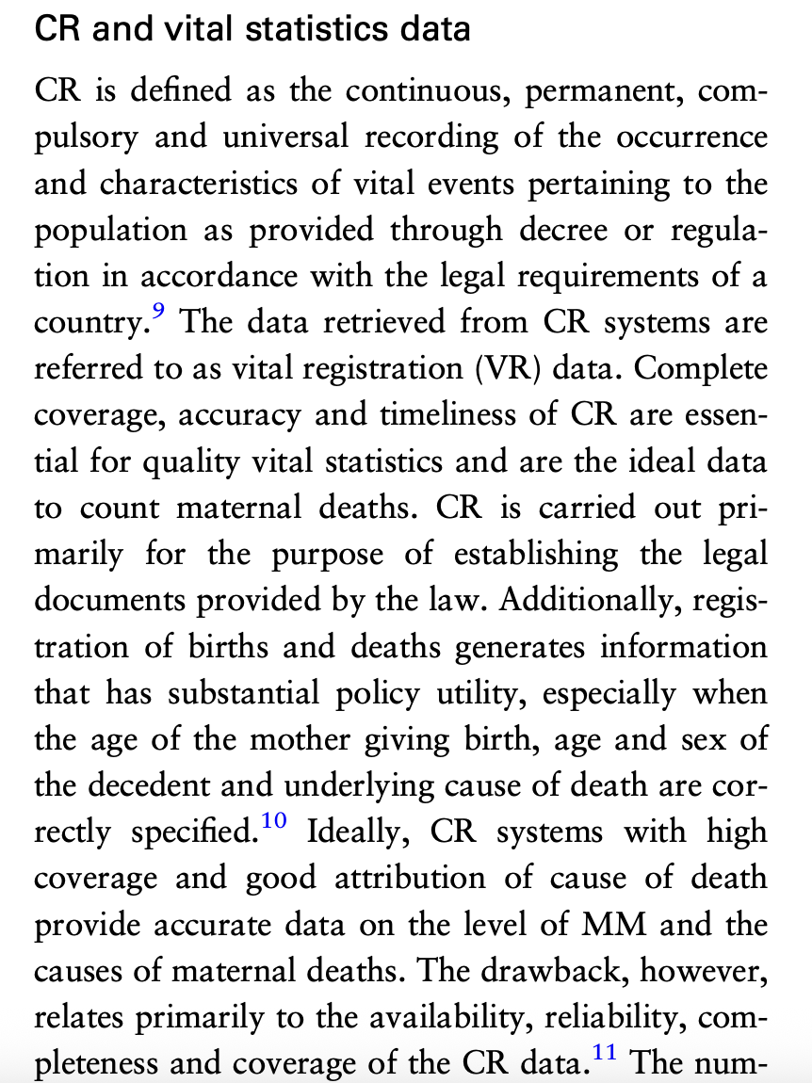 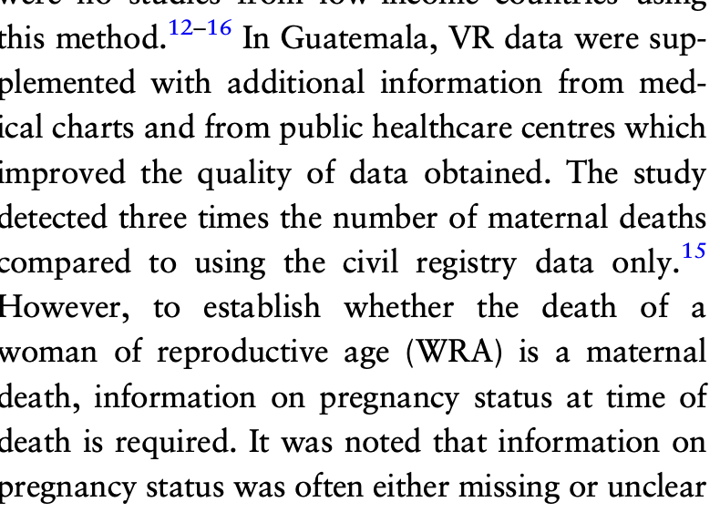 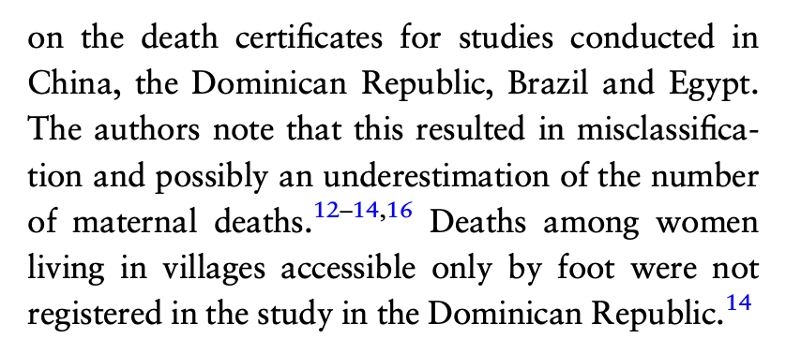

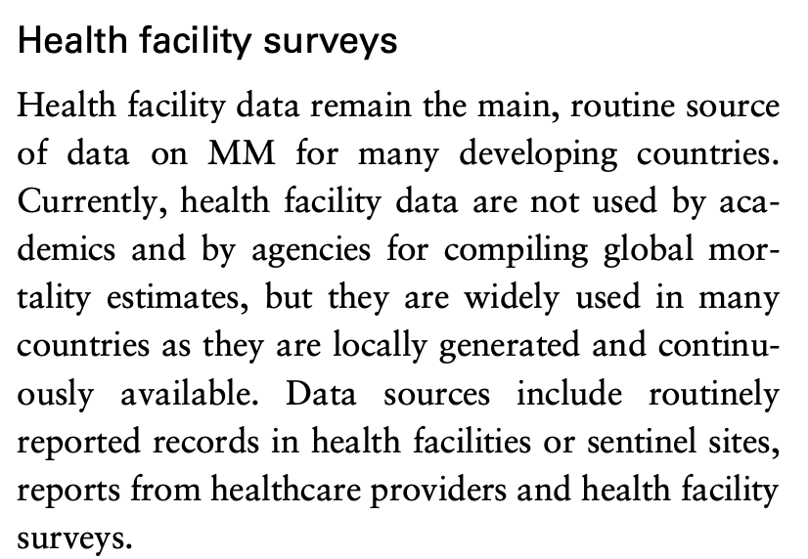 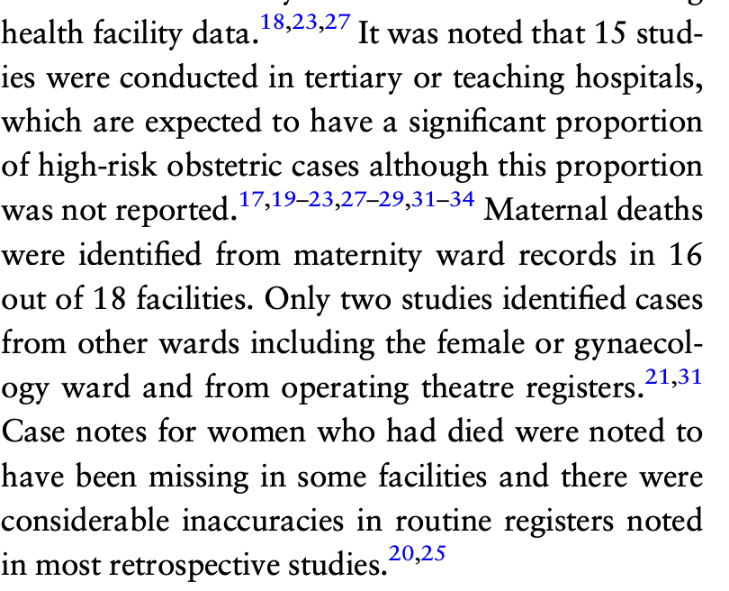 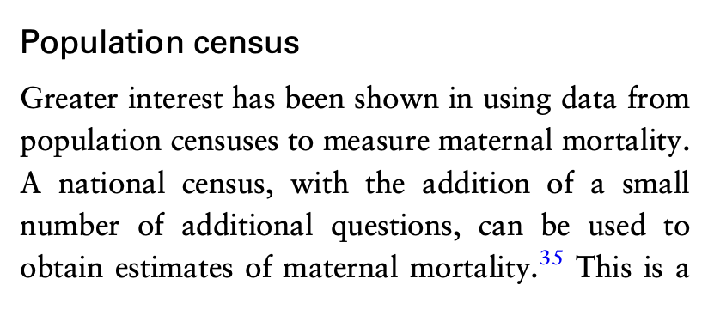 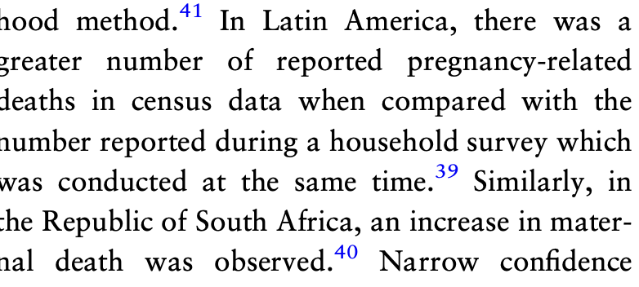

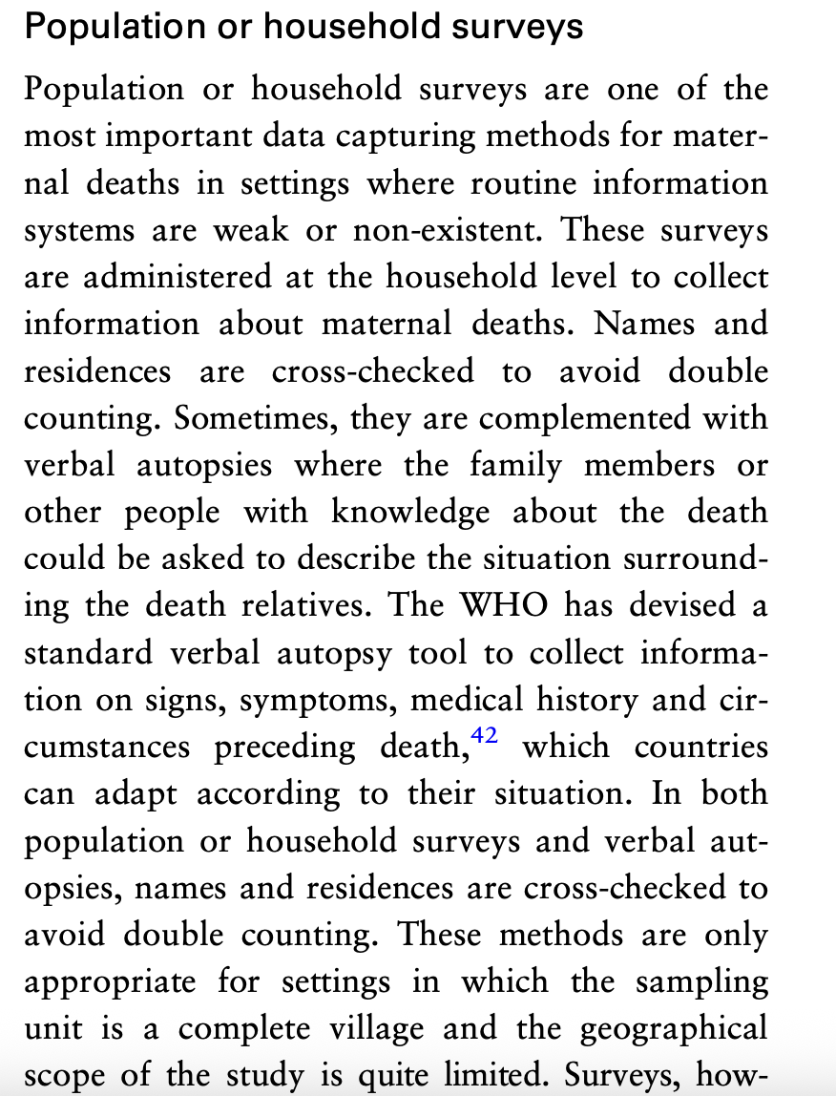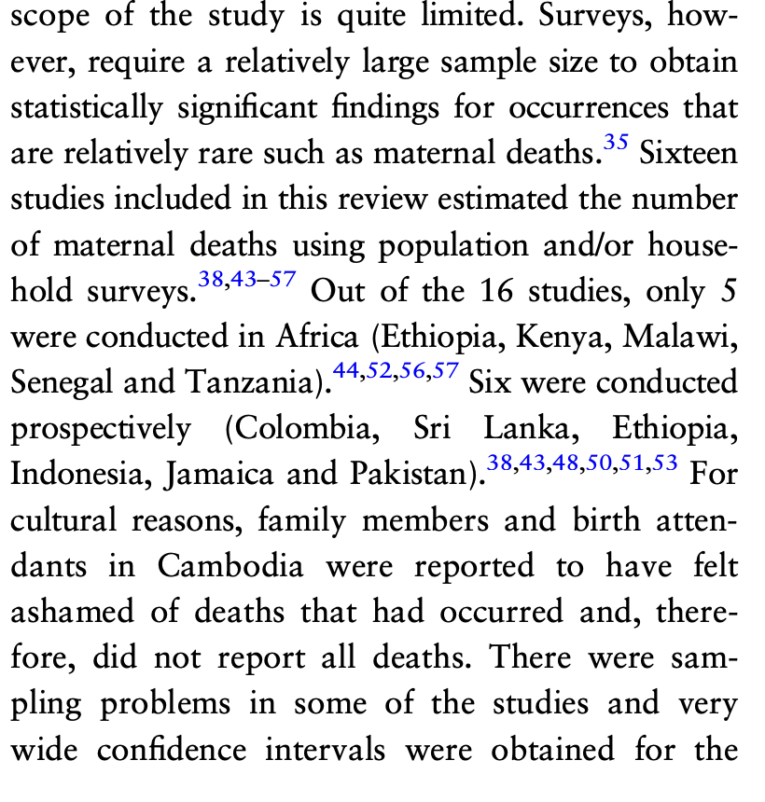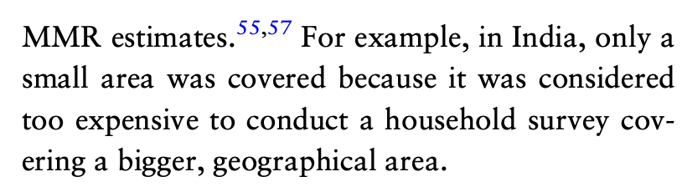

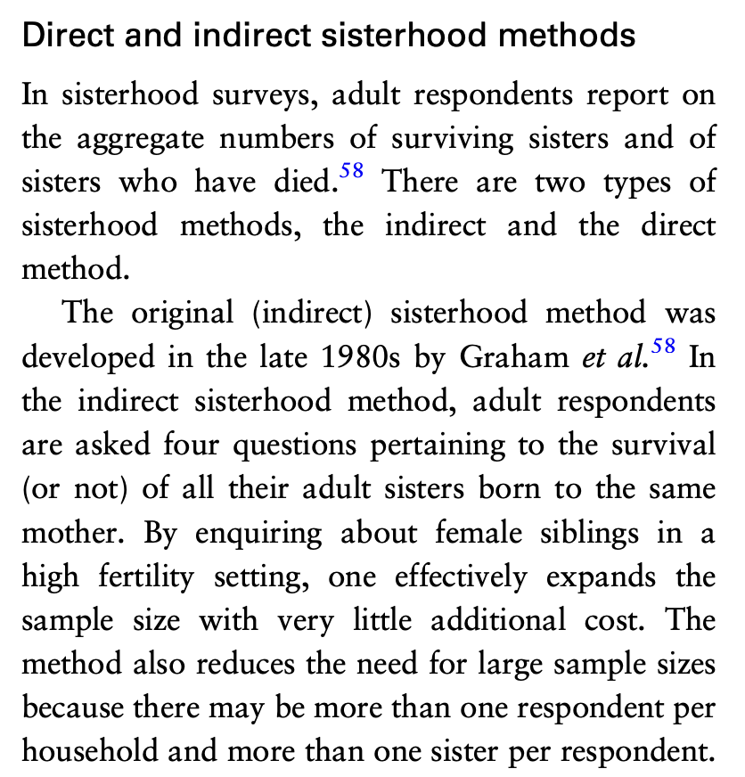 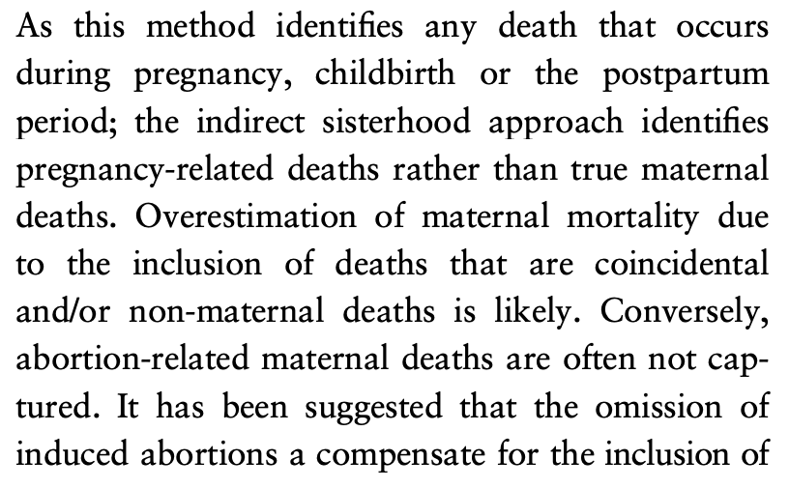

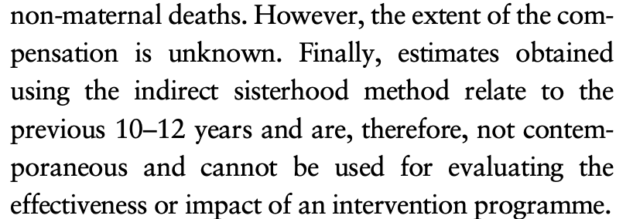 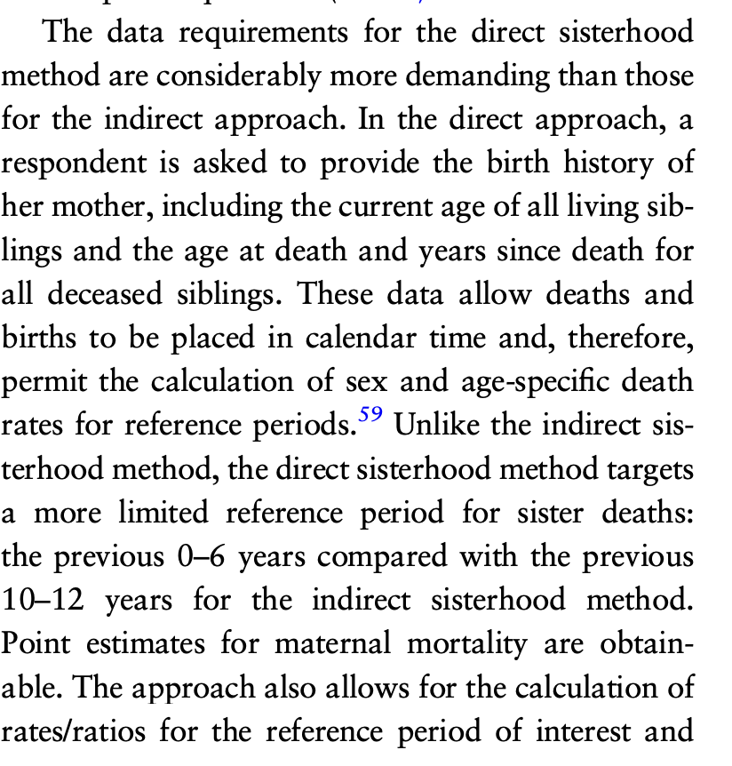 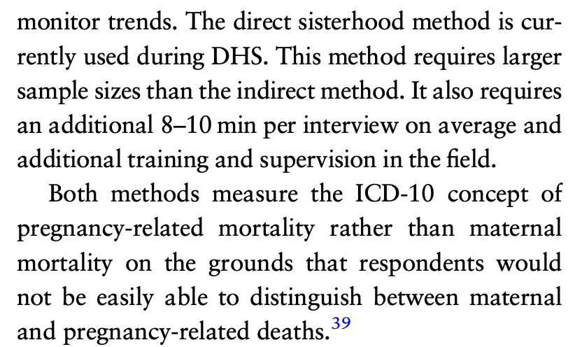

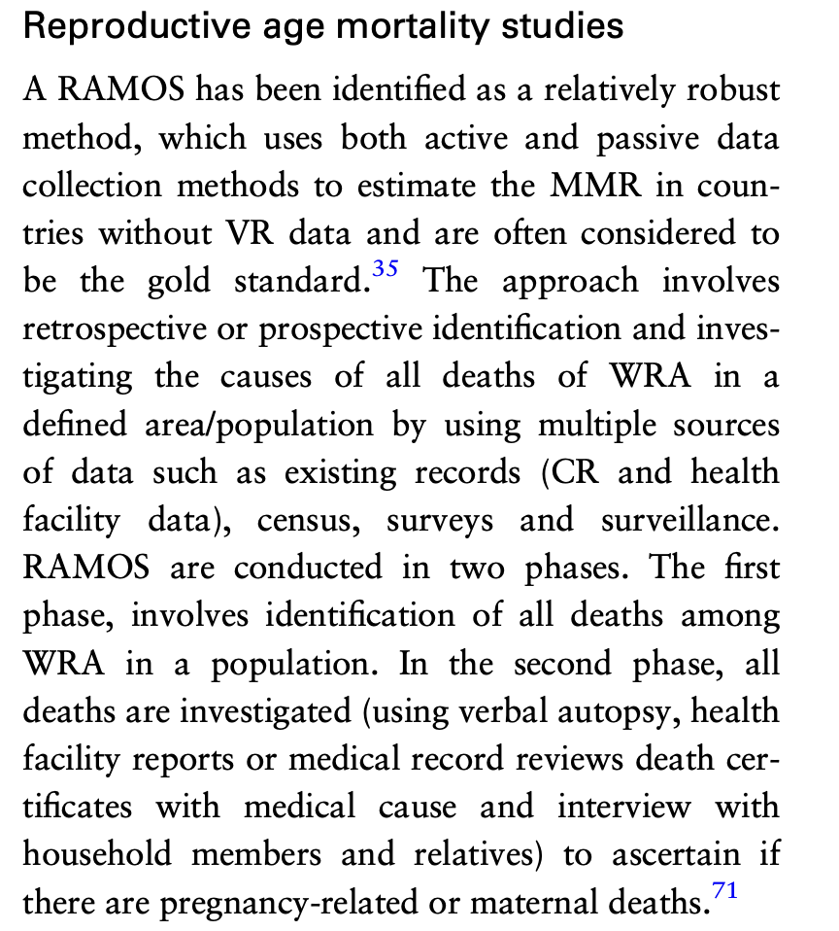 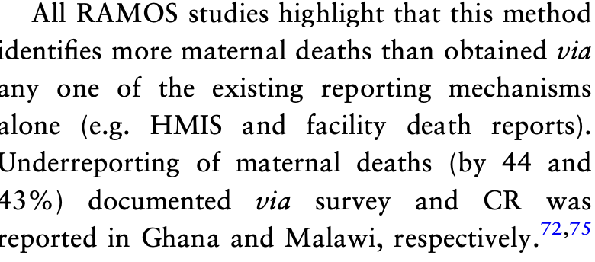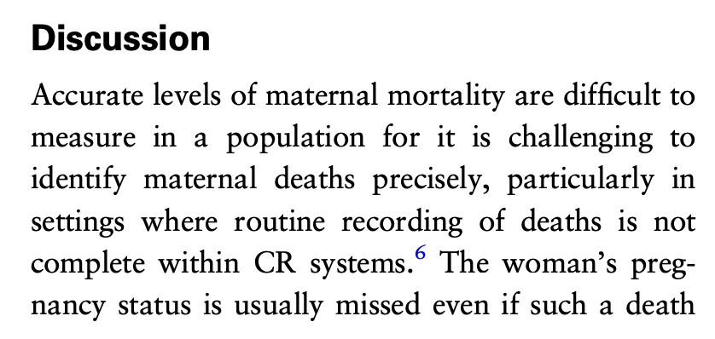

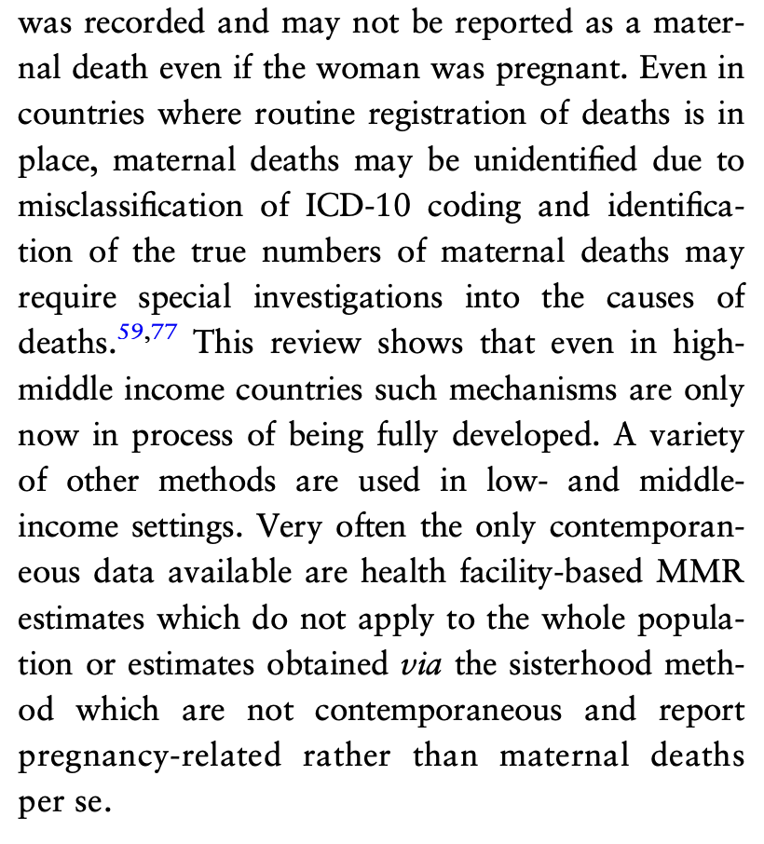 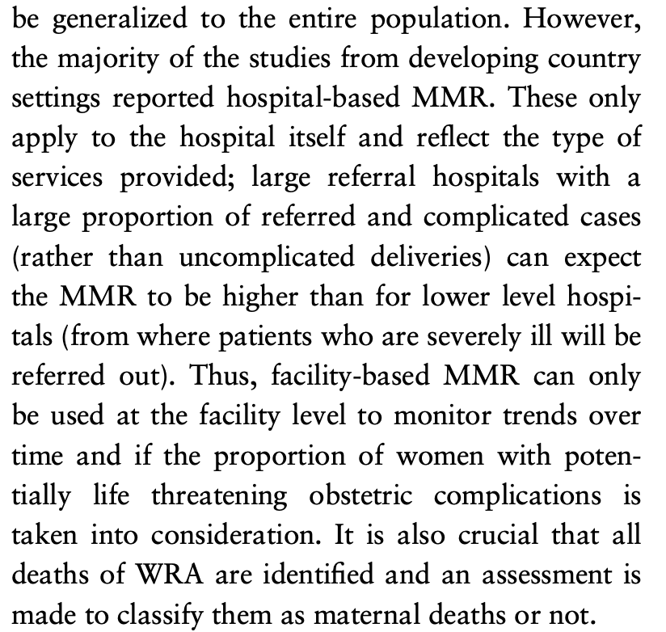

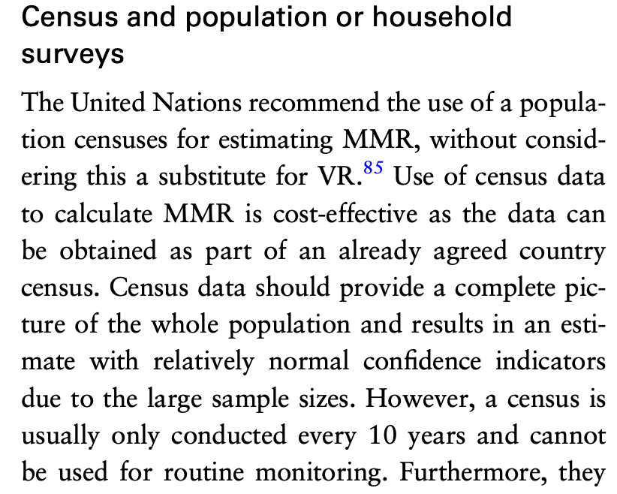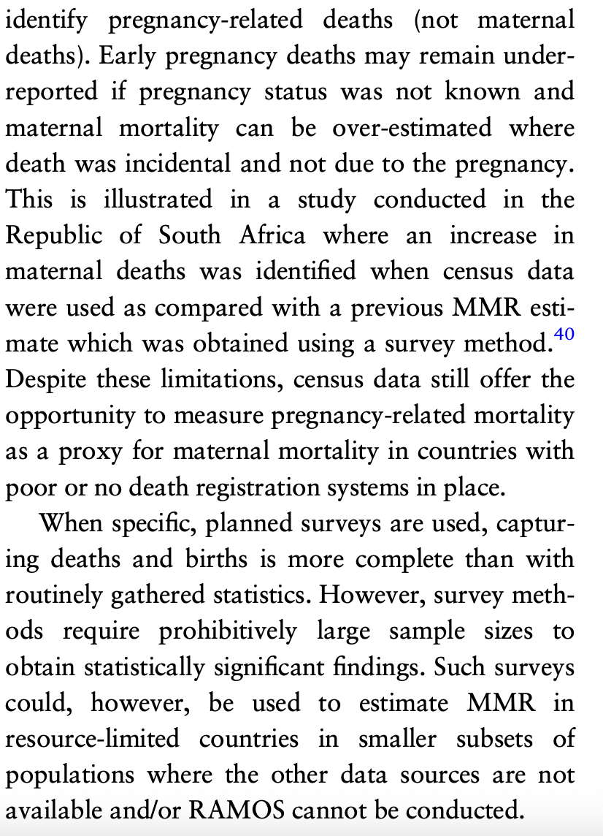 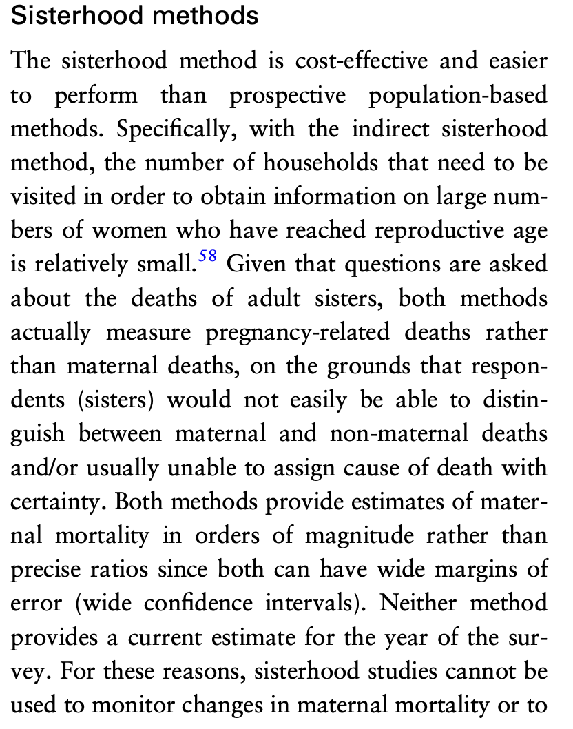 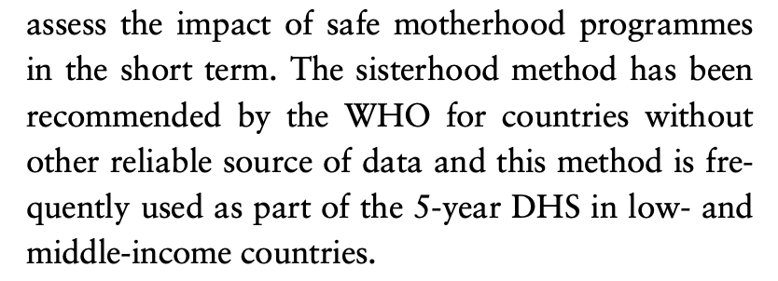 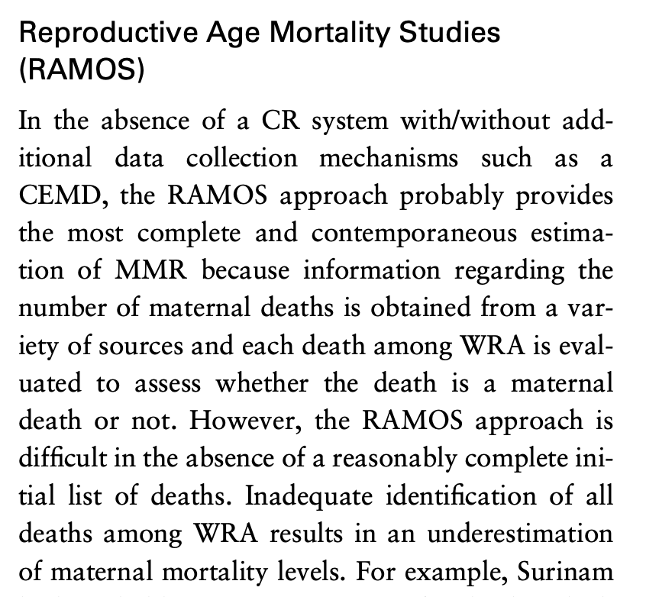 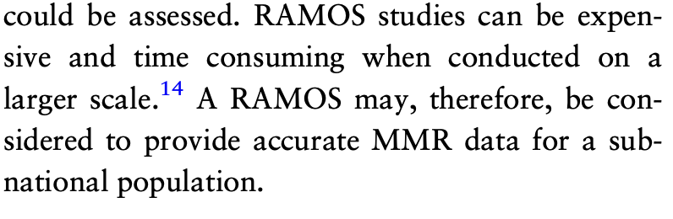

## Trends in Maternal Mortality, Africa, 1990-2030 : ARIMA

<https://www.mdpi.com/2673-3986/4/3/32>

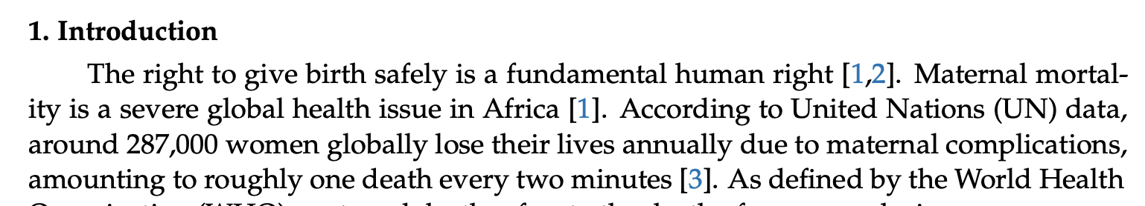

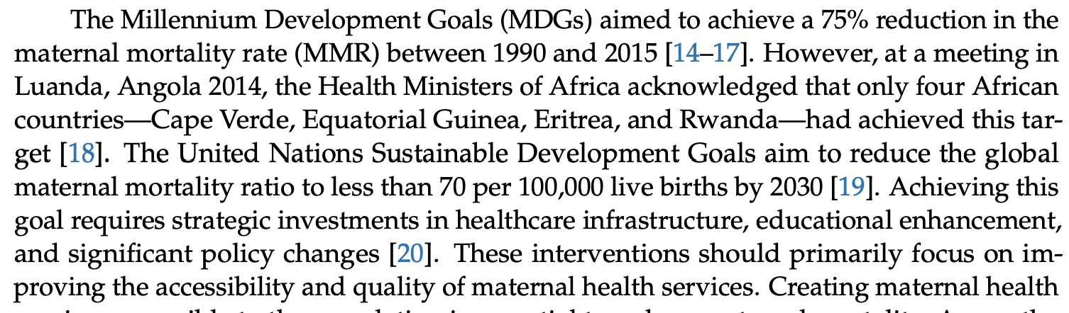

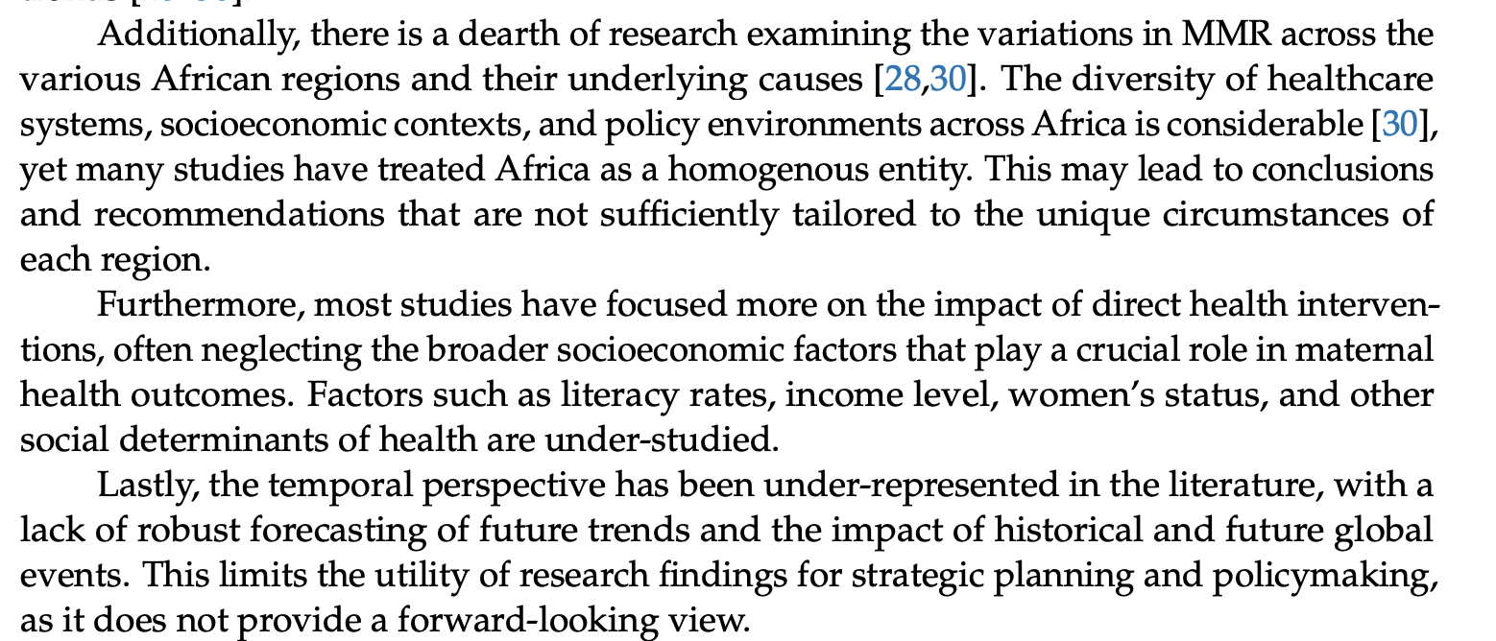

Use of the ARIMA and Holt models to forecast trends and disparities in maternal mortality across Africa based on data from the World Bank’s public data repository.

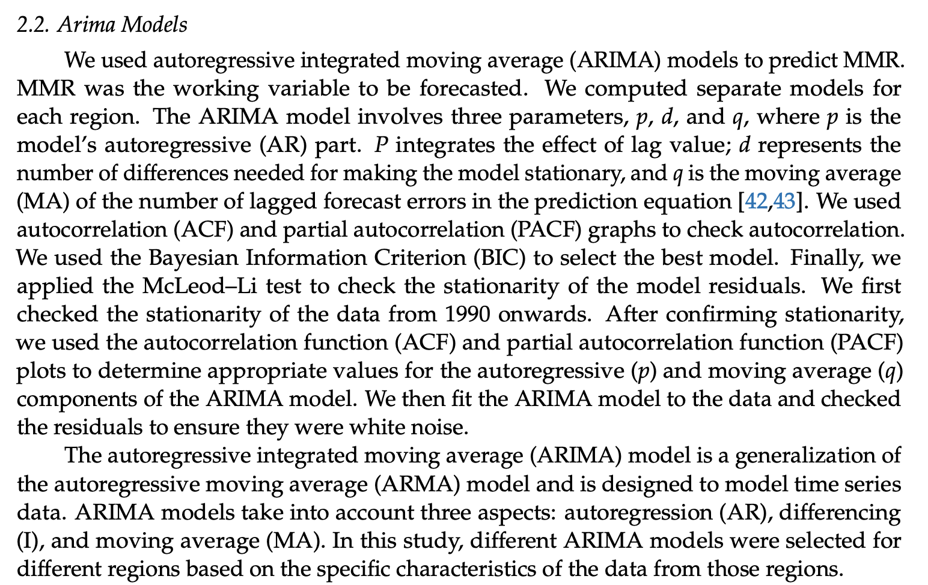

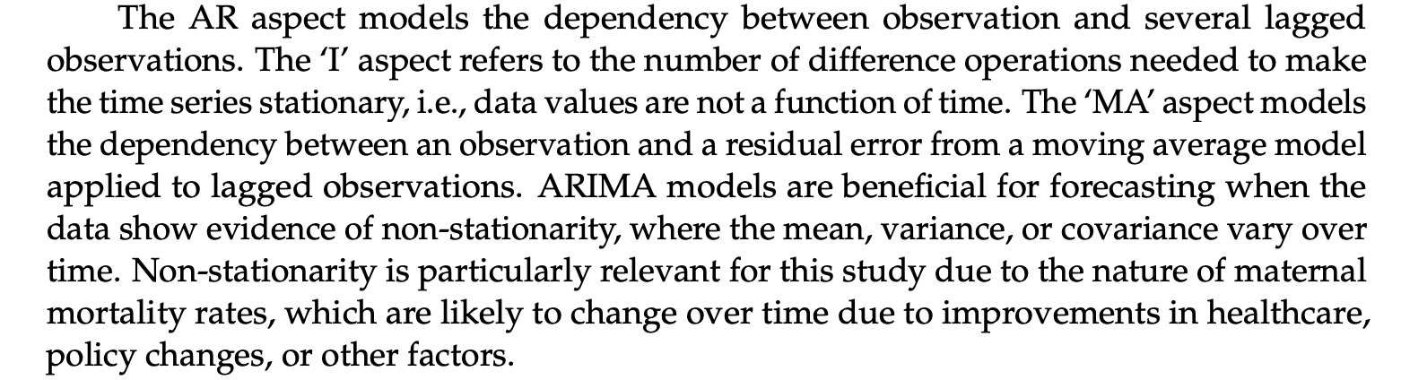

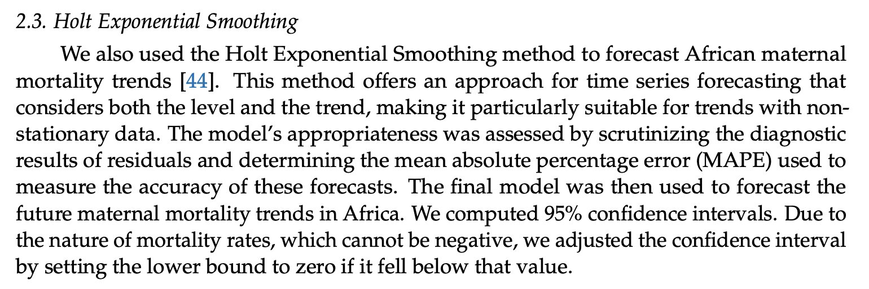 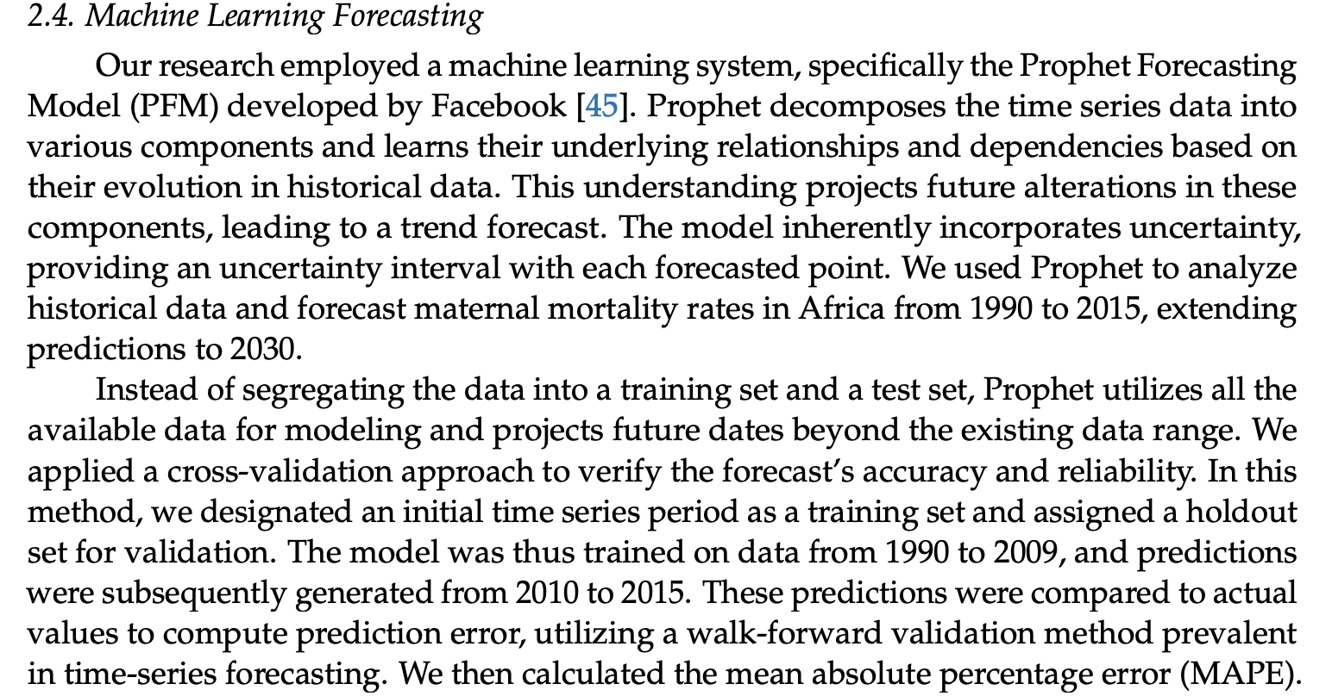 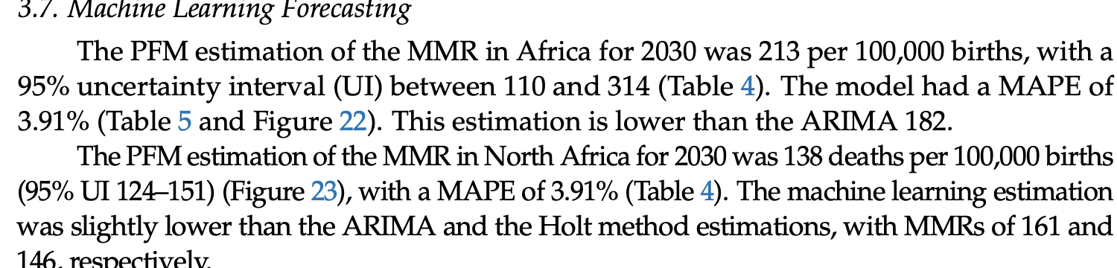 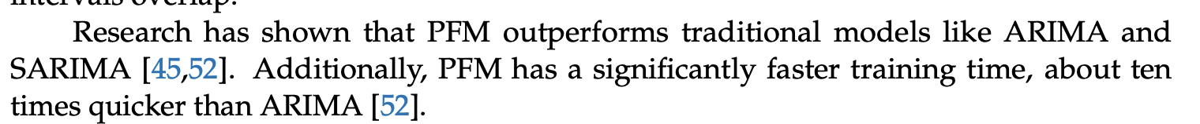

Arima is more statistically grounded than ML, assuming stantionarity in the data

See this paper for more info about MMR and potential discussion points

No mention of missing data – assumed they did not have it

## Stat Insights Using ML into MM

<https://ieeexplore.ieee.org/stamp/stamp.jsp?tp=&arnumber=10529290&utm_source=scopus&getft_integrator=scopus&tag=1>

Review of how machine learning can be used to reduce maternal mortality.

* See for descriptions of different machine learning models

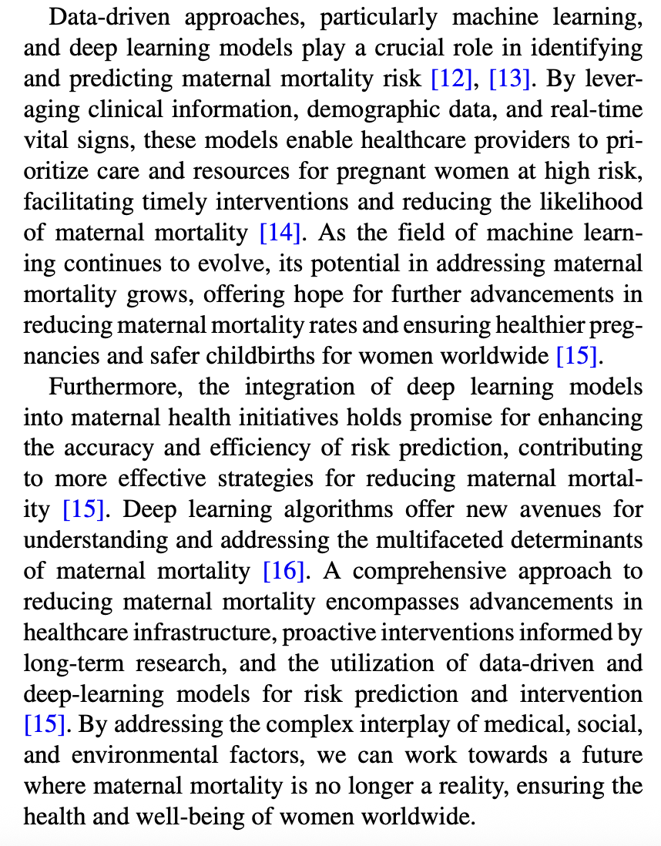 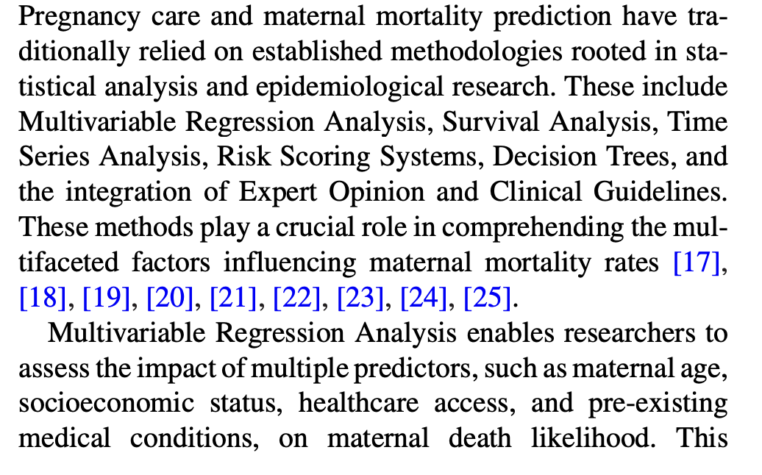

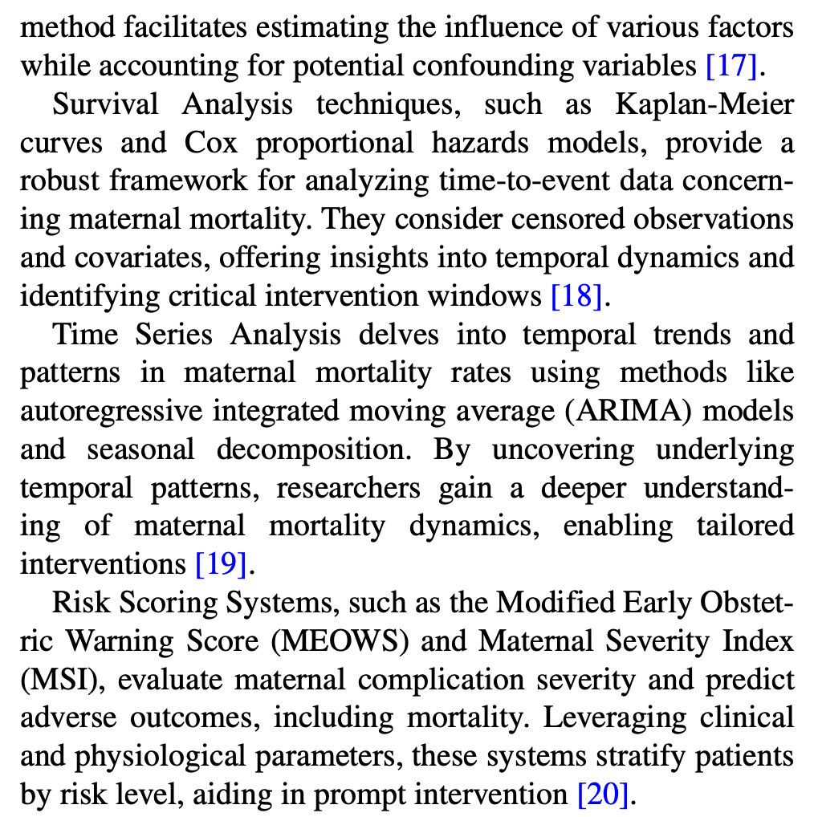 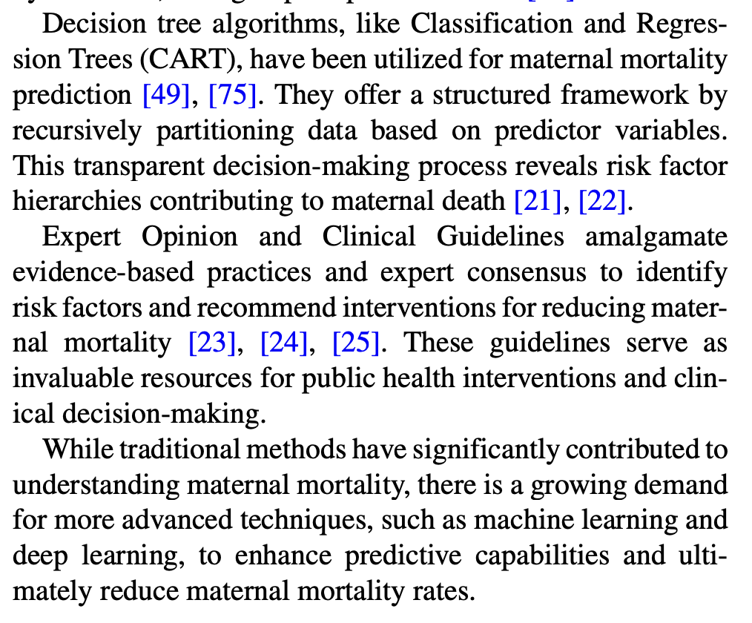 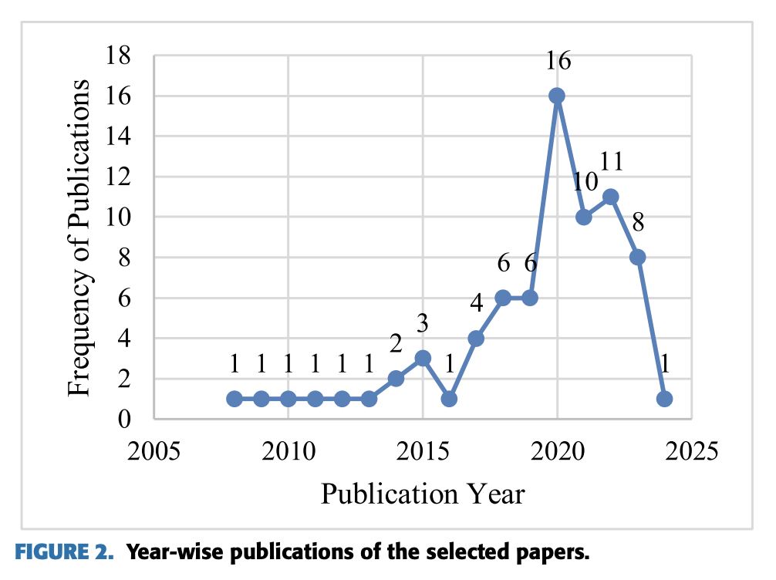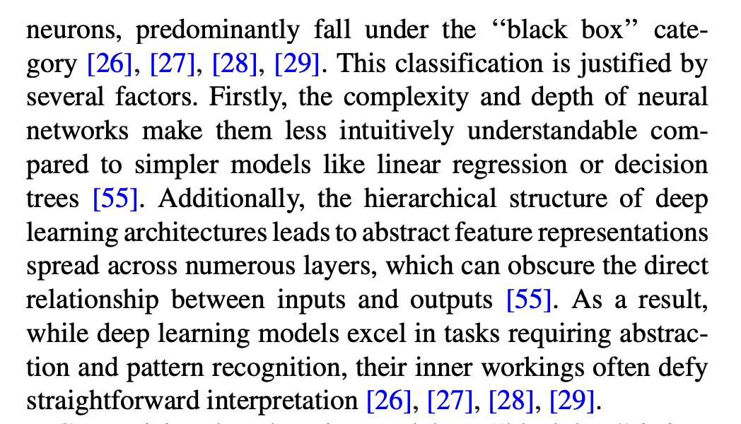

e trends in publications concerning the utilization of machine learning and deep learning-based box models in pregnancy care and initiatives aimed at reducing maternal mortality rates from 2008 to 2024.

* Potentially cite for why they are not used: prefer models that can be interpreted/see which variables have the greatest effect to be able to inform policy
* This paper says that decision trees are white box models

“The identification, mitigation, and prediction of the risk of maternal mortality are all significant tasks that are carried out using white box machine learning models, which are very interpretable. These models provide healthcare professionals with valuable insights into the causes of maternal mortality, which can improve care and potentially save lives.”

* See paper for references to other papers that speak to how maternal mortality is influenced by clinical biomarkers, medical history, prenatal care, geographic information, social determinants, obstetric history, behavioural data, genetic factors, multiple pregnancies, substance abuse, infections, and other (“According to Lucas et al. [1], hemorrhage, which refers to excessive loss of blood from the genital tract within 24 hours of delivery, severe anemia characterized by insufficient blood volume, and various infections such as sepsis, malaria, and viral hepatitis, pose significant risks contributing to maternal mortality and morbidity in women. Additionally, unsafe abortion, hypertensive disease or eclampsia during pregnancy, obstructed labor, and malnutrition in pregnant women are also identified as risk factors associated with adverse maternal outcomes.”)

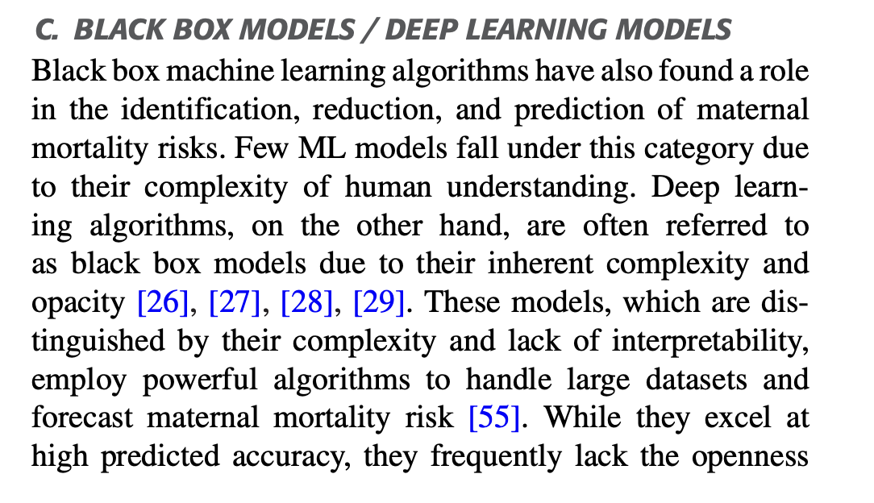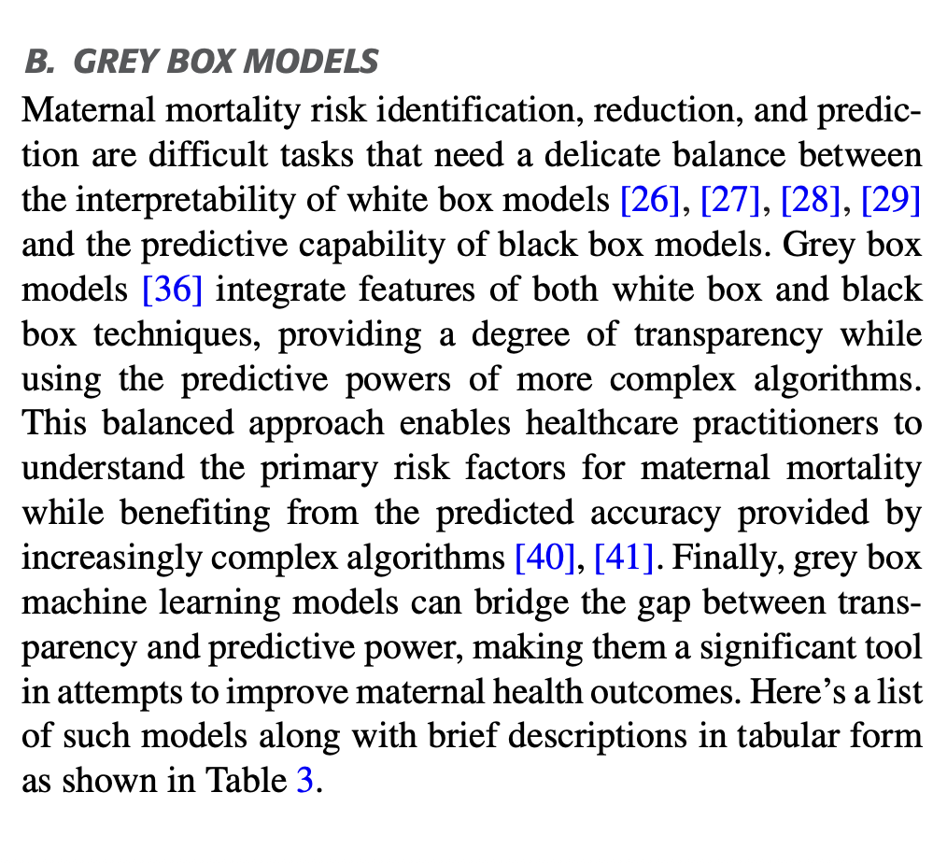

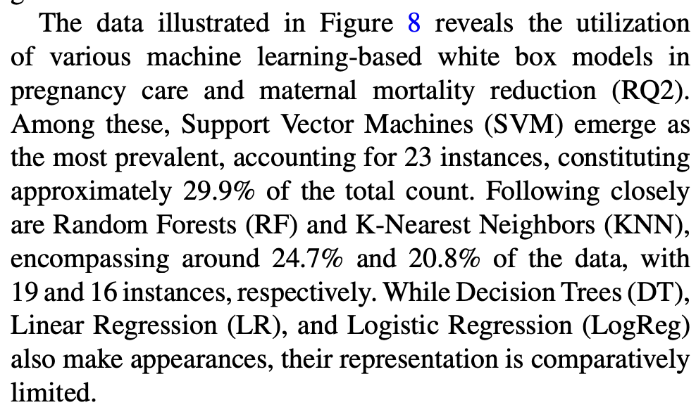

Black box models can uncover difficult to detect, but important patterns in the dataset. They are used frequently in diagnosis from images.

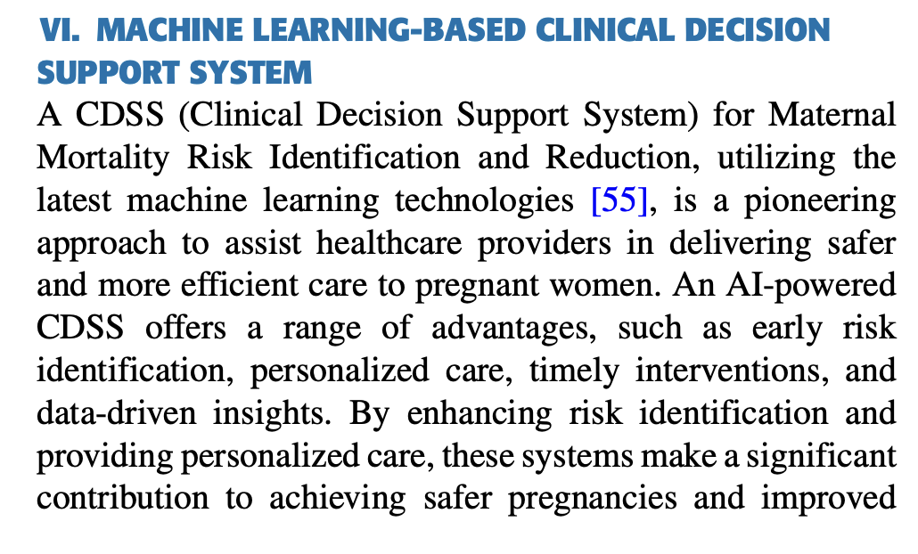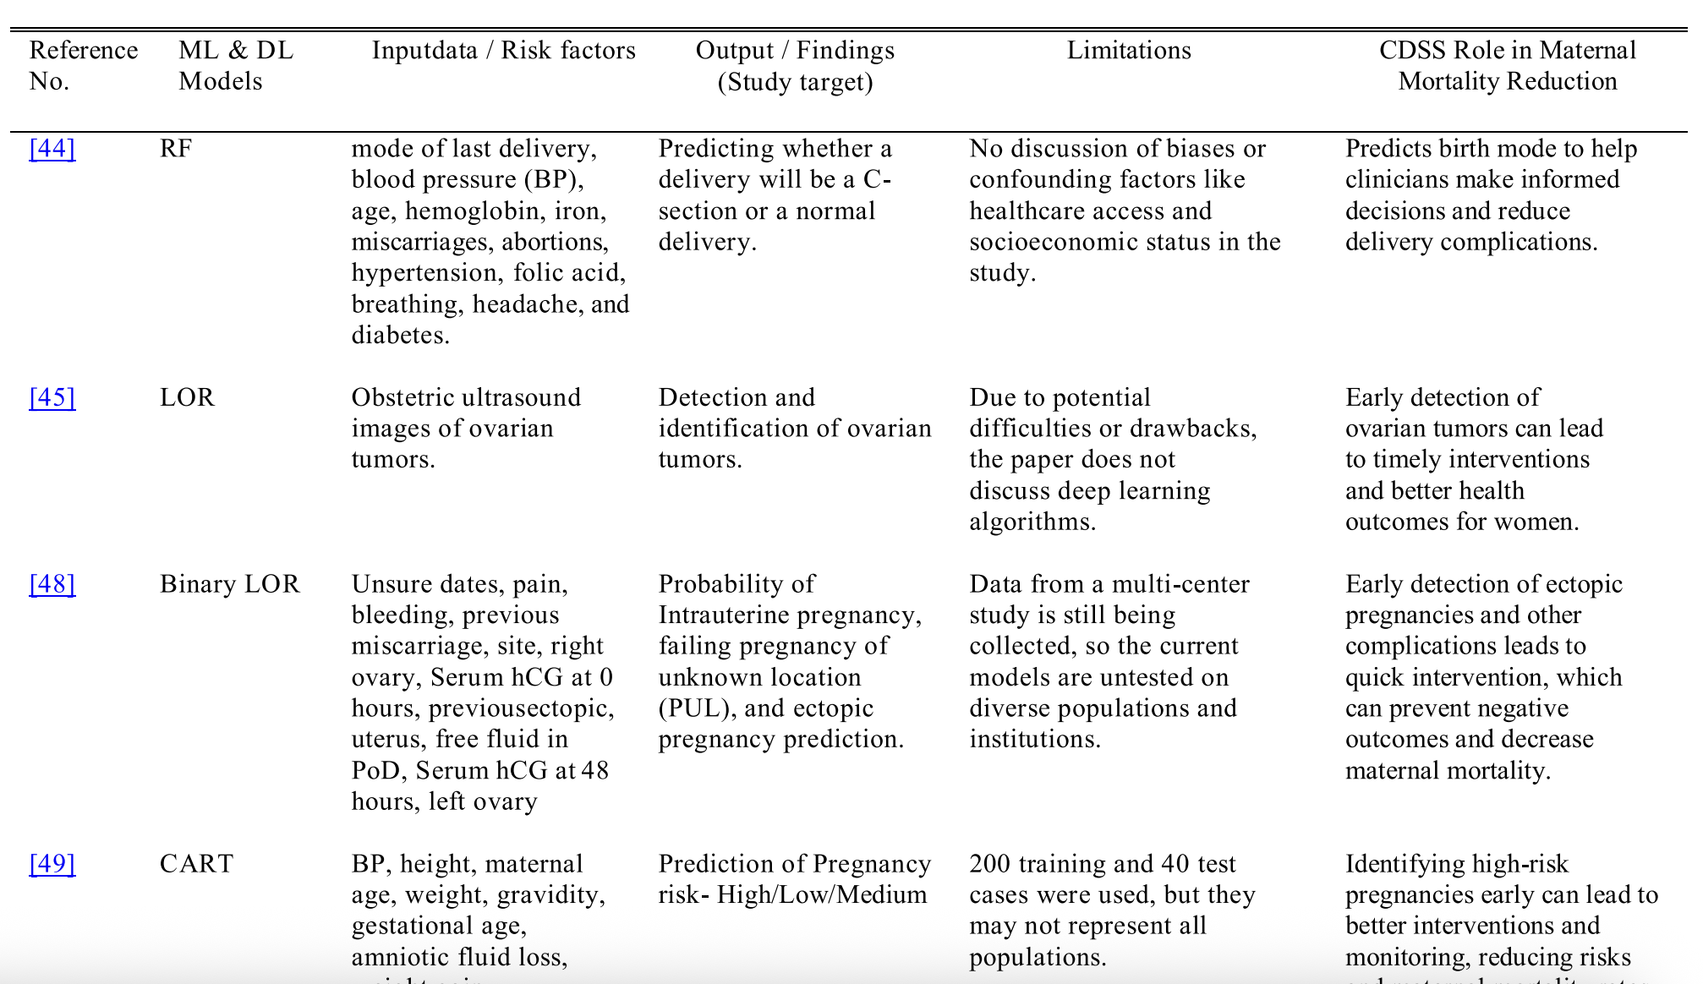

* Enable early interventions and produces personalised risk assessments

# Feature Analysis

Also see: <https://link.springer.com/article/10.1186/s12911-025-02921-z?fromPaywallRec=false>

## Explainable ML for Maternal Health

<https://www.sciencedirect.com/science/article/pii/S0169023X23000587?pes=vor&utm_source=scopus&getft_integrator=scopus>

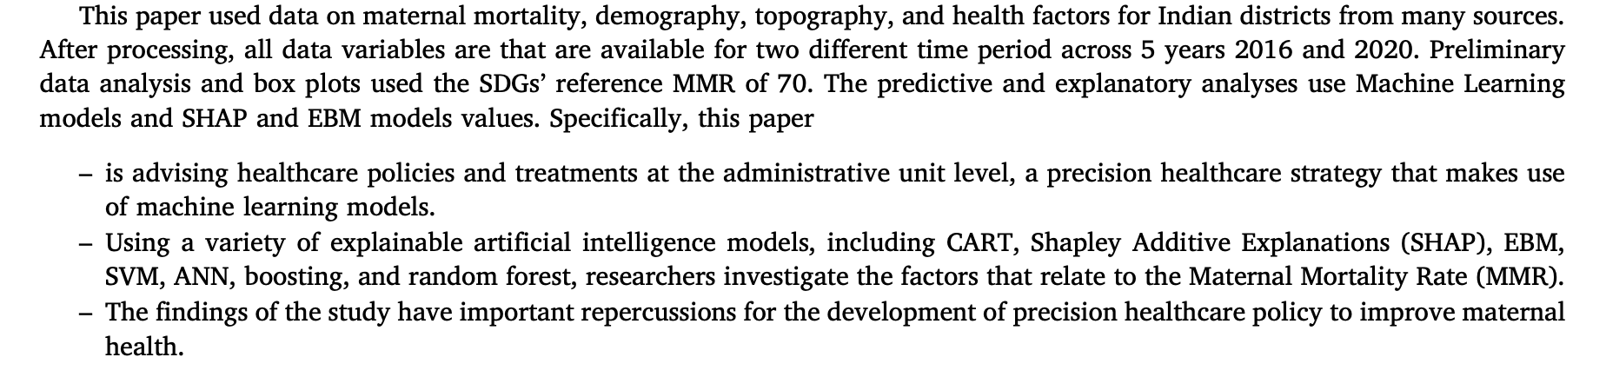

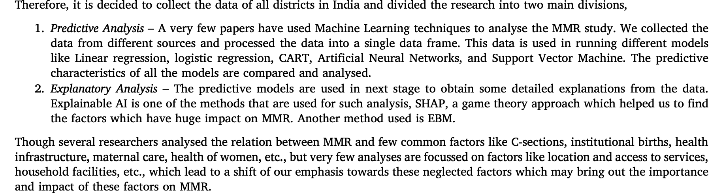

* Expand this for all countries, not just India
  + This is kind of like a proof of concept

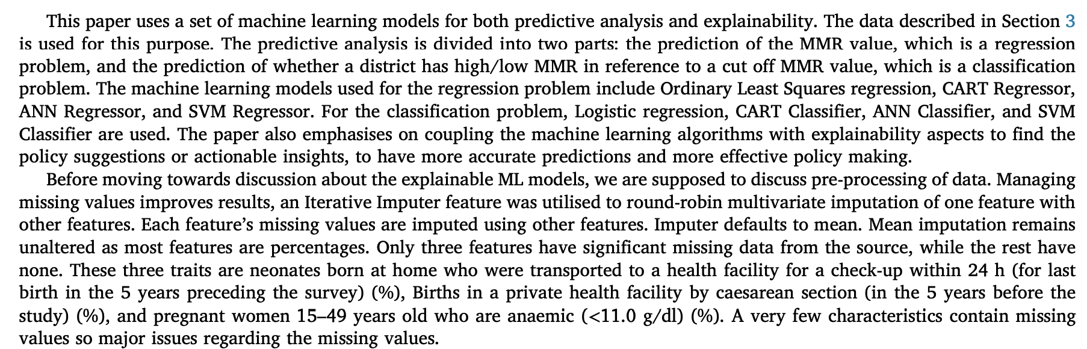

* My study uses more missing data (potentially able to be used in more settings?)

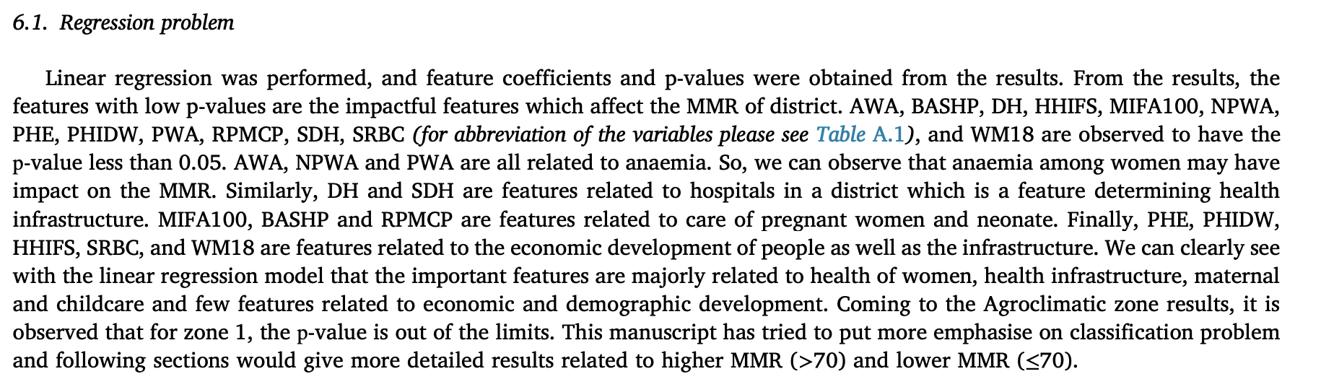

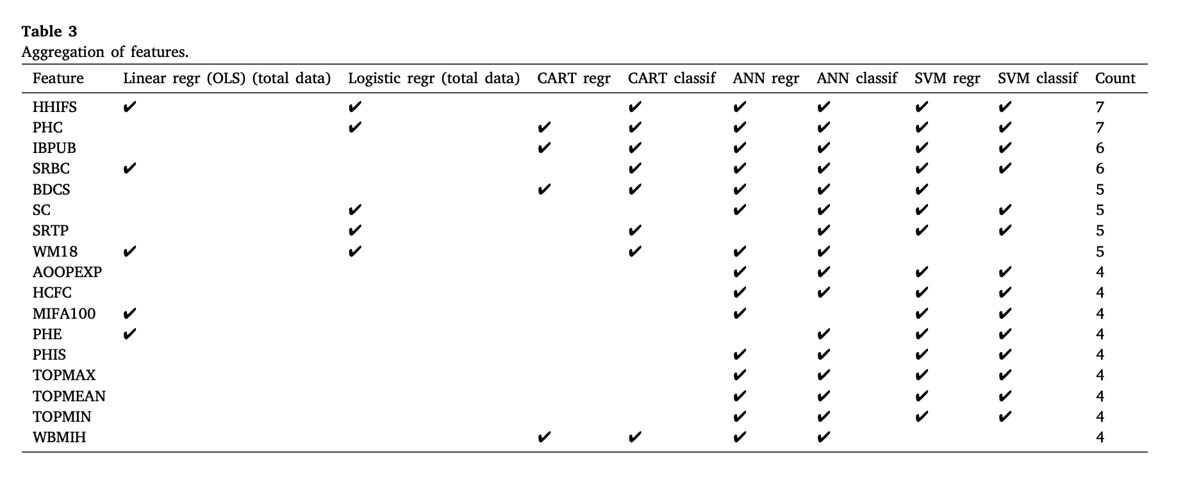

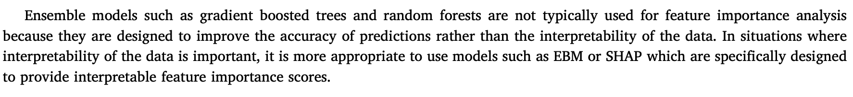

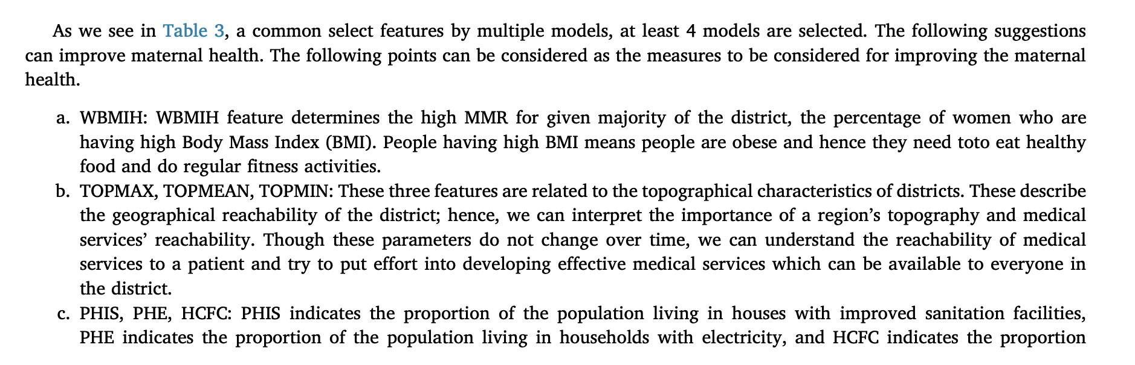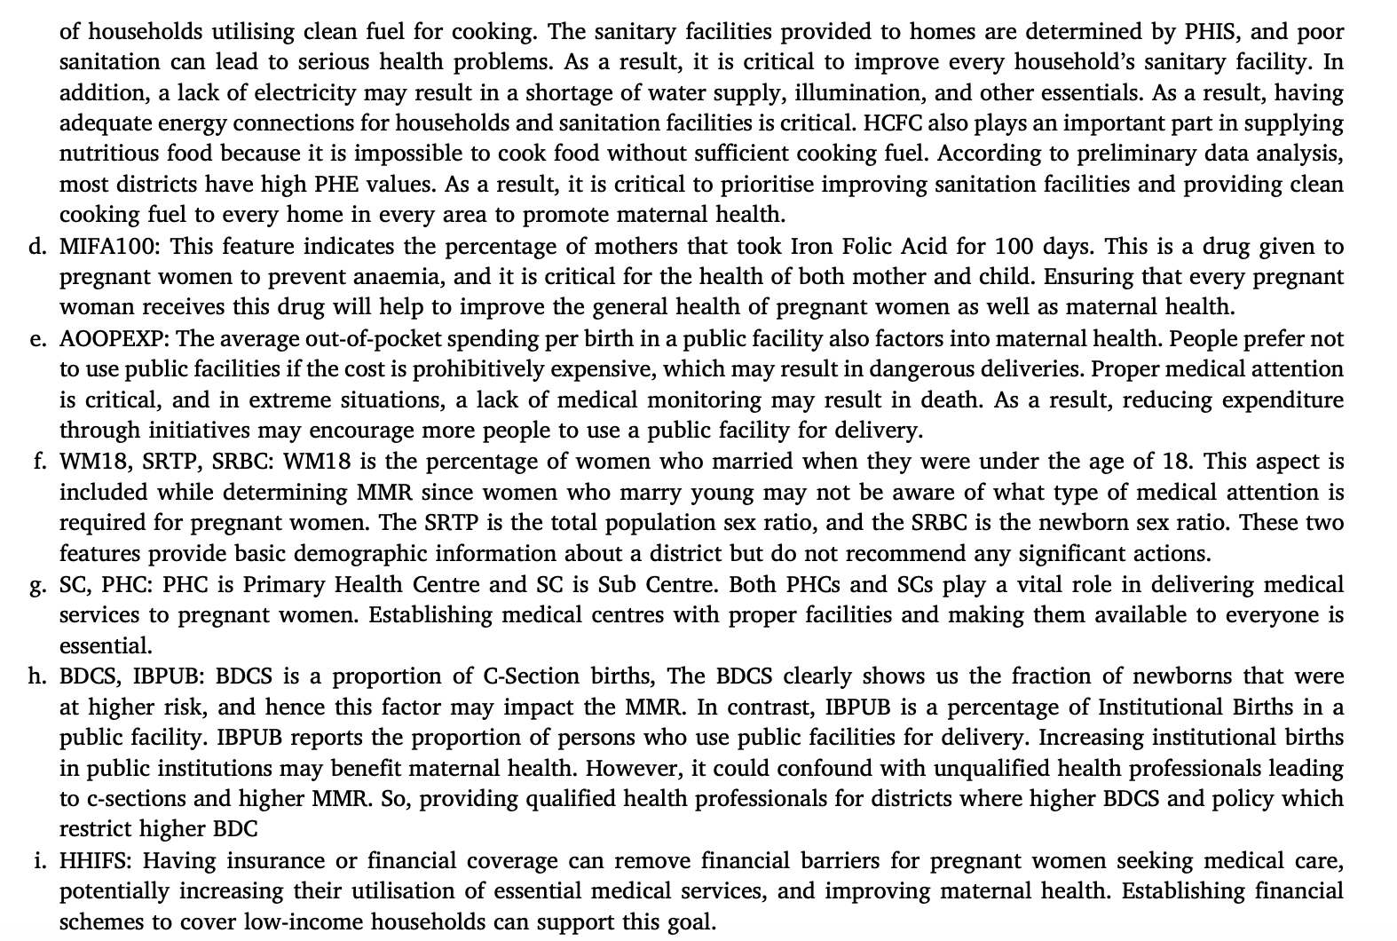

* Can use this as a sanity check for my results?
* Can also use them to compare global recommendations versus local
* Can look at SHAP values for SVM and MLP to say they align and thus were maybe less necessary to test?
* My study has more empowerment and economic information, as well as a wider, less focused range of health indicators

## ML Pregnancy + Childhood Risk

<https://www.mdpi.com/2075-4426/13/6/975>

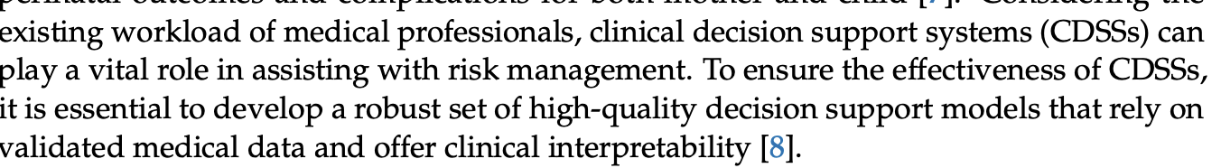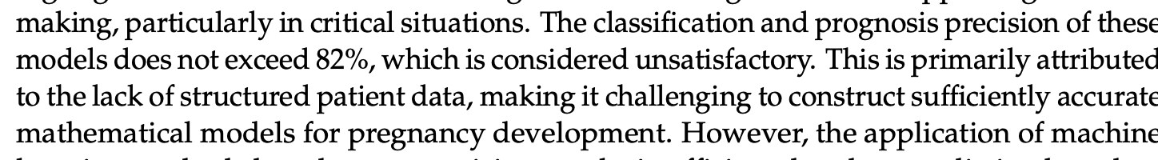

* Could be a benchmark for comparison benchmarks?

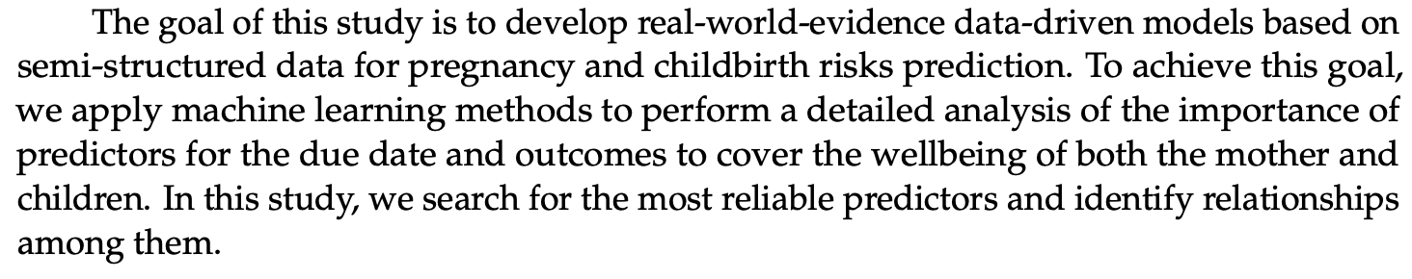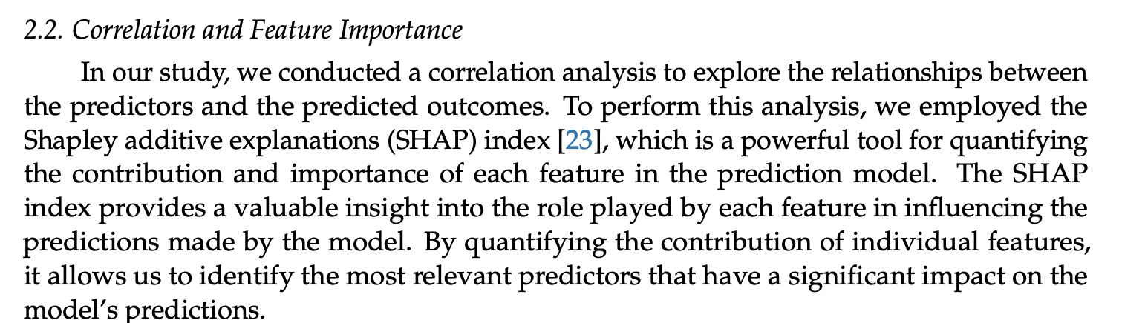

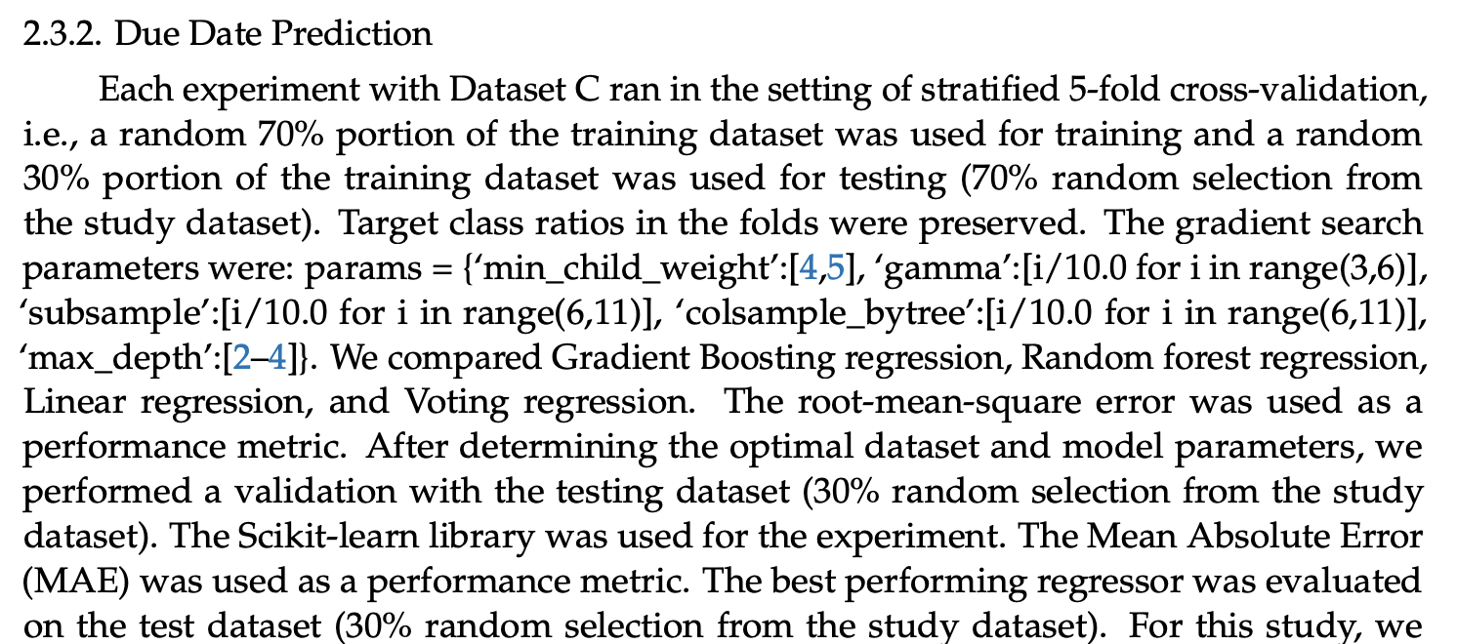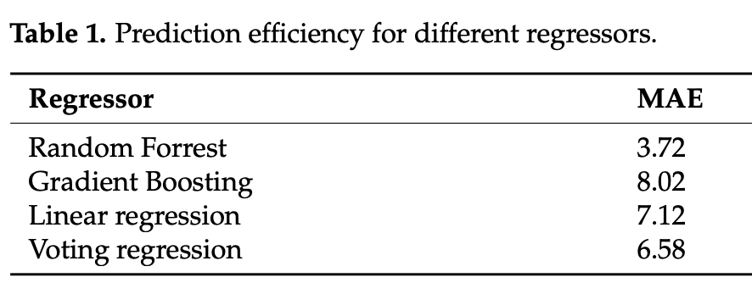

Childbirth risks prediction: random forest

Compare relative ordering to my study

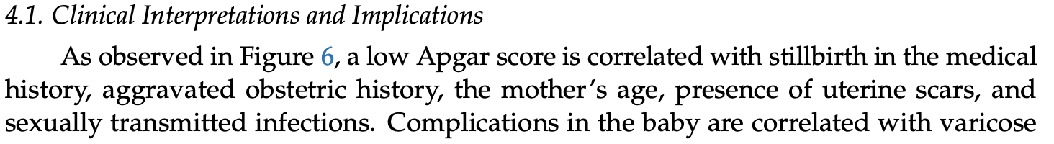

## Maternal Mortality and Newborn Health Factors

<https://jmai.amegroups.org/article/view/8590/html>

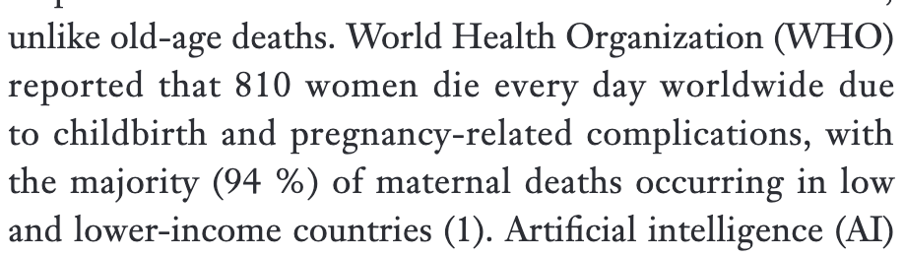 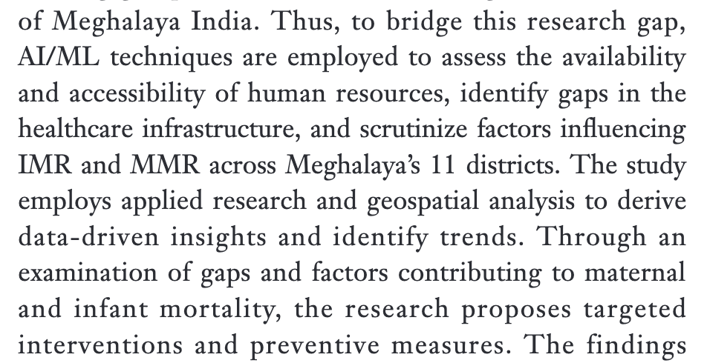 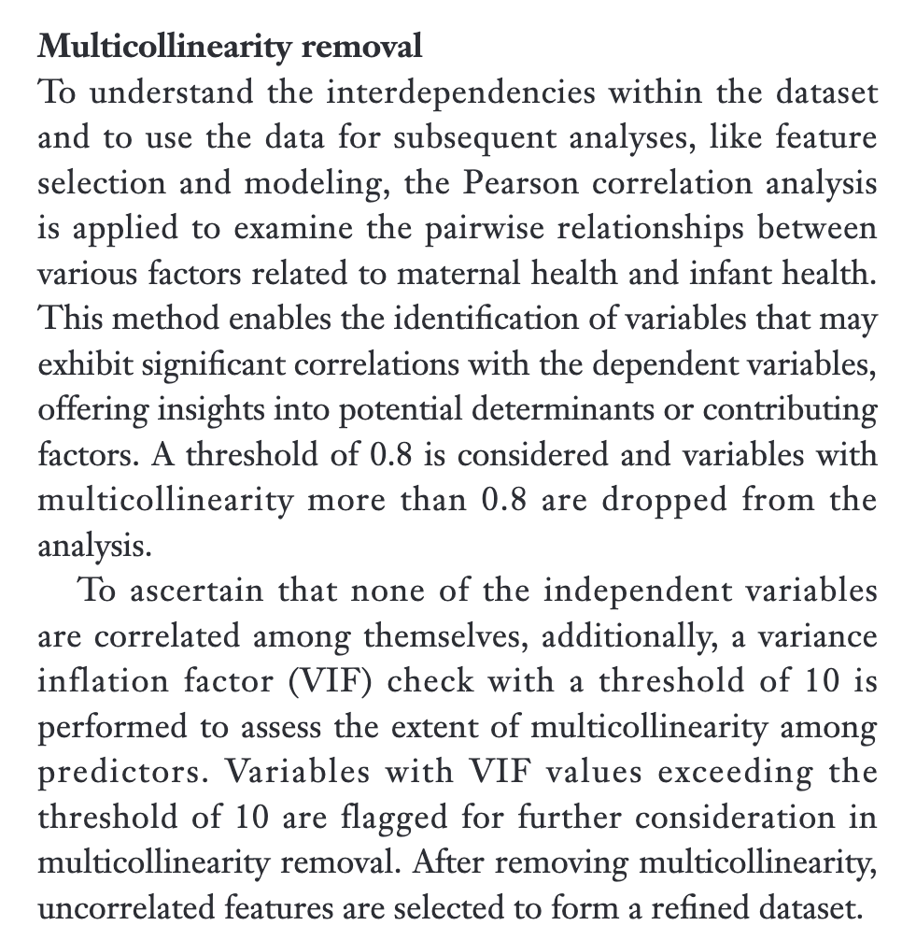

Hyperparameter optimisation via grid search

More important variables are extracted from random forest and used in EFA

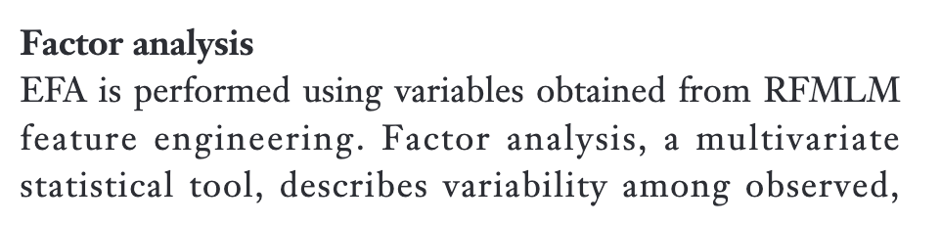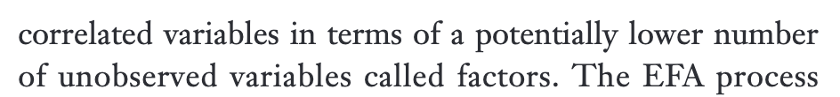

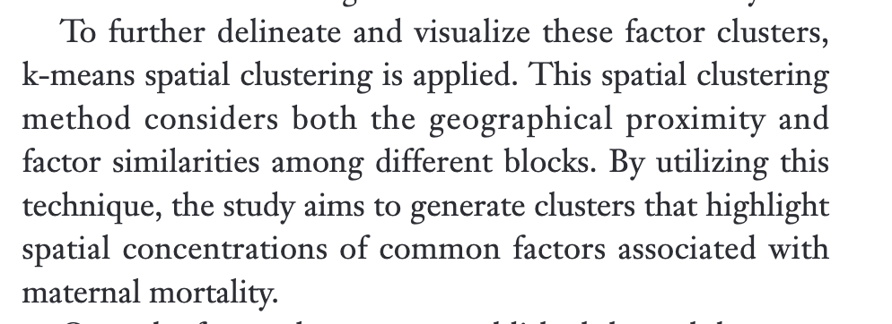 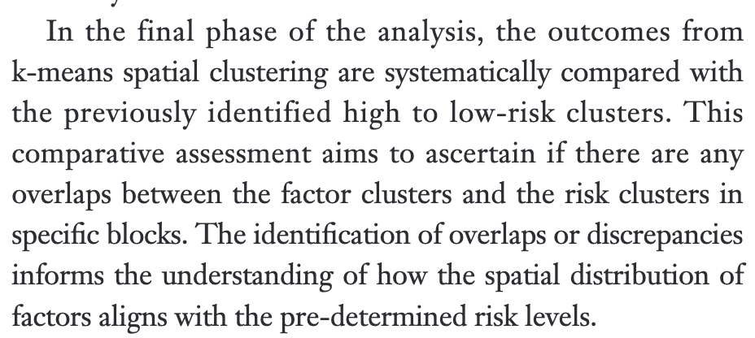

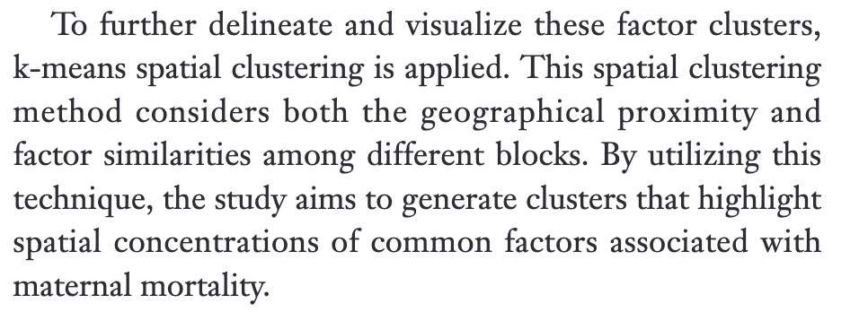

* Could be a cool extension of the research at the end
  + As a limitation could be that factors from low vs high mmr regions may have different predictive power

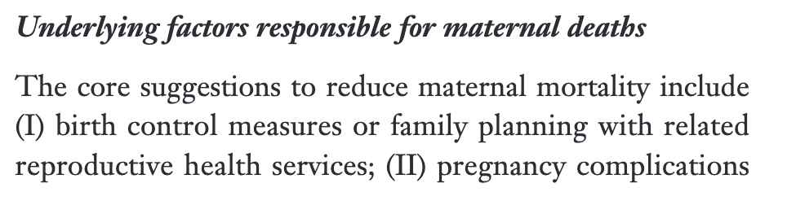 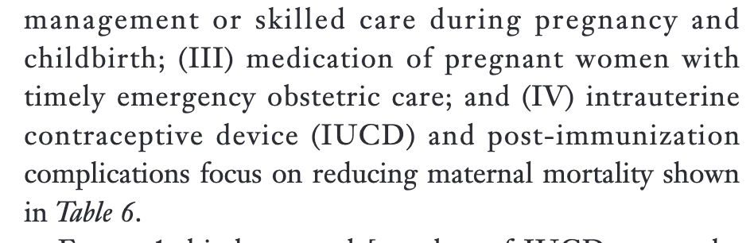

* Gives some reasoning behind why these factors are useful
  + See later if relevant to discussion
* Can see differences in importance of different predictive factors in different regions, showing how policy makers should focus on different things in each space
  + Again, a point to add to my limitations/discussion

## Infant Mortality Predictors - XGBoost

<https://link.springer.com/article/10.1007/s41870-025-02467-3?utm_source=getftr&utm_medium=getftr&utm_campaign=getftr_pilot&getft_integrator=scopus>

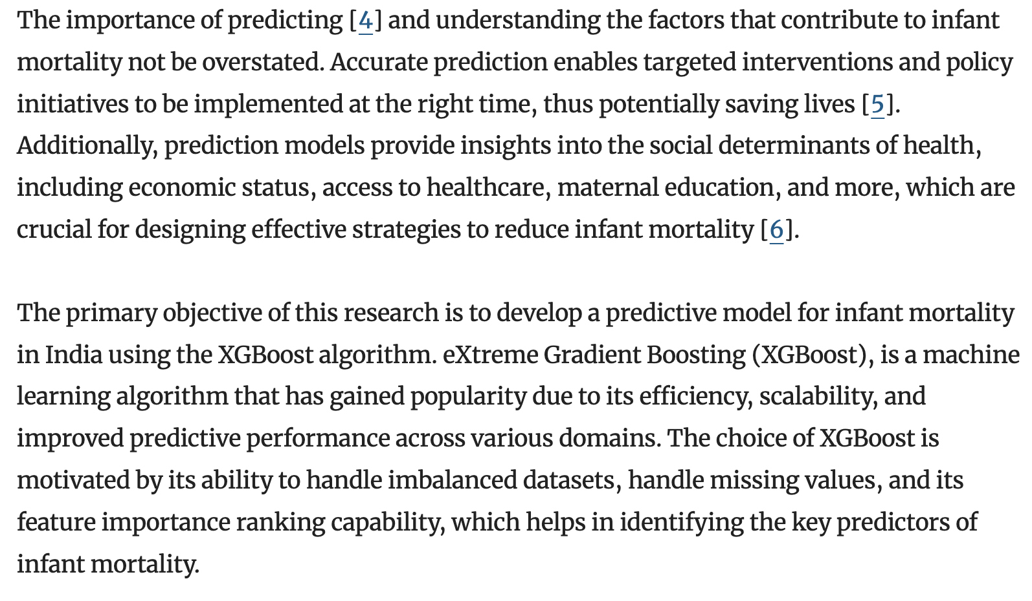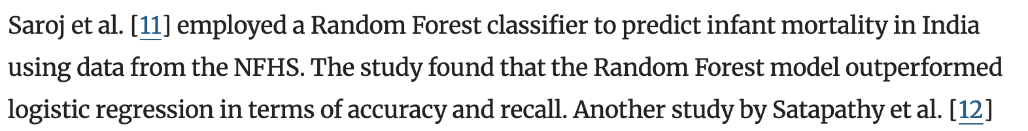

Used multiple imputation to replace missing values, where multiple versions of the imputed dataset were produced, with the model results from analysing each dataset version combiend to give the final results. Grid search for hyperparameter tuning

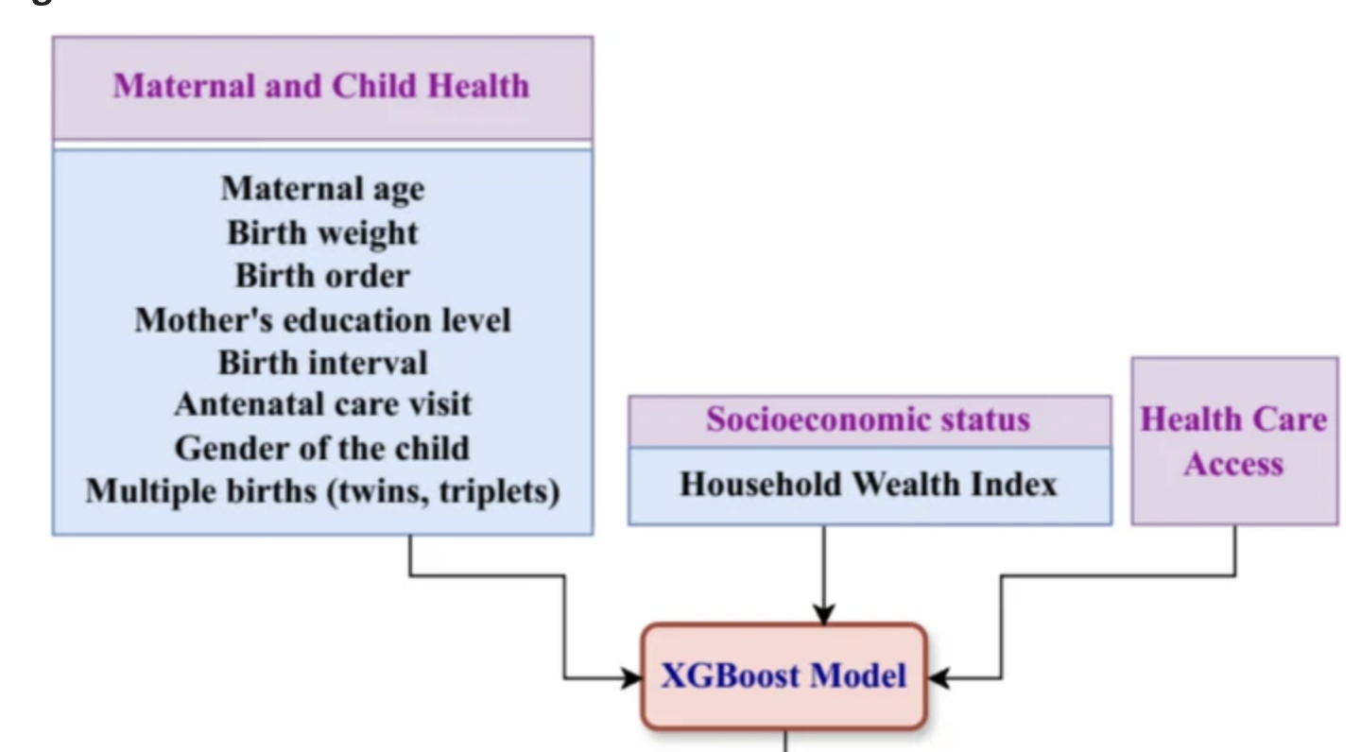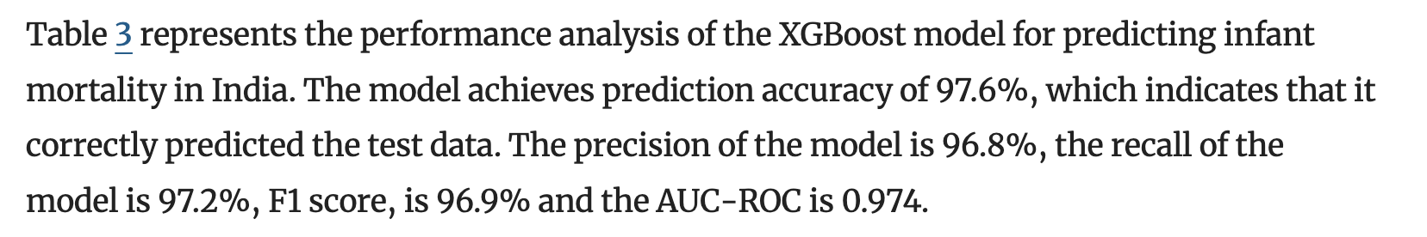

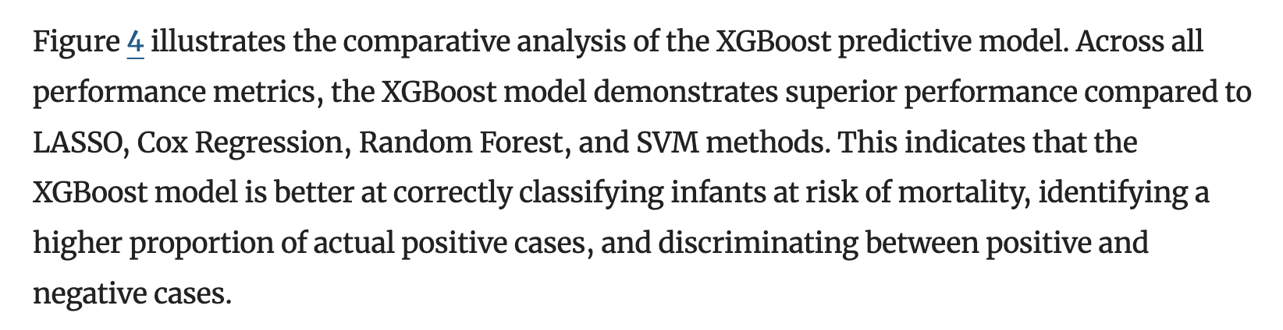

* From other papers

# Uses for ML – Case Studies

## ML in Medicine

<https://bmcmedresmethodol.biomedcentral.com/articles/10.1186/s12874-022-01758-8#Sec4>

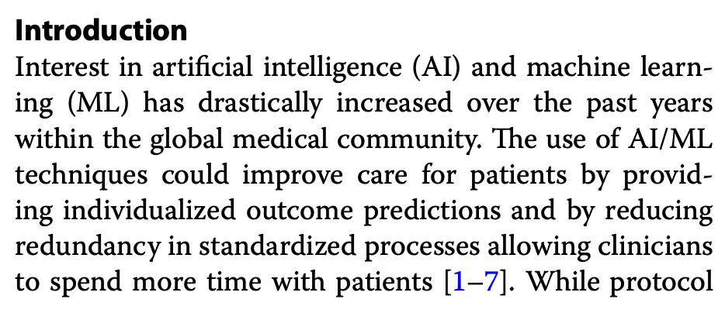 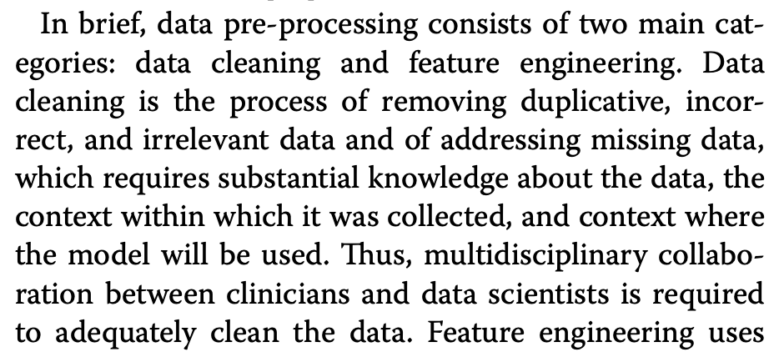 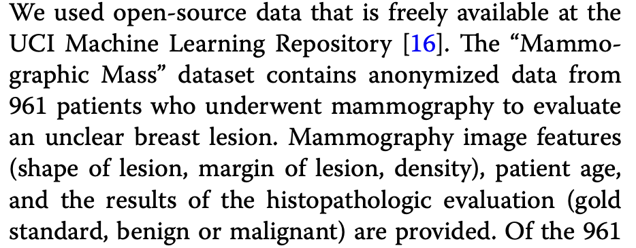 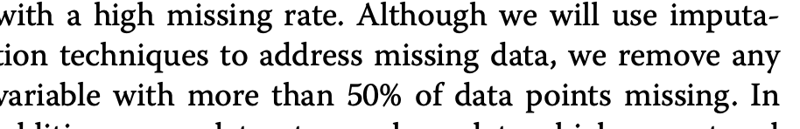 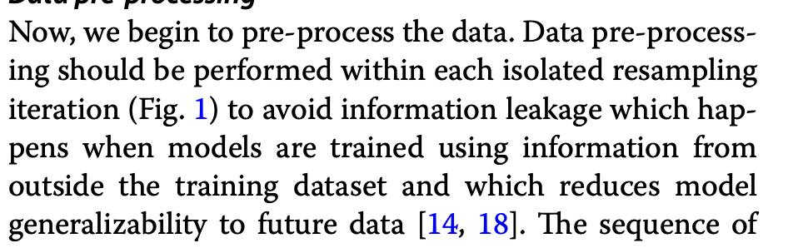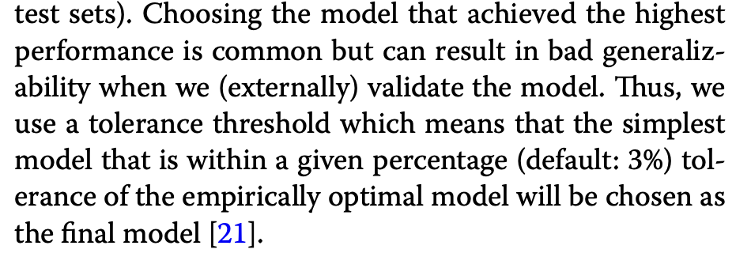

Grid search for optimal hyperparameters -> 10 fold cross validation with 3 repetitions 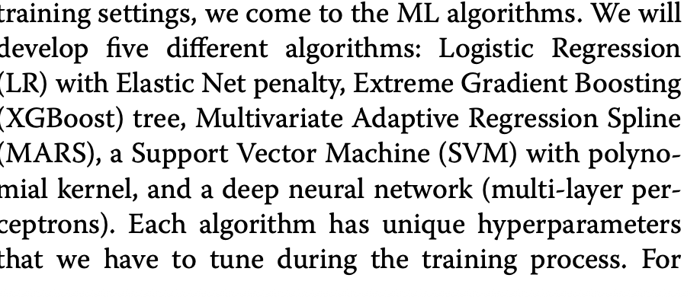 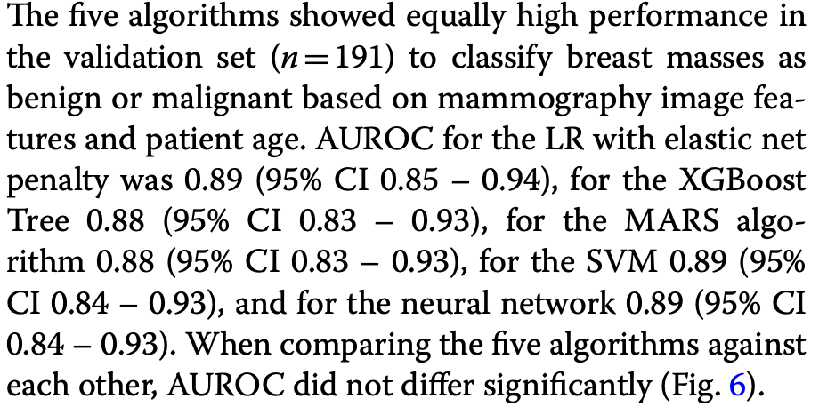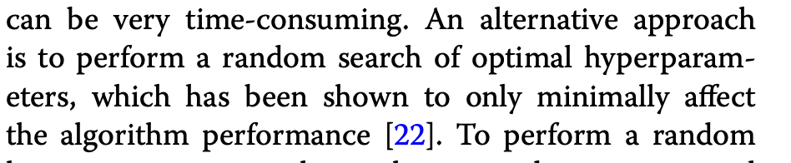

## ML in Public Health – Bibliometric Survey

<https://www.sciencedirect.com/science/article/pii/S0360835219305893#ab005>

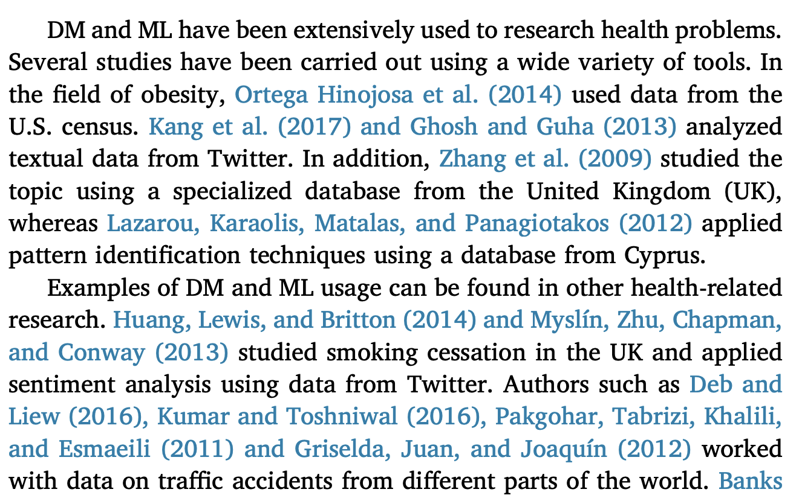 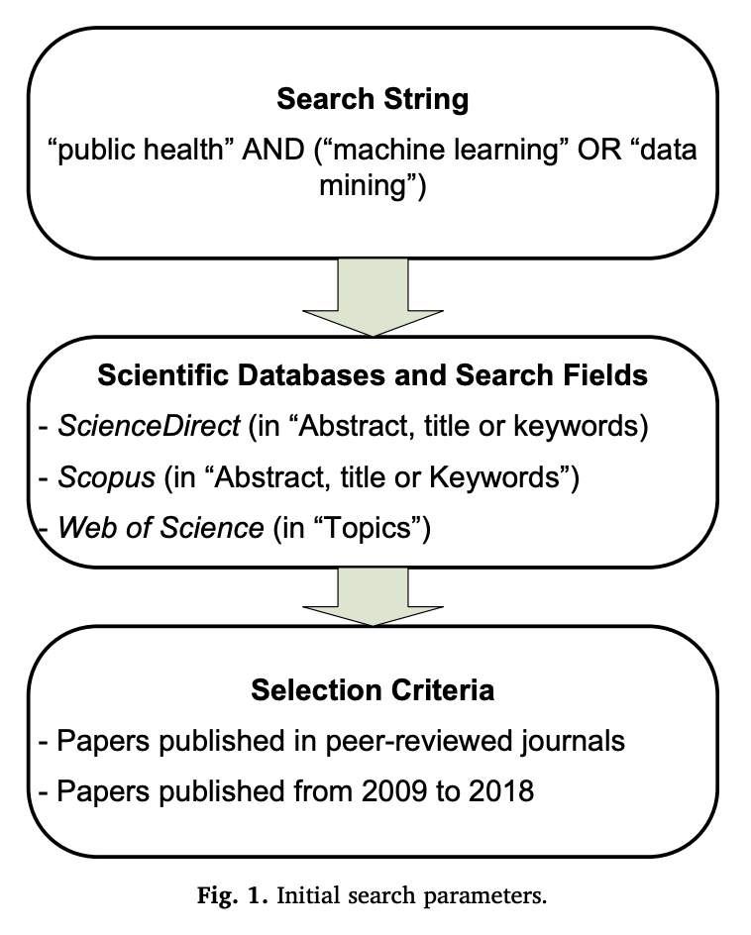

250 papers after exclusion

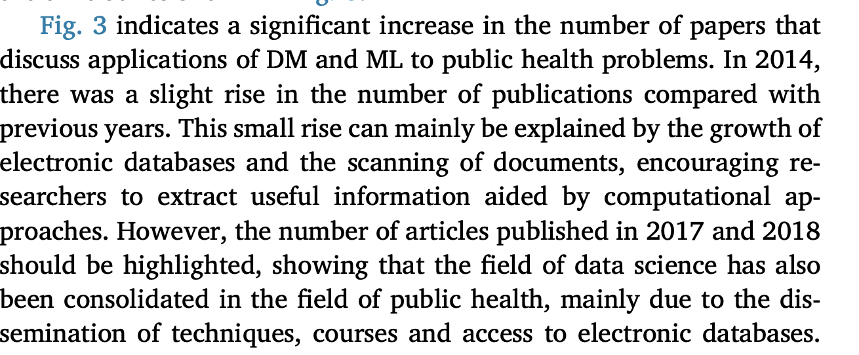 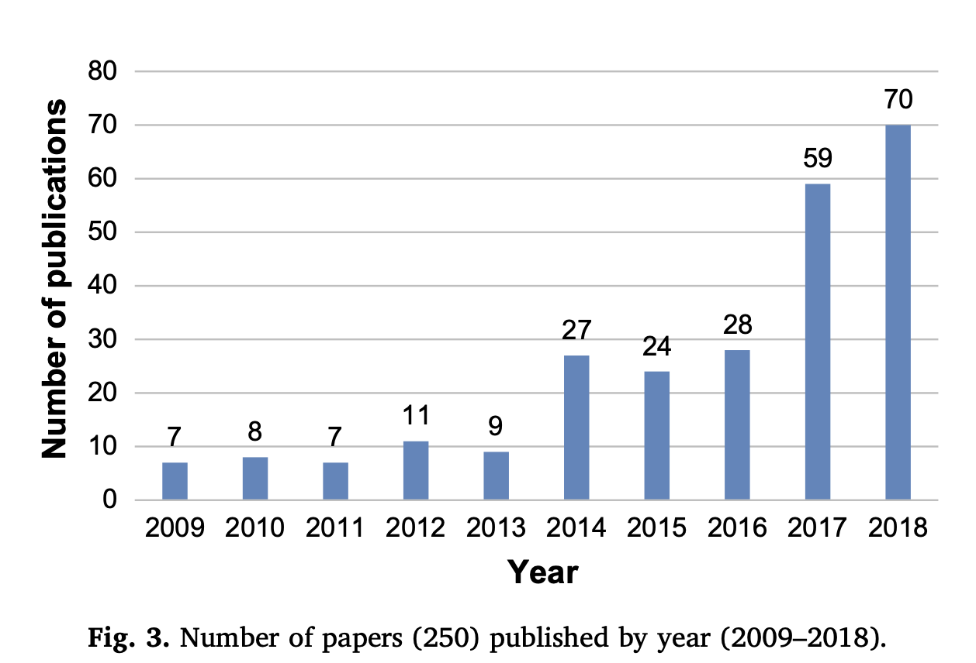 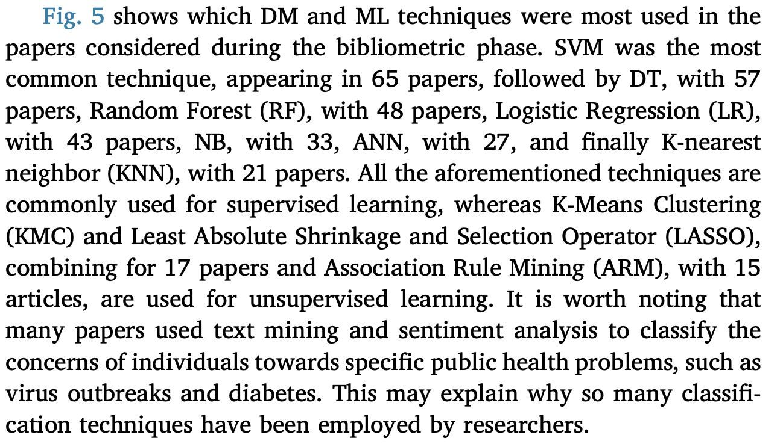 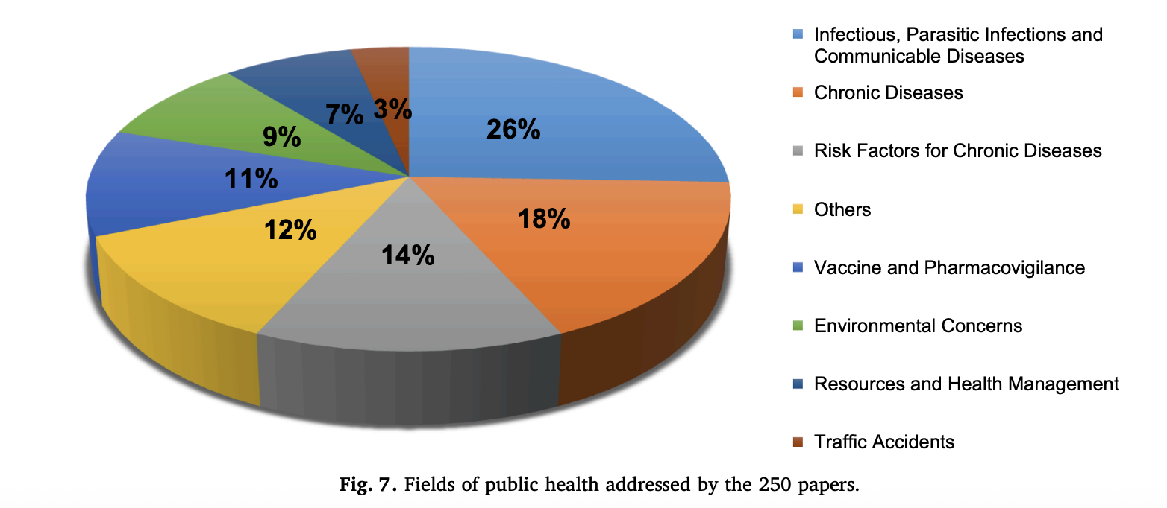

* Using Twitter to examine smoking behavior and perceptions of emerging tobacco product

## Pre-term Infant Survival Estimation

<https://www.nature.com/articles/s41598-018-31920-6>

they excluded cases that had a missing value for any predictor

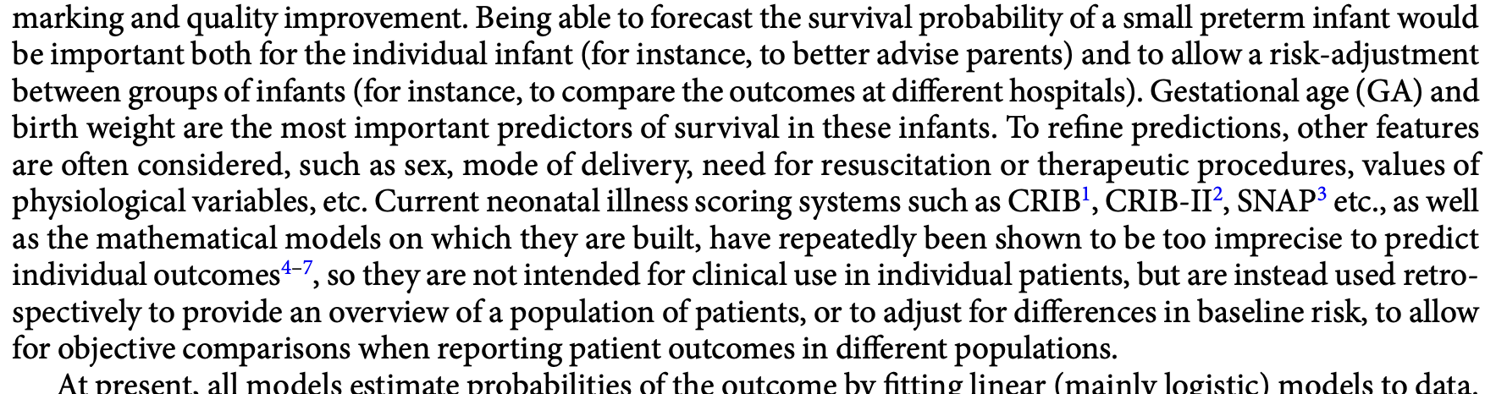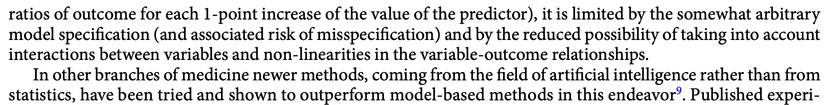

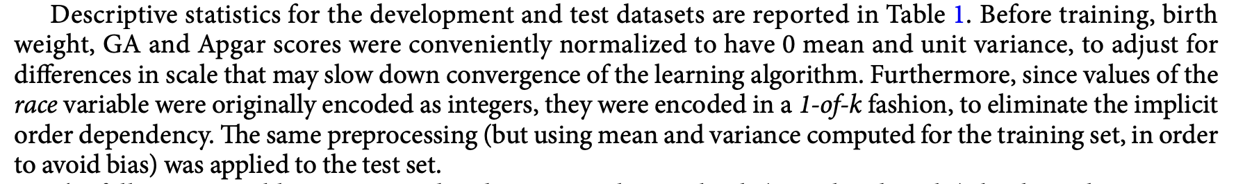

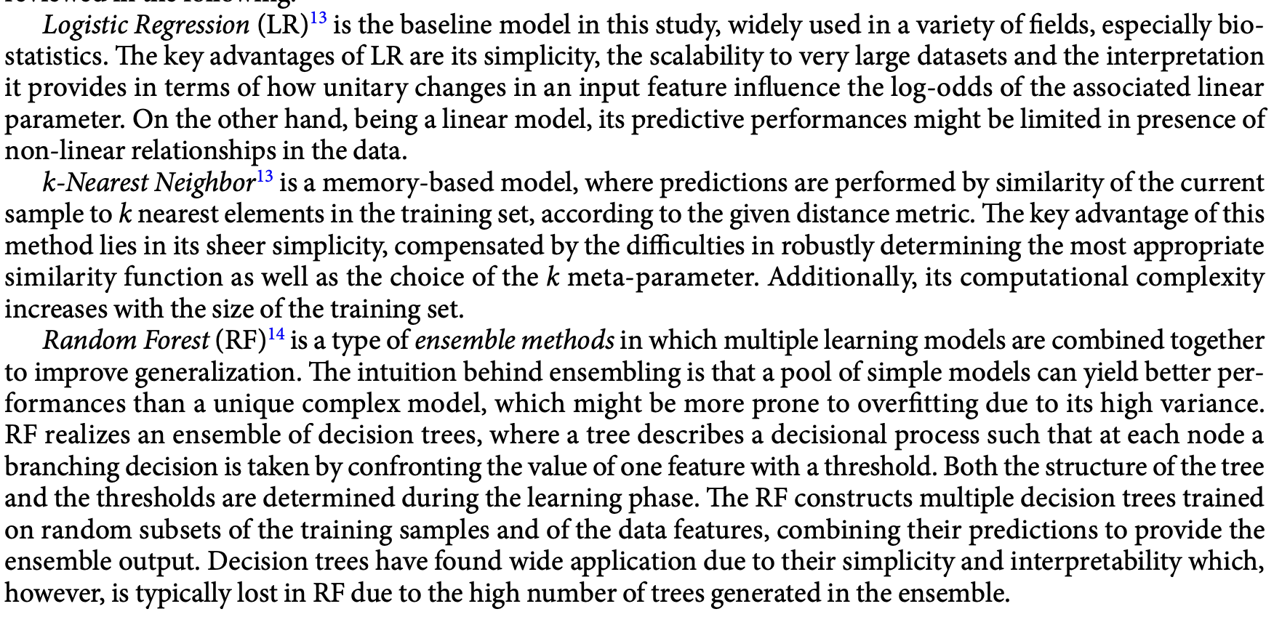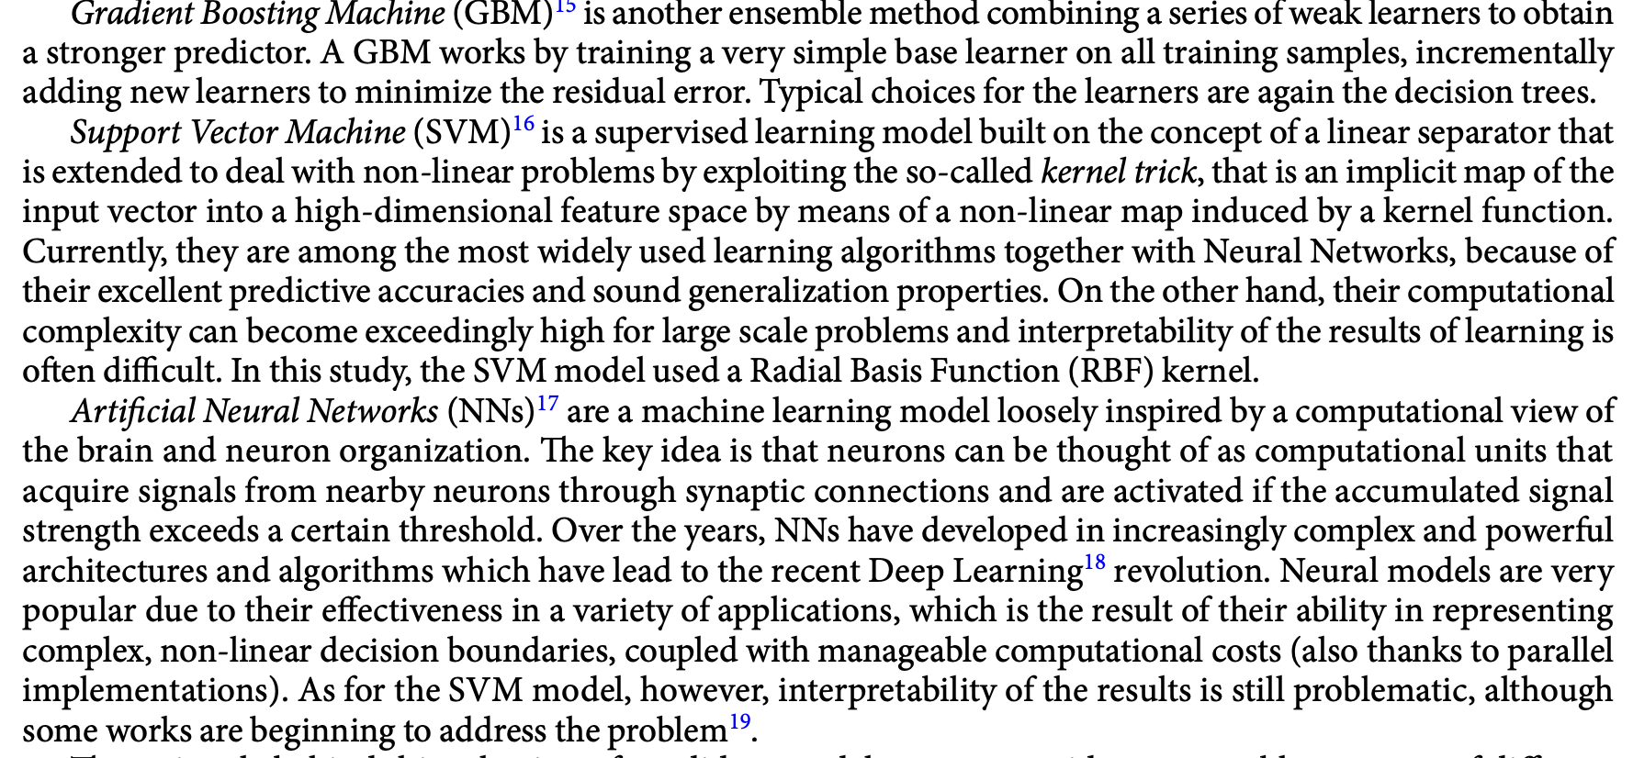

Hyperparameter tuning employed

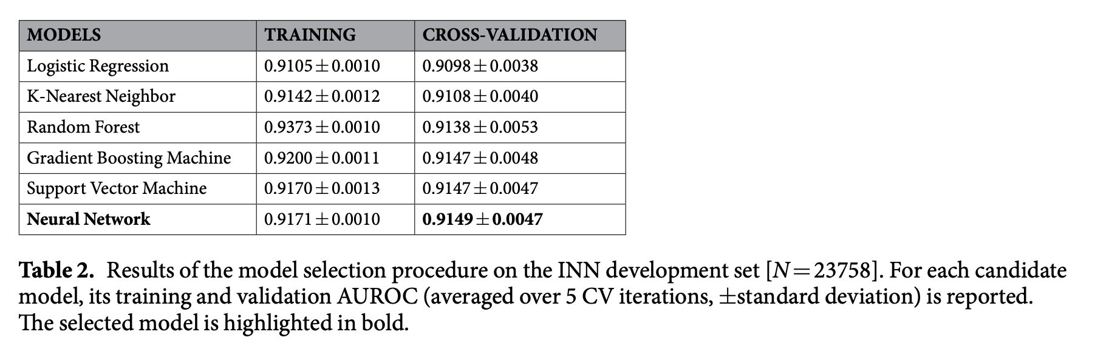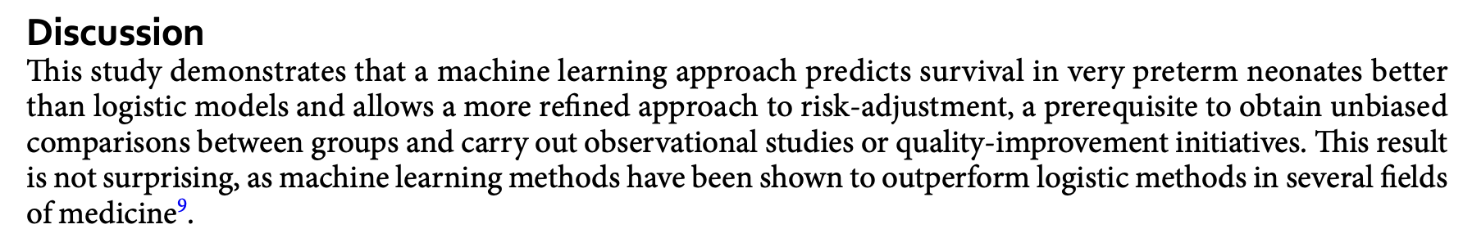

## Breast Cancer Detection – ML – Systematic Review

<https://www.sciencedirect.com/science/article/pii/S0040816625002095?via%3Dihub>

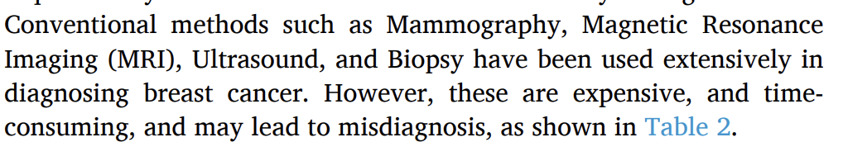  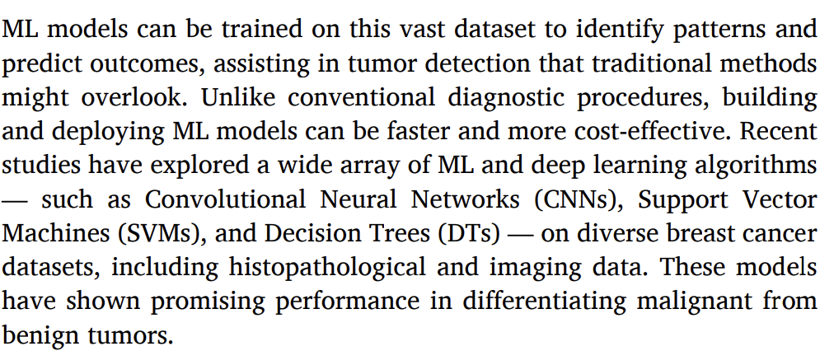 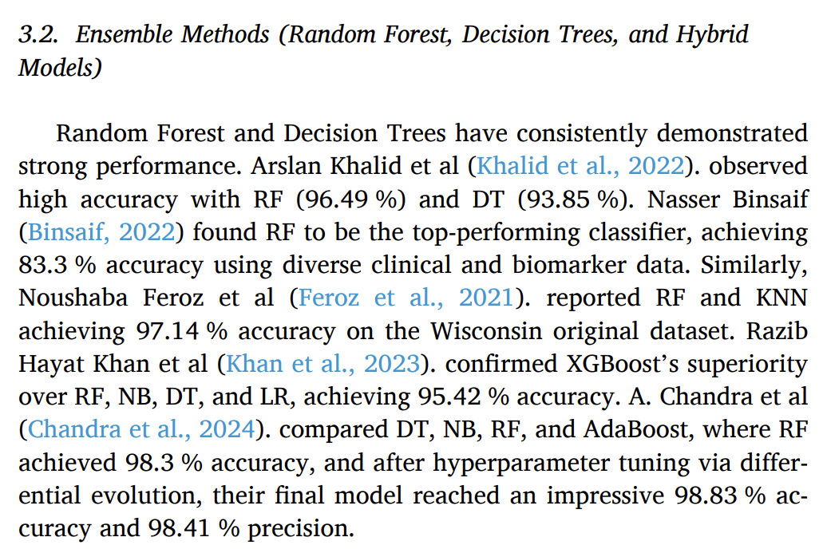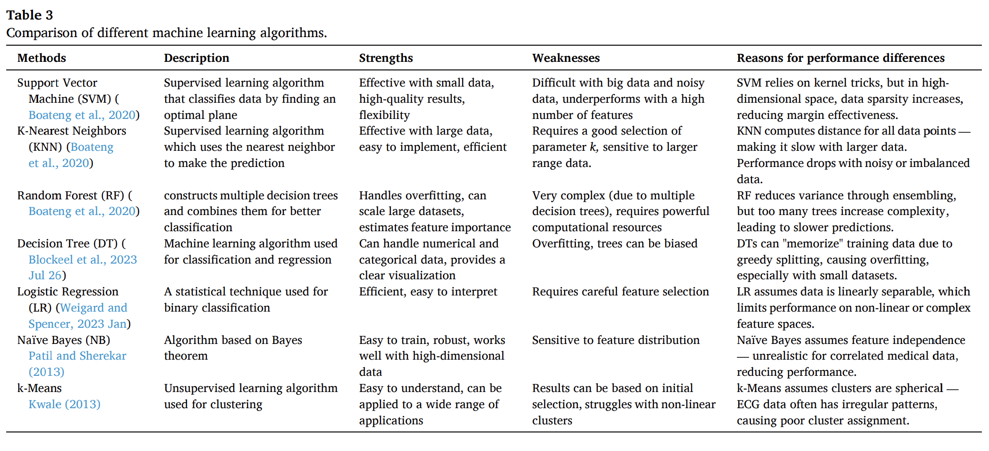

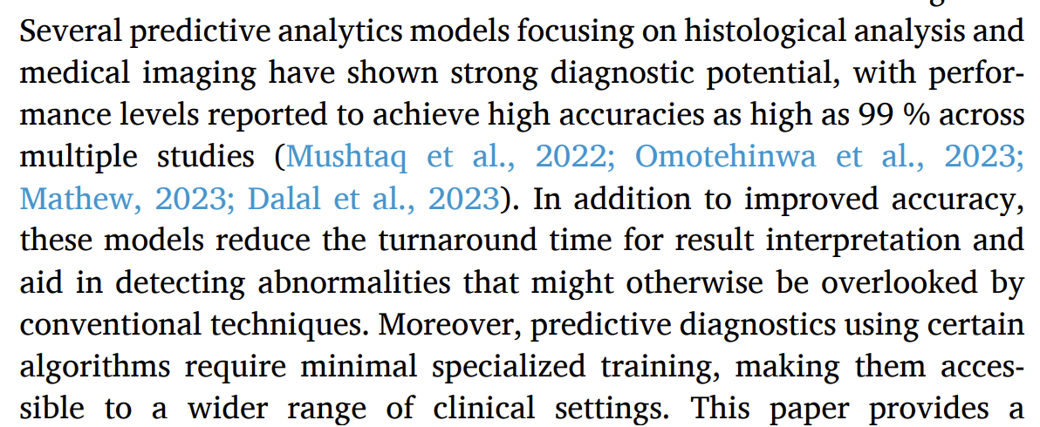

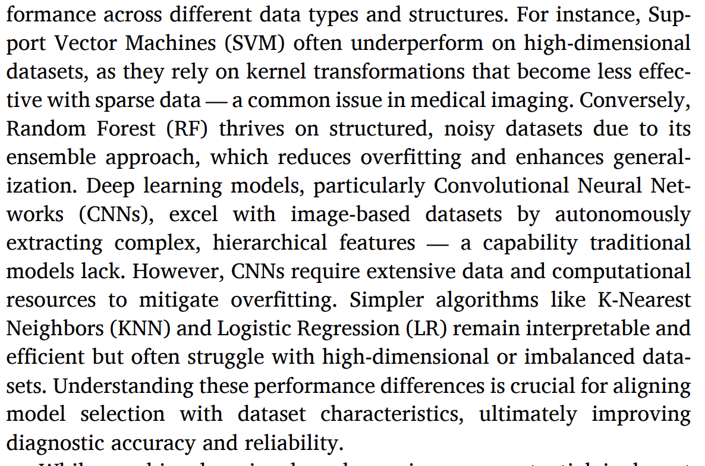 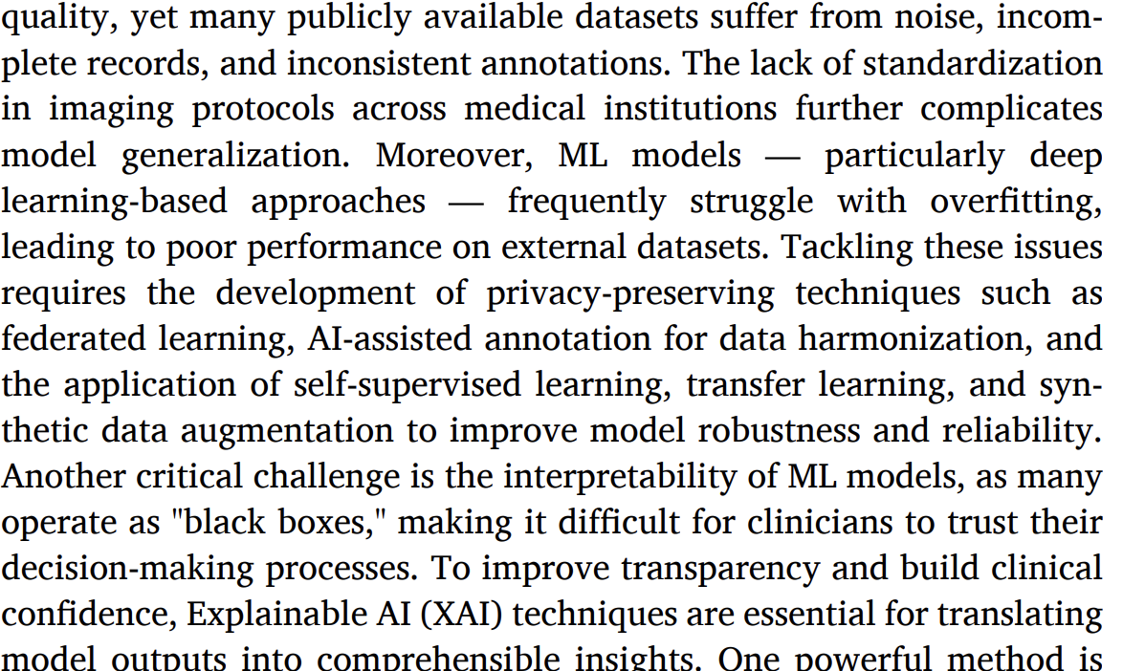

## Live Birth Forecasting – Tree Based ML

<https://www.scopus.com/pages/publications/85166474707>

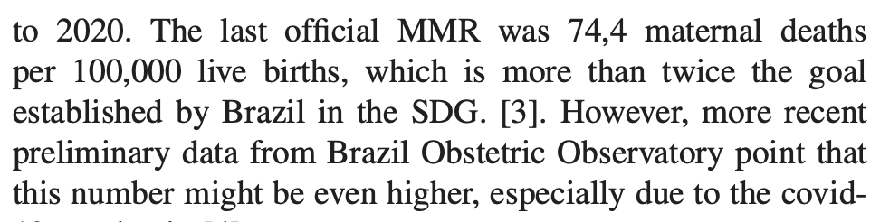2023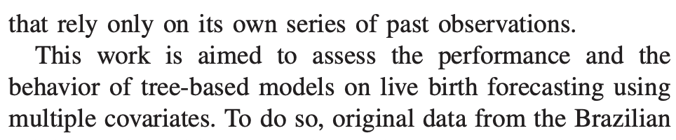

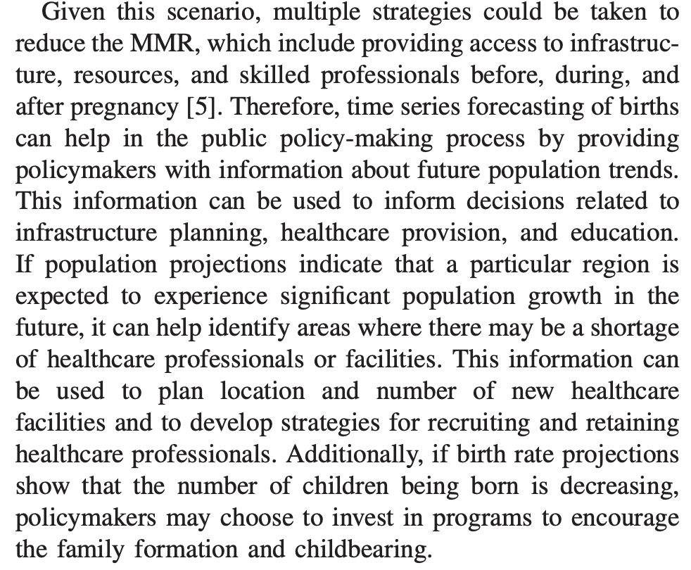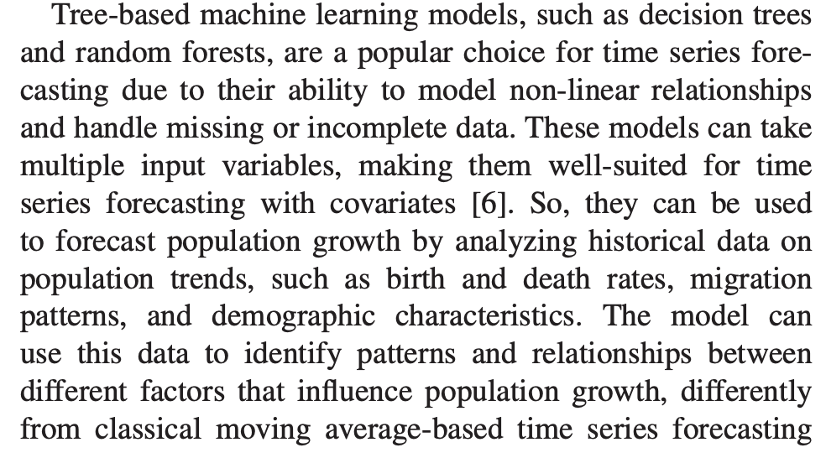

xgboost, lightgbm and catboost (gradient boosting that works particularly well for categorical variables -> not enough cat variables in my study to justify use)

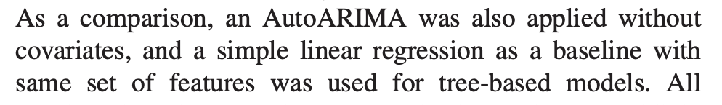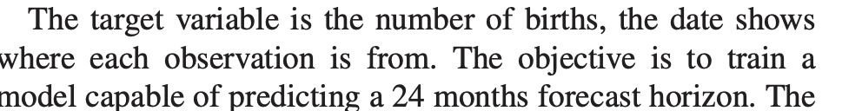

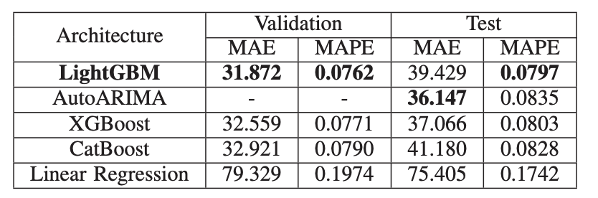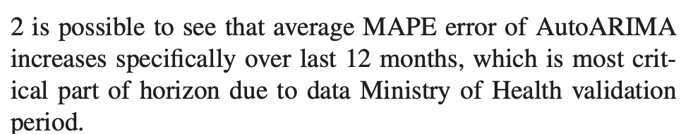

## ML Prediction of Postpartum Haemorrhage in Vaginal Birth

<https://www.nature.com/articles/s41598-021-02198-y>

classification combined with deep neural network (a form of ensemble model?)

“Postpartum hemorrhage (PPH) is the leading cause of morbidity in pregnant women worldwide and in Japan.”

“To save PPH cases worldwide in vaginal birth, the prediction and subsequent stratification of high-risk women is considered essential. A prediction model that integrates a variety of small risk factors and accurately produces the overall risk is required. In this study, we attempted to construct a deep learning model to predict PPH in vaginal birth.”

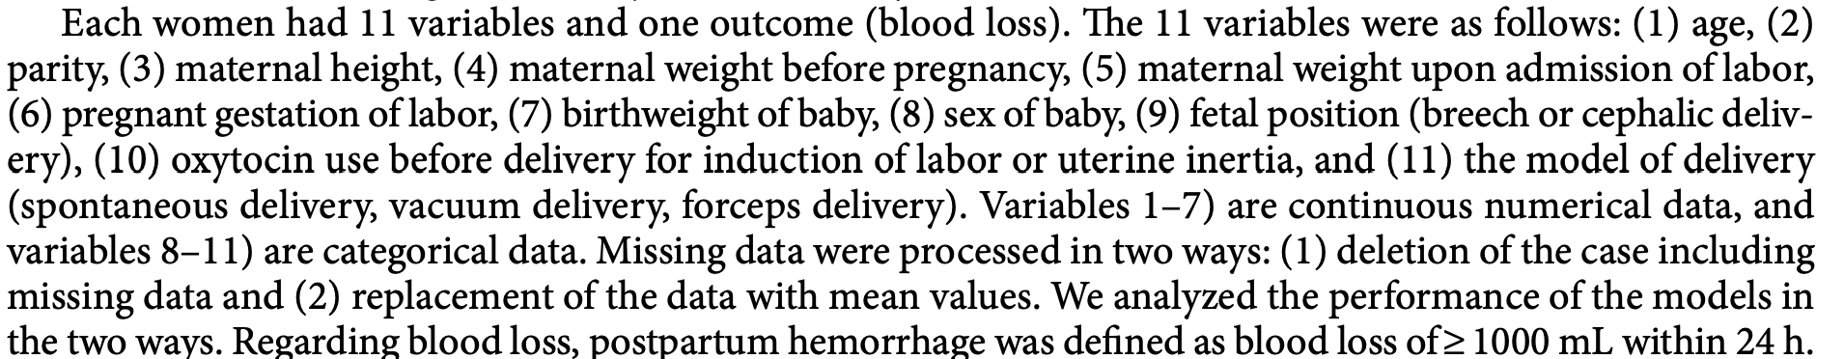

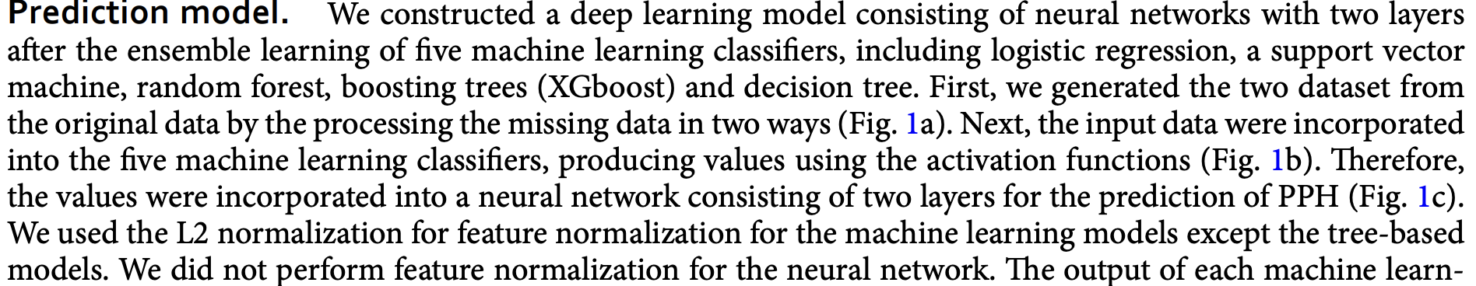

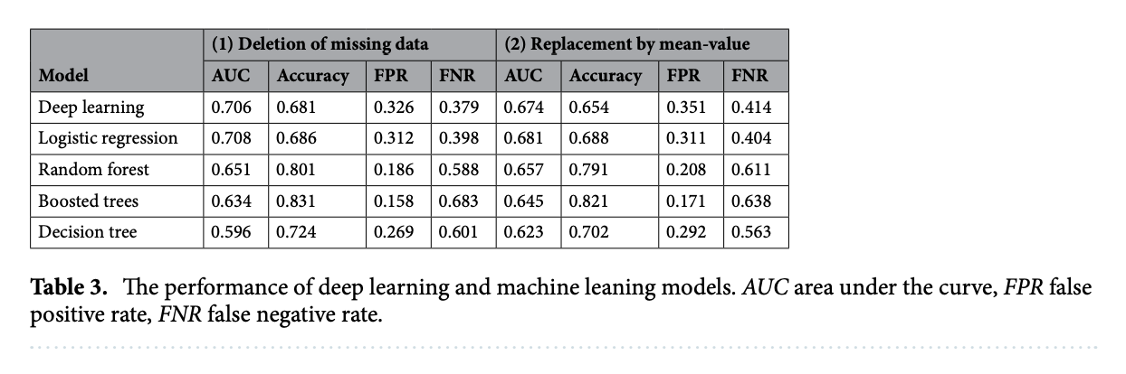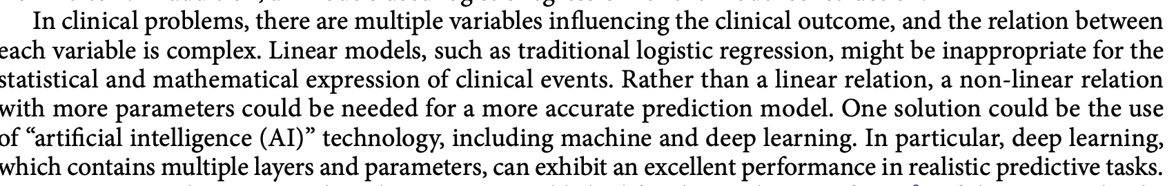

* They mention a limitation of their study is that ‘the size of the dataset was small for the deep learning model. Although we collected 10,000 vaginal cases, the PPH cases only numbered 1000.’
  + Maybe justify why not using deep learning in my study?

## Early Pre-Eclampsia Prediction via ML

<https://www.sciencedirect.com/science/article/pii/S2589933320300306?via%3Dihub>

‘The best detection has been achieved by prediction models that include, in addition to selected maternal characteristics and medical history, uterine artery pulsatility index, placental growth factor, and estimated placental volume, which are markers that are not provided by routine prenatal care’

* Like my study, not just medical markers (e.g. history)
* Covariates: maternal age, race, ethnicity, number of pregnancies, number of babies, and other vital signs (e.g. blood pressure and pre-existing conditions), lab test data, and use of medicines

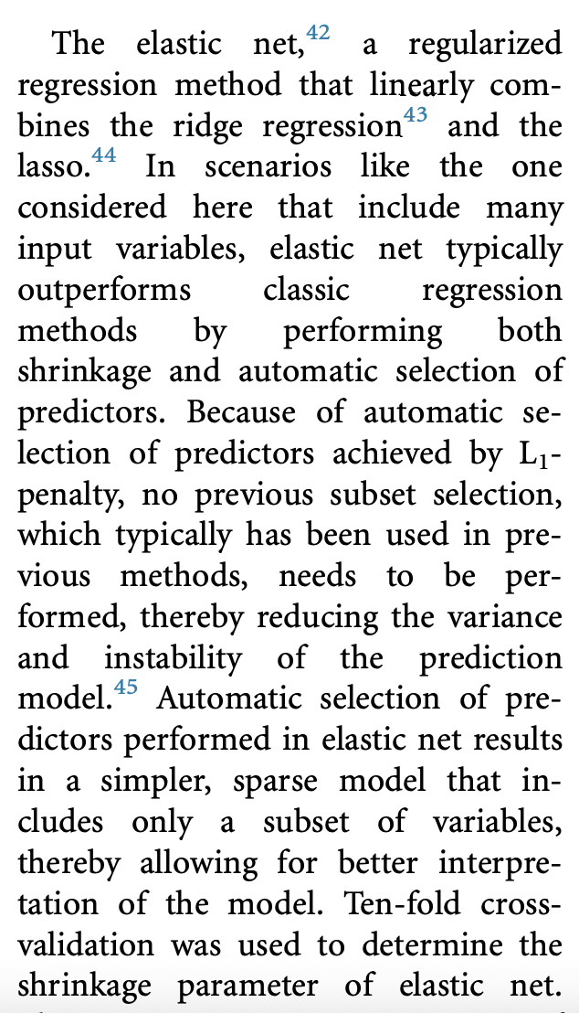 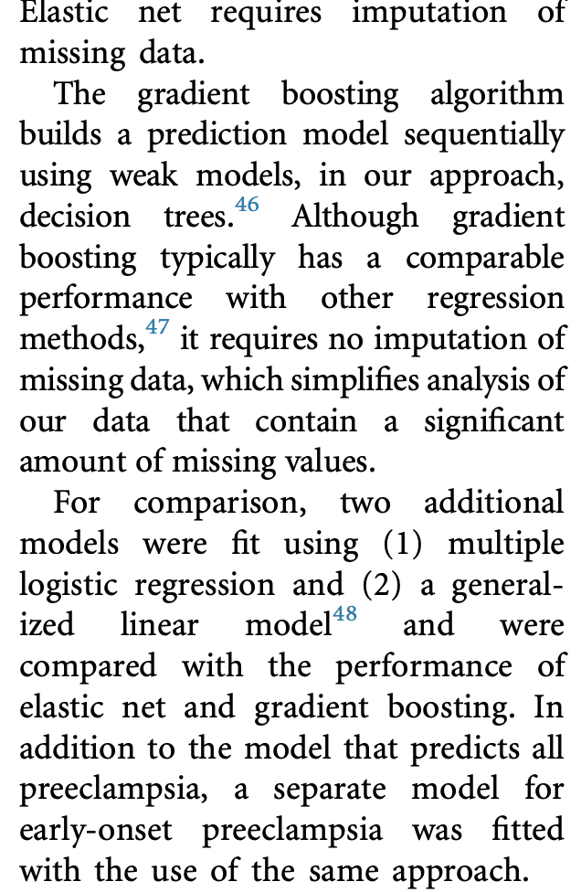 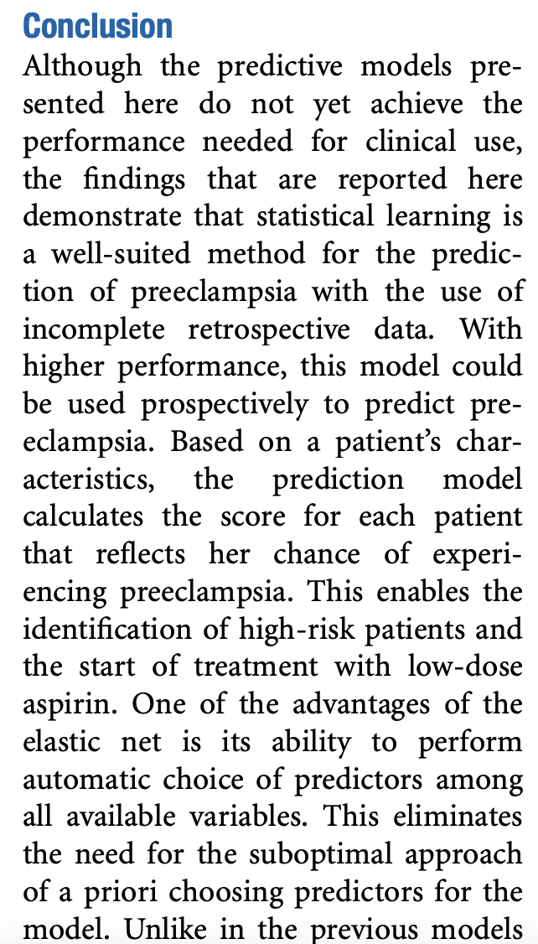

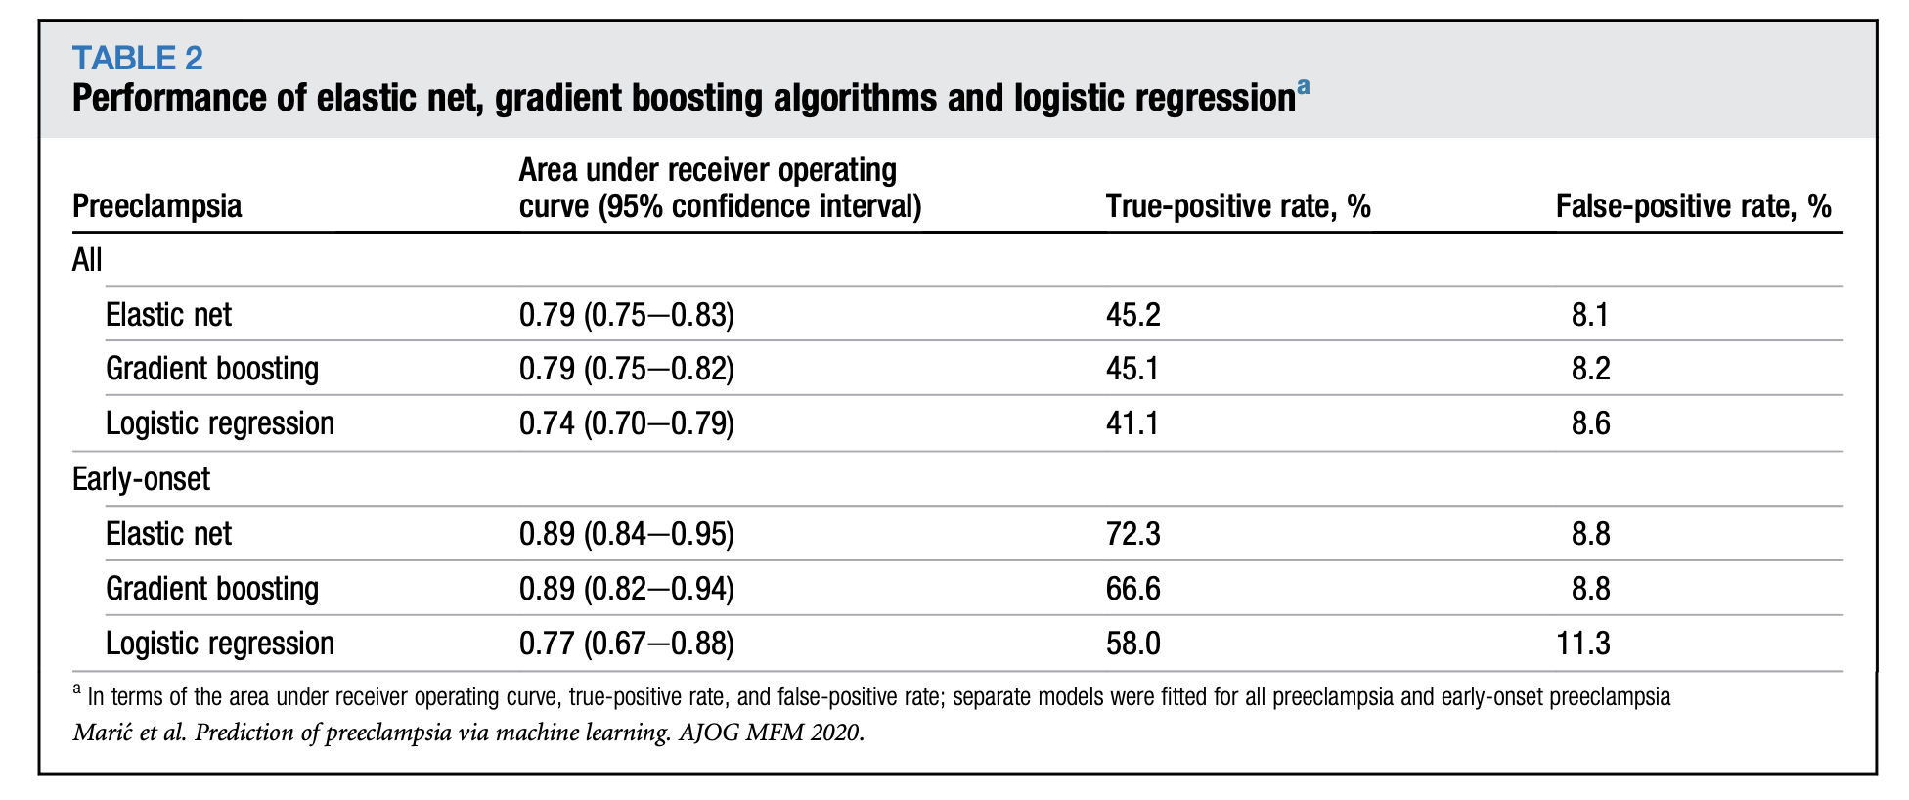

## Hospital Stay Length Prediction with ML

<https://dl.acm.org/doi/pdf/10.1145/3545729.3545757>

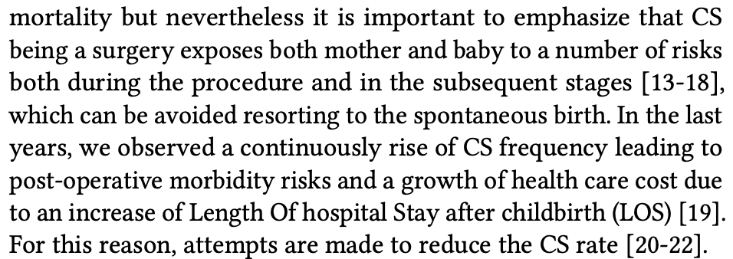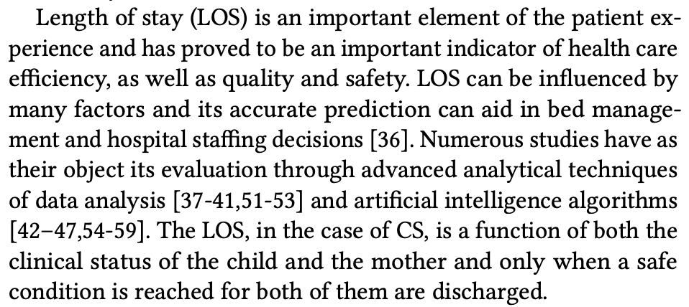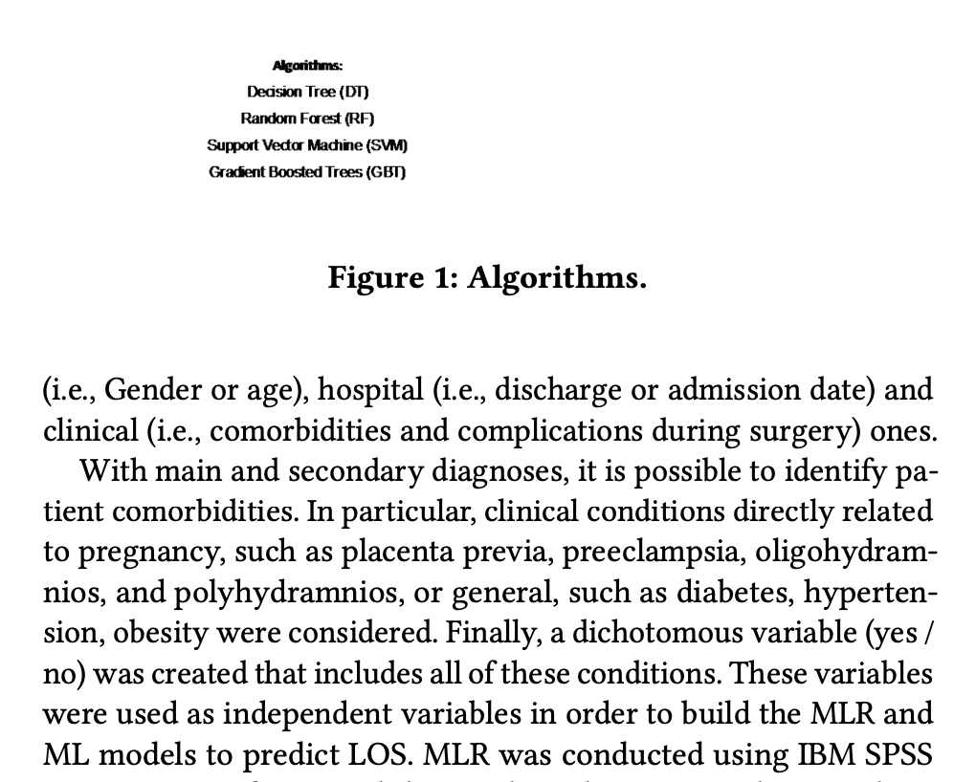

* Both models = multiple linear regression for each of the two hospitals from which data was collected

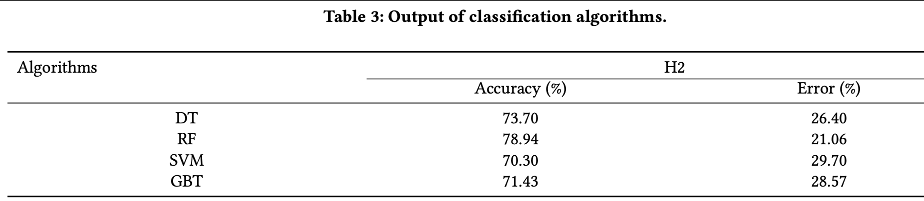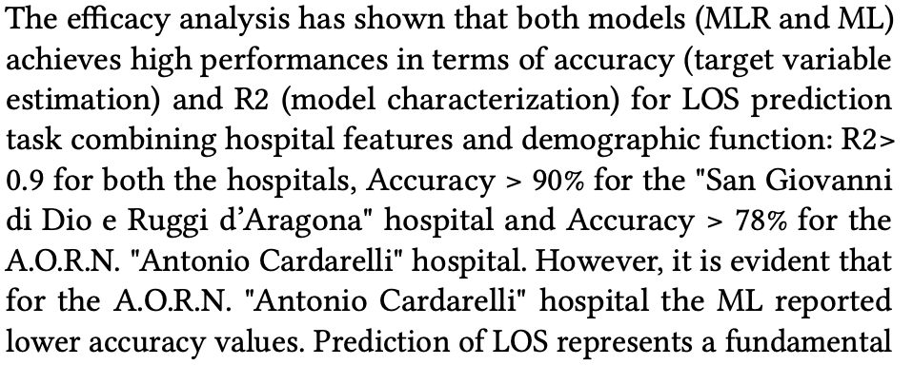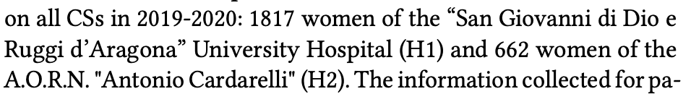

* Potentially lower accuracy for AORN due to lower number of samples

## Essential Medicine Demand Prediction by Random Forest

<https://pmc.ncbi.nlm.nih.gov/articles/PMC9379432/pdf/PAMJ-42-89.pdf>

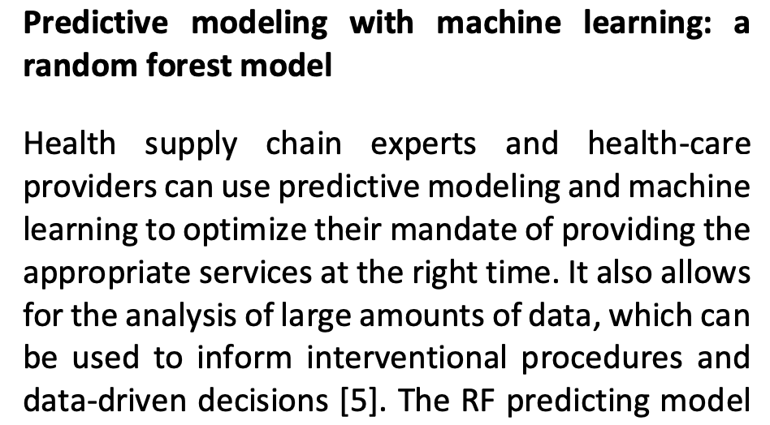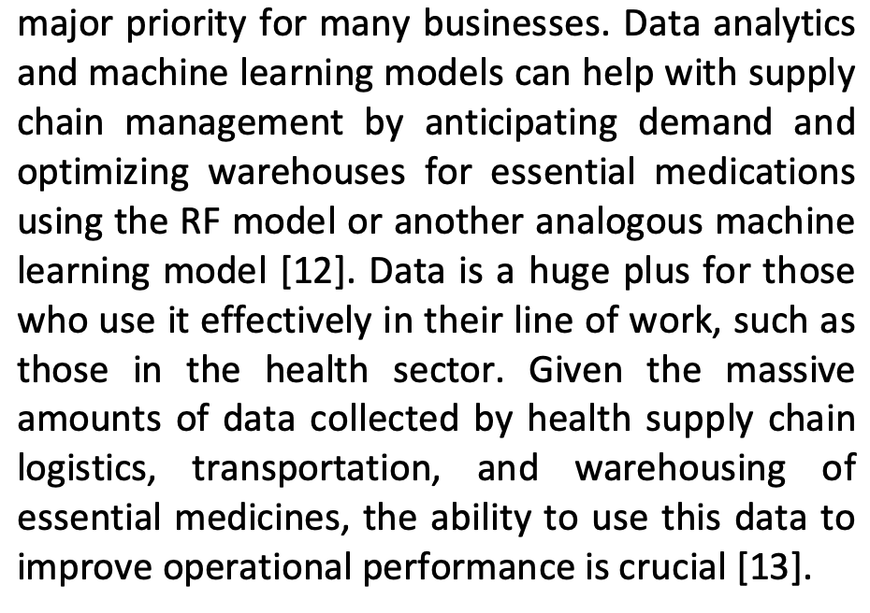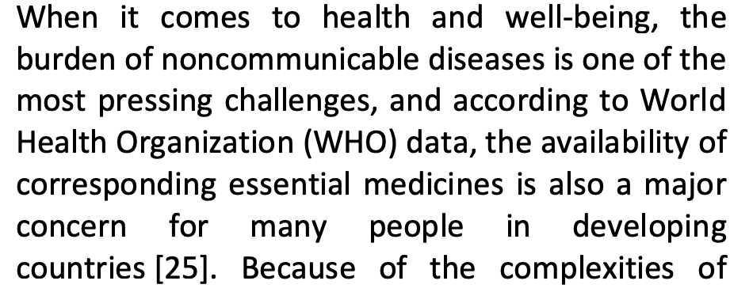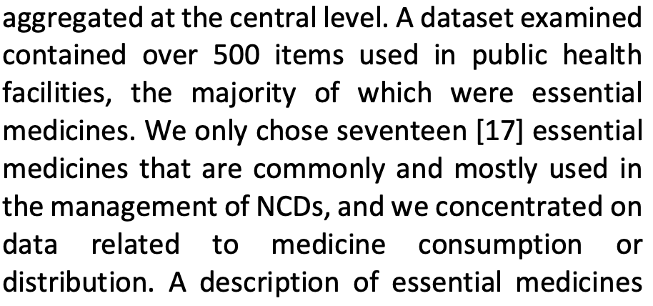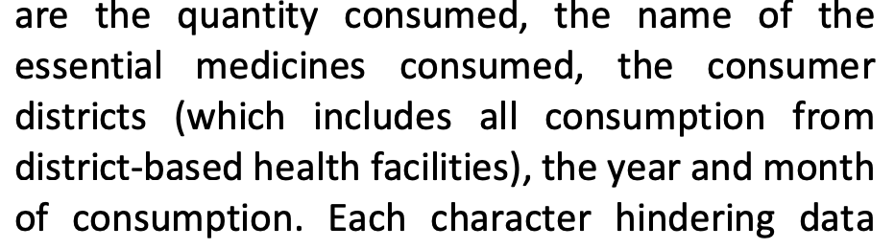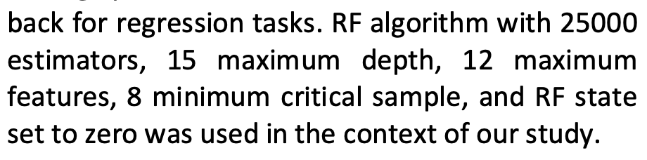

Evaluated with rmse and r^2

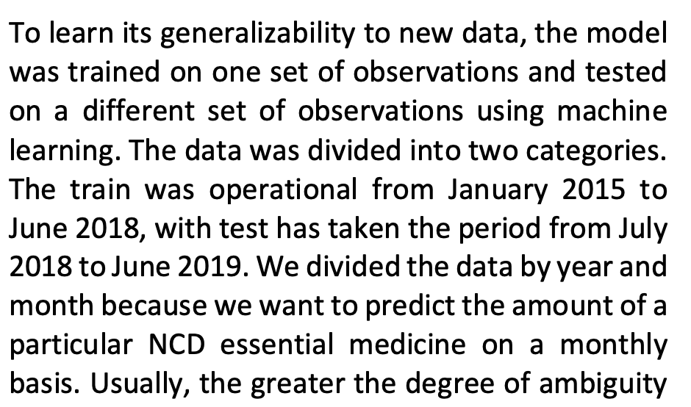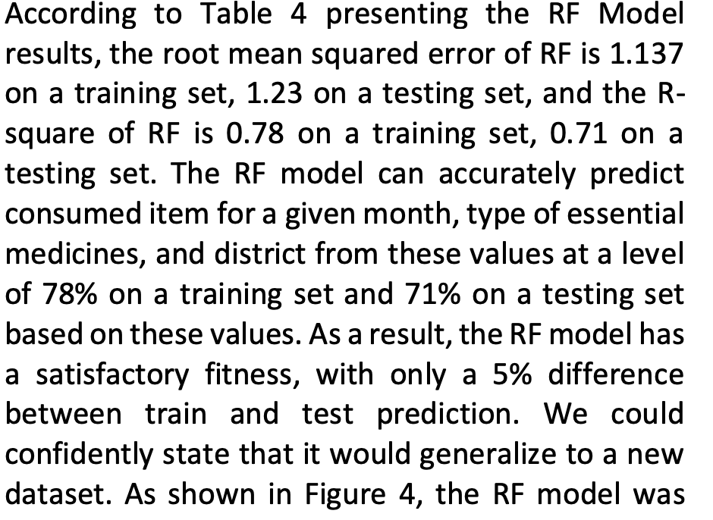

## Predict Skilled Birth Attendance – Sub-Saharan Africa – RF

<https://bmcpublichealth.biomedcentral.com/articles/10.1186/s12889-025-22007-9#Sec2>

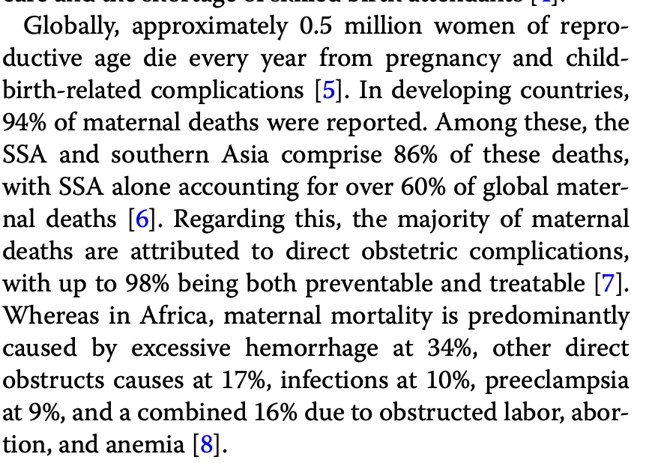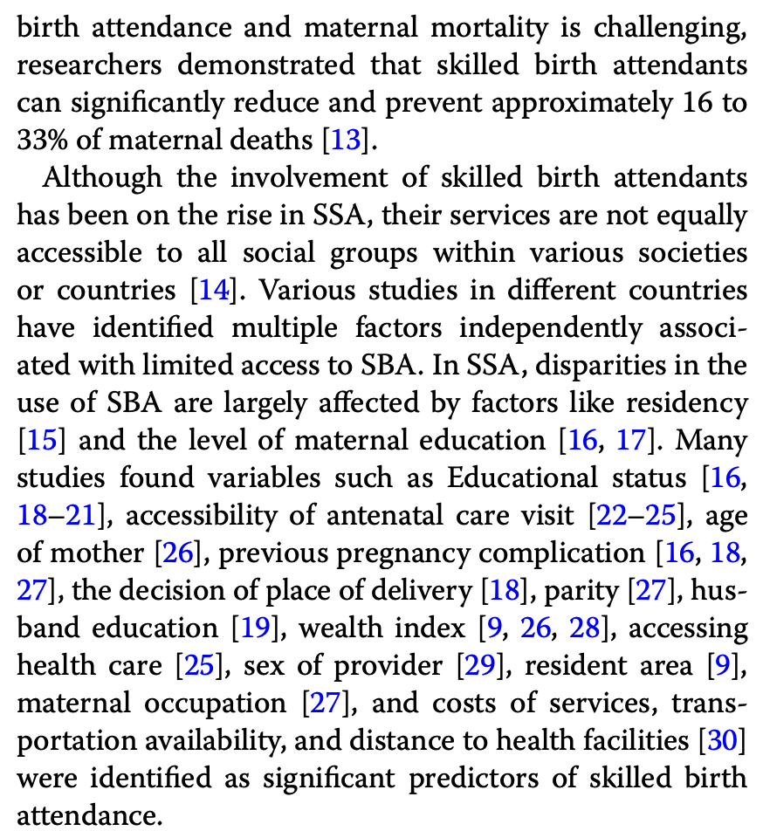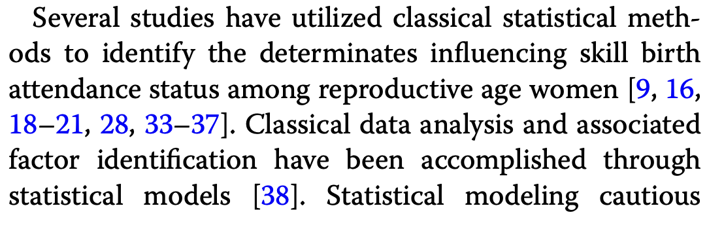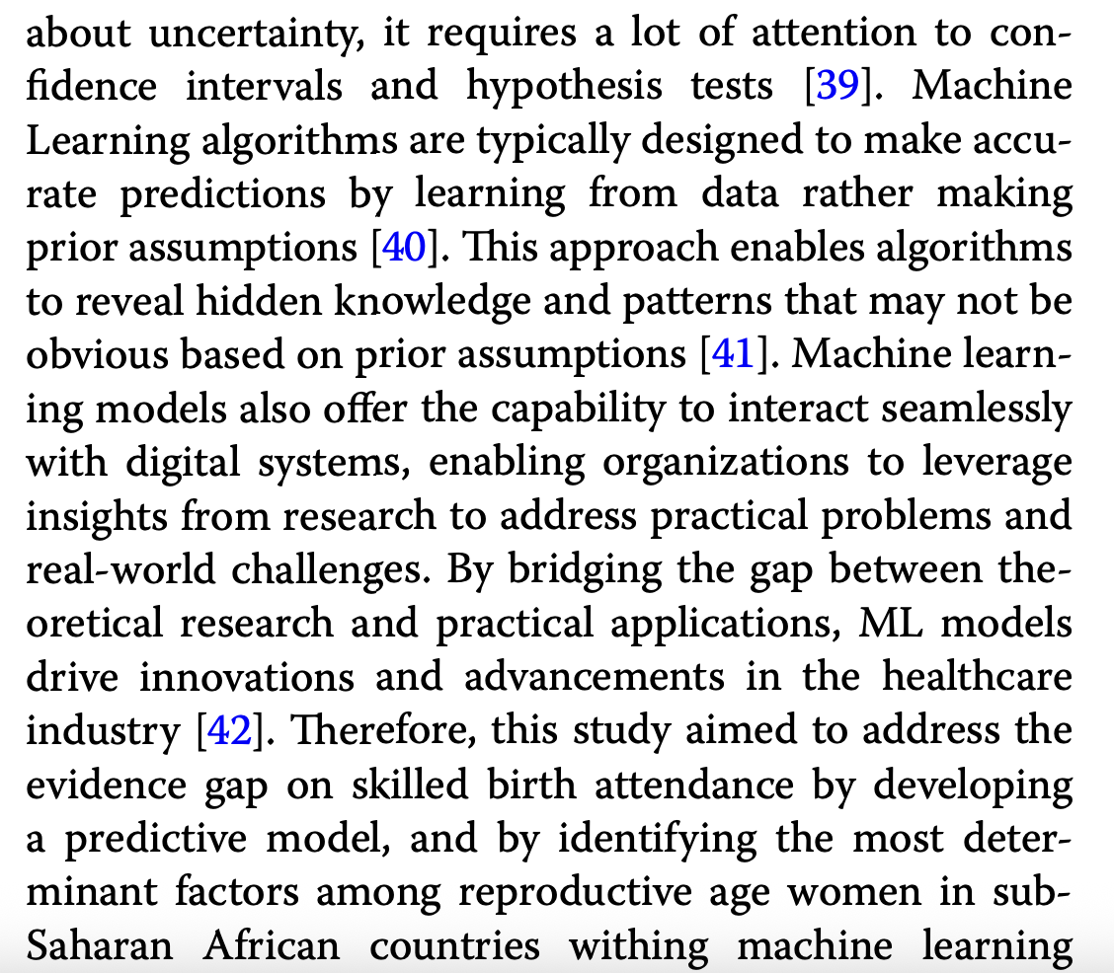

‘The study used data from recent surveys conducted in 27 SSA countries between 2016 and 2024 G.C’

’A total weighted sample of 198,707 reproductive women who had at least one live birth was included in this study’

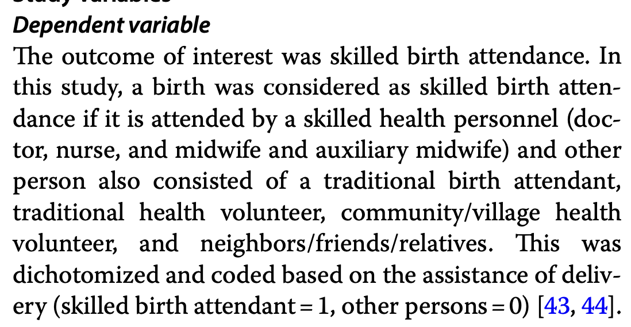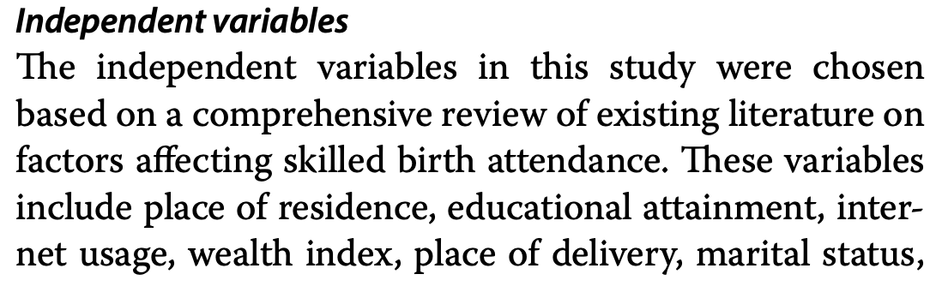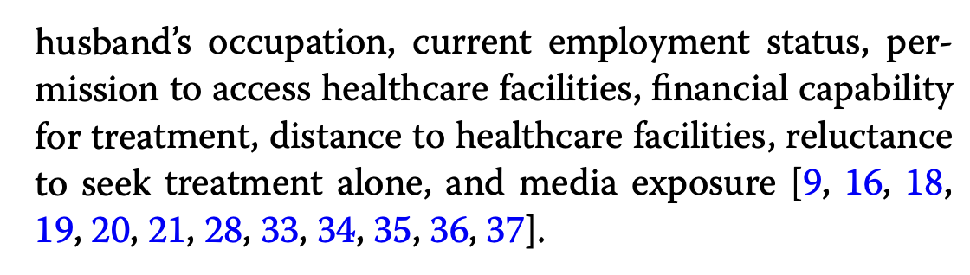

‘For model development and feature selection, the Random Forest classifier was selected as the primary algorithm.’

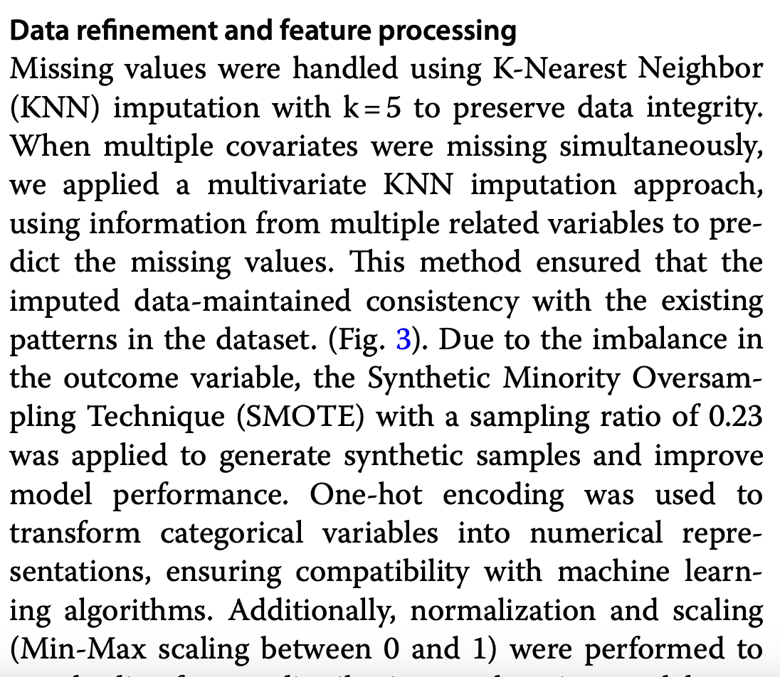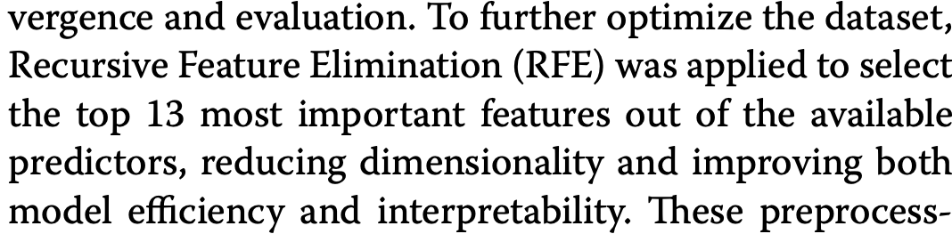

Used SHAP for feature importance rating 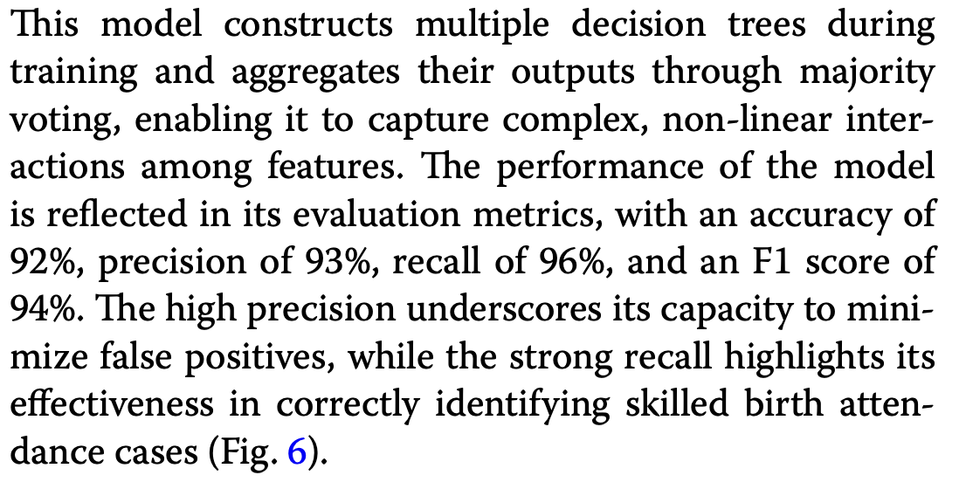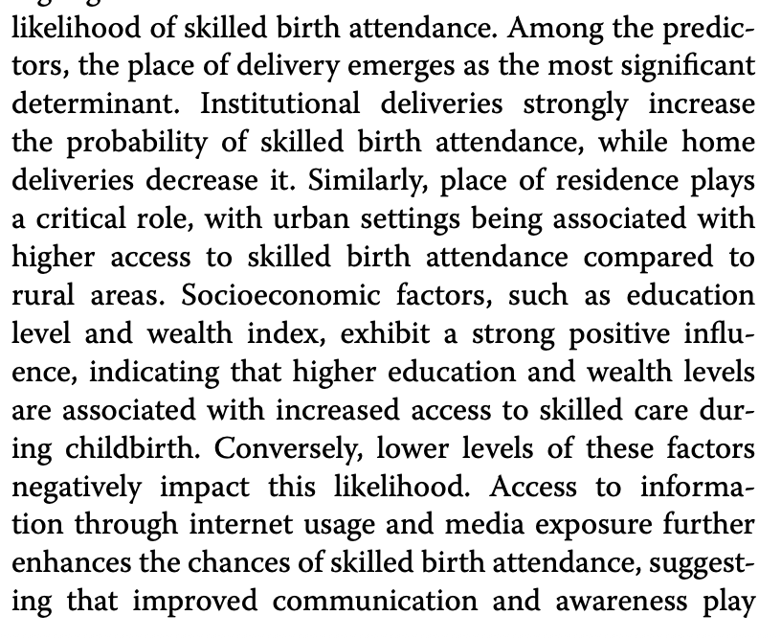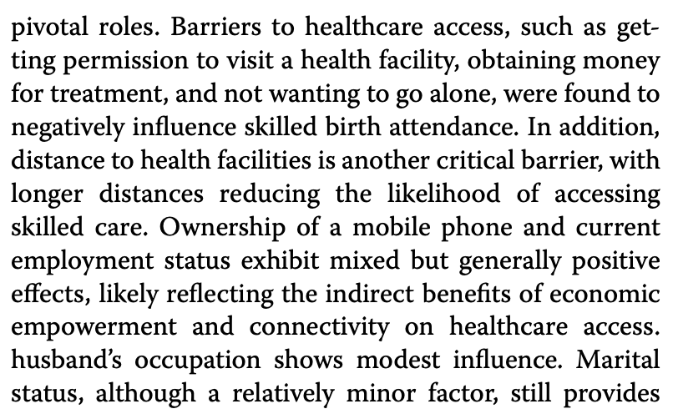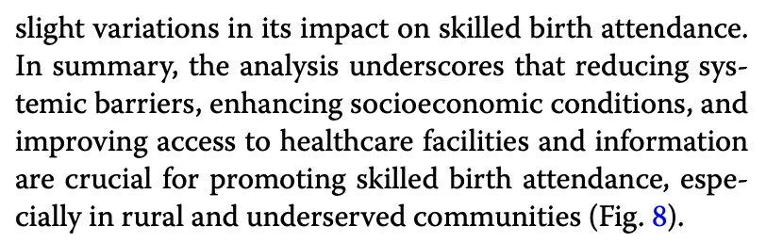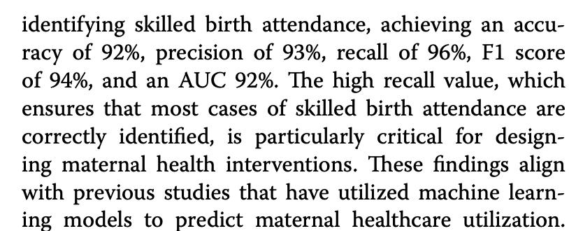

Read discussion for more information about importance of different factors and why

## Predict Delivery Location – Zanzibar

<https://www.frontiersin.org/journals/digital-health/articles/10.3389/fdgth.2022.855236/full>

considered socioeconomic variables, pregnancy characteristics, clinical characteristics/medical history, antenatal visit experience/frequency, community characteristics (e.g. rate of facility delivery by women in same local area)

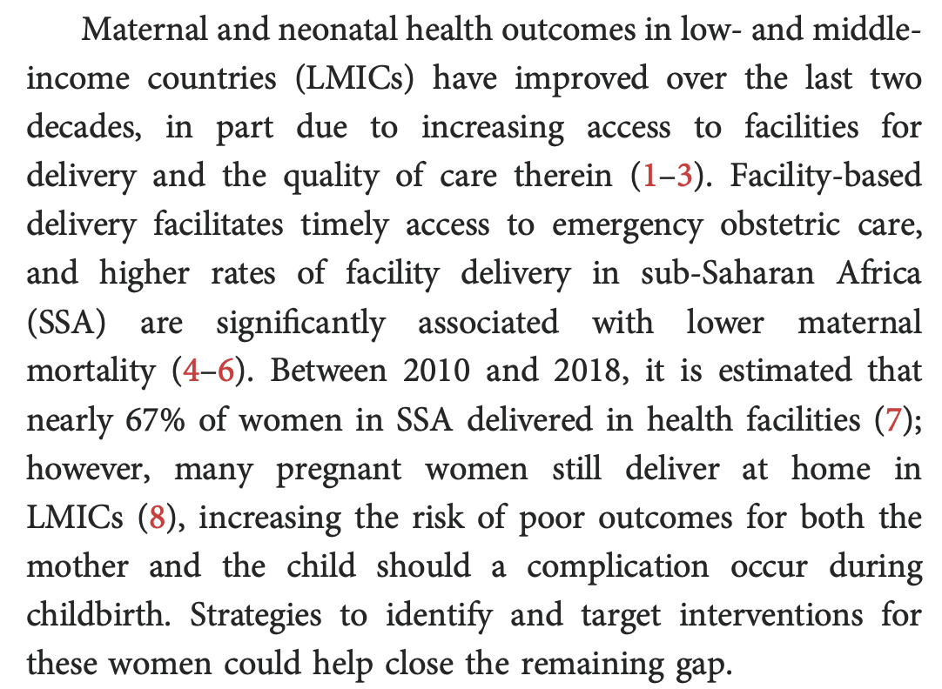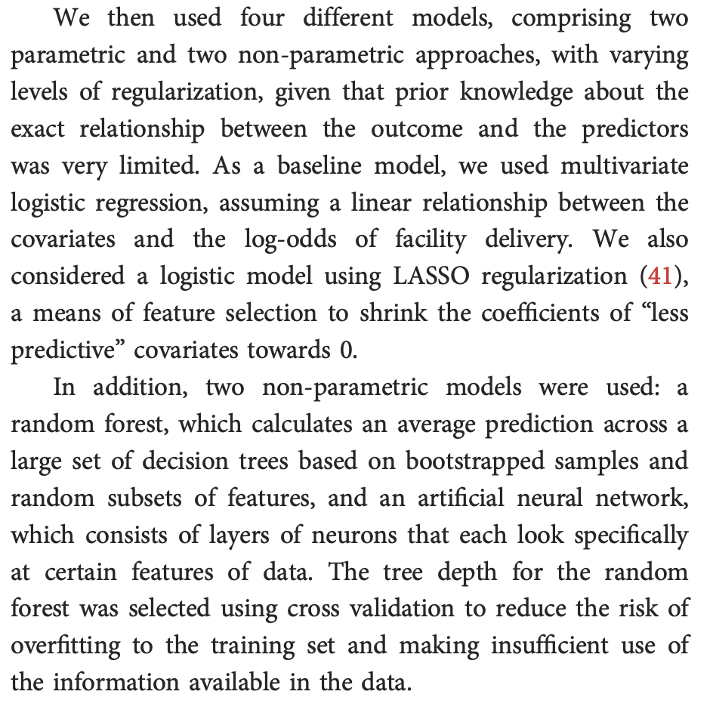

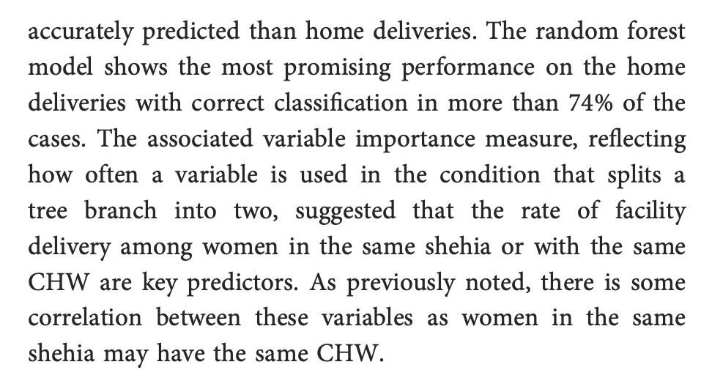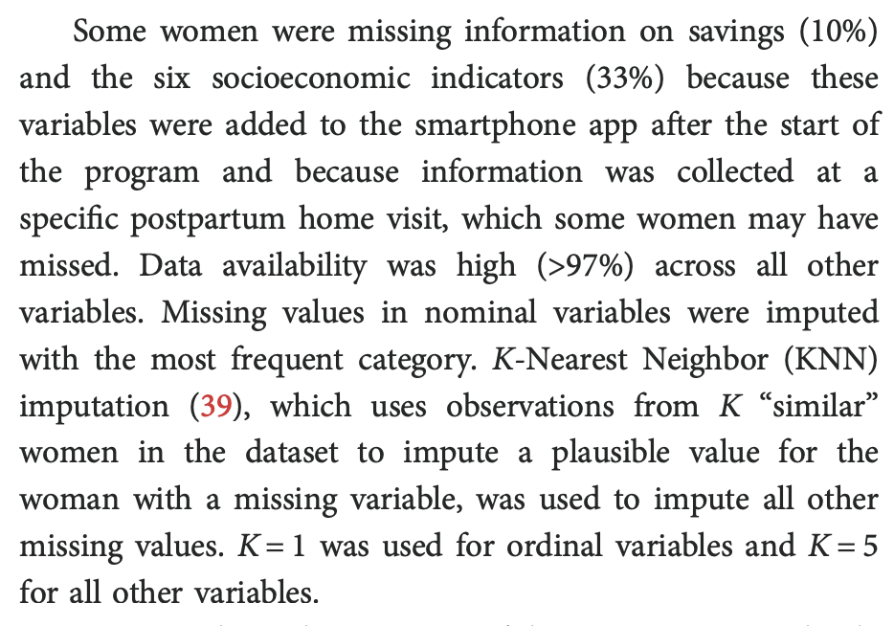

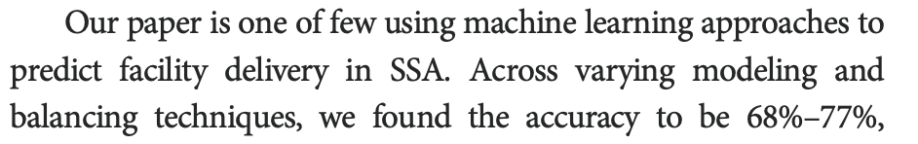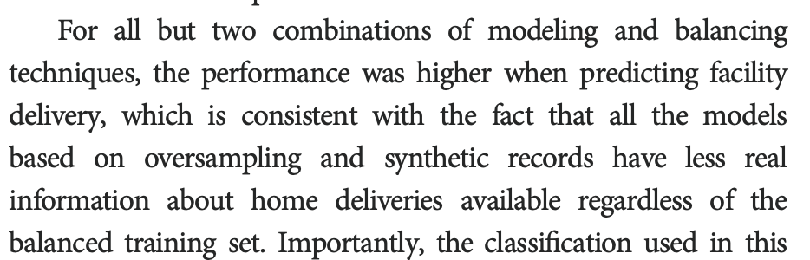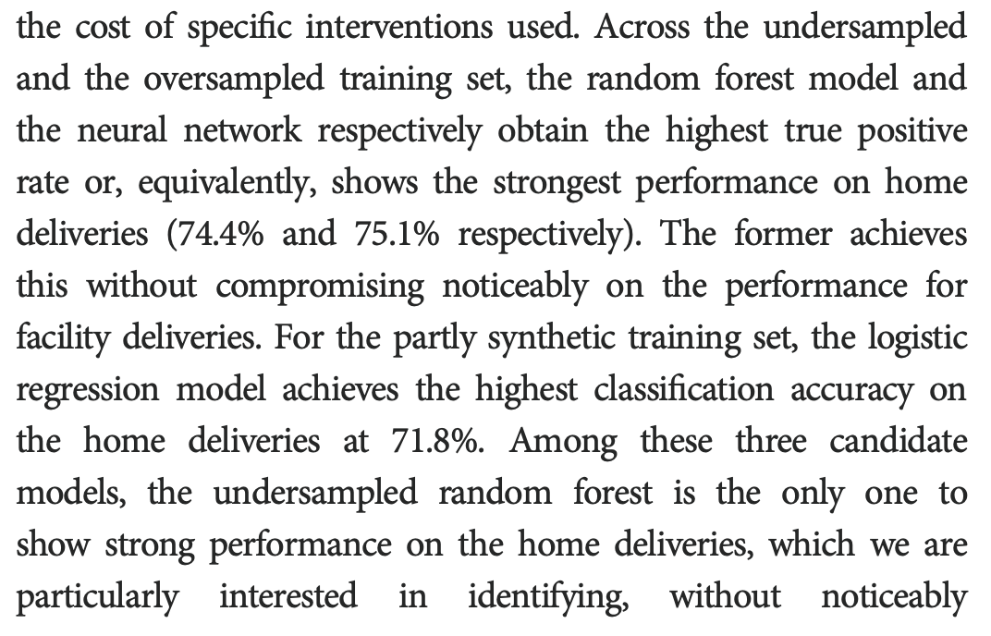

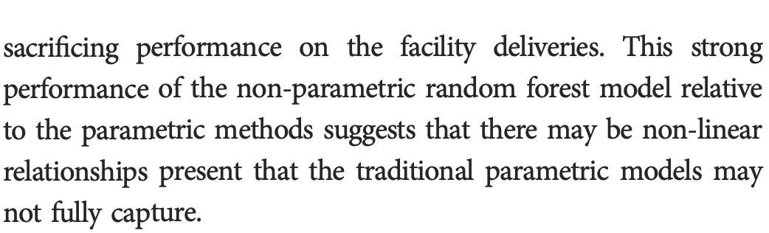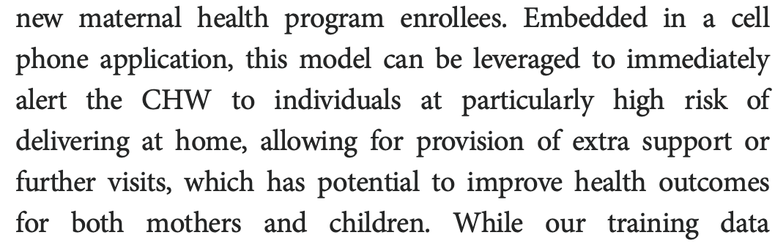

## Predict Adverse Pregnancy Outcomes - Rwanda

<https://link.springer.com/article/10.1186/s12911-025-02921-z?fromPaywallRec=false>

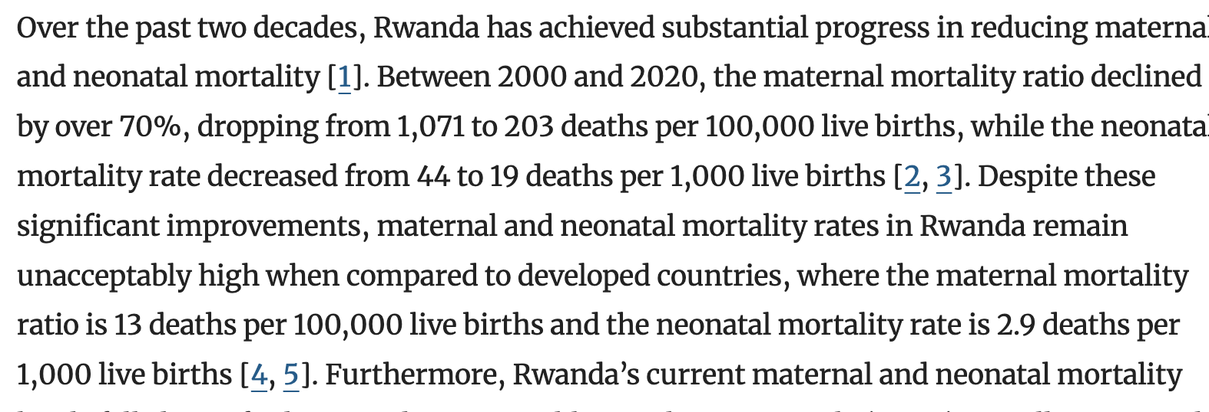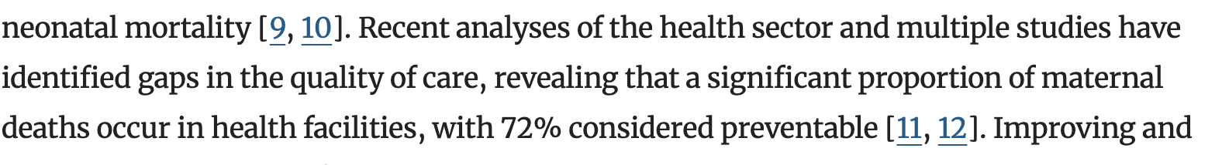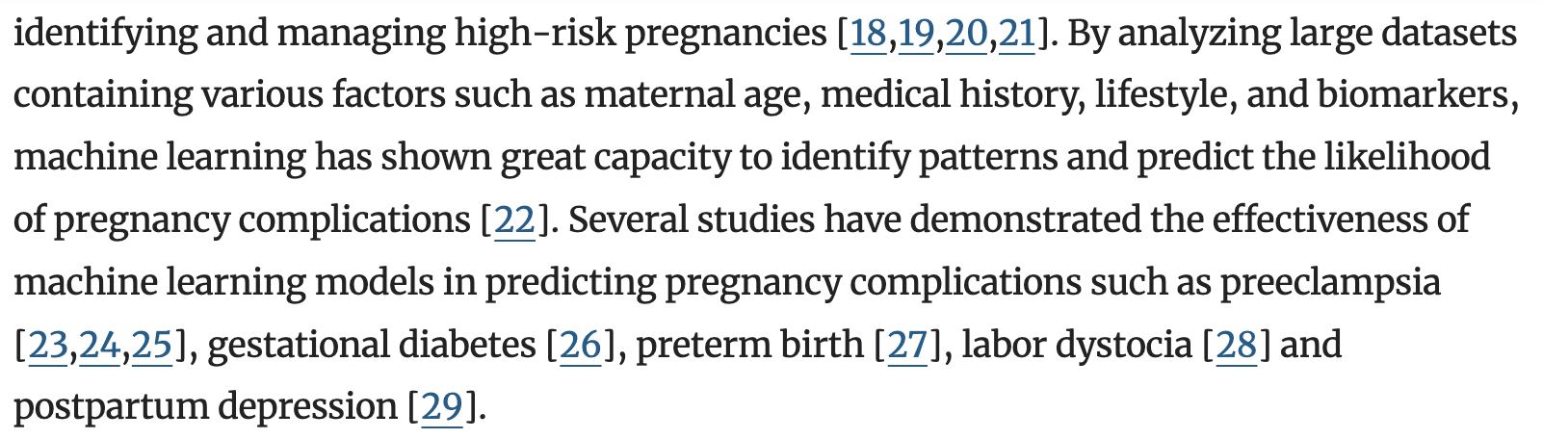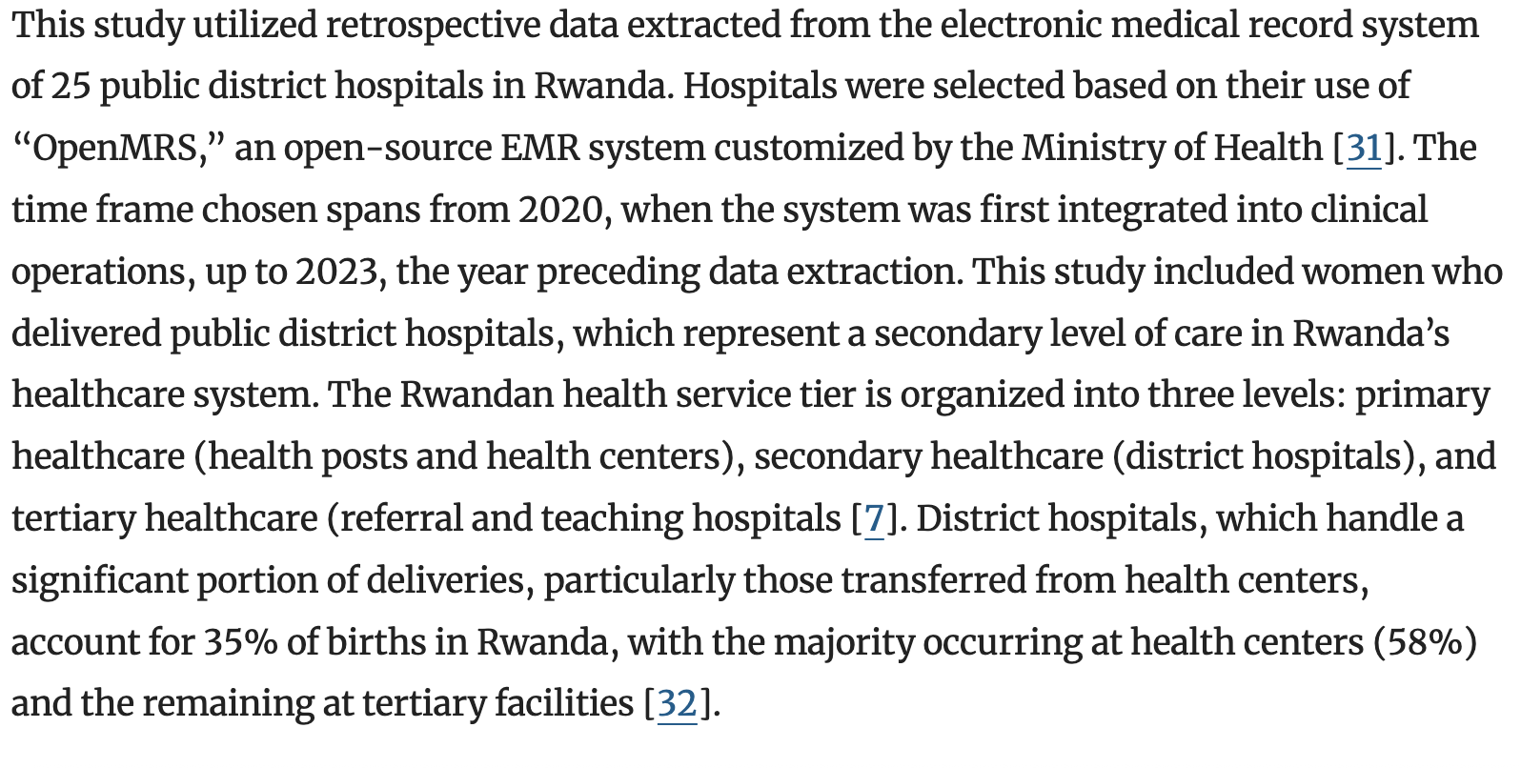

* So not super comprehensive of births in the country

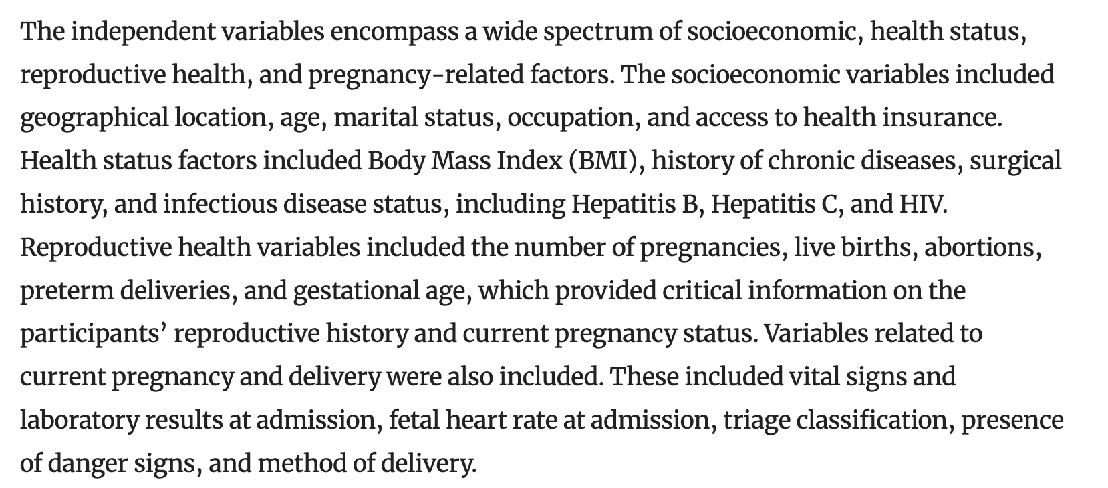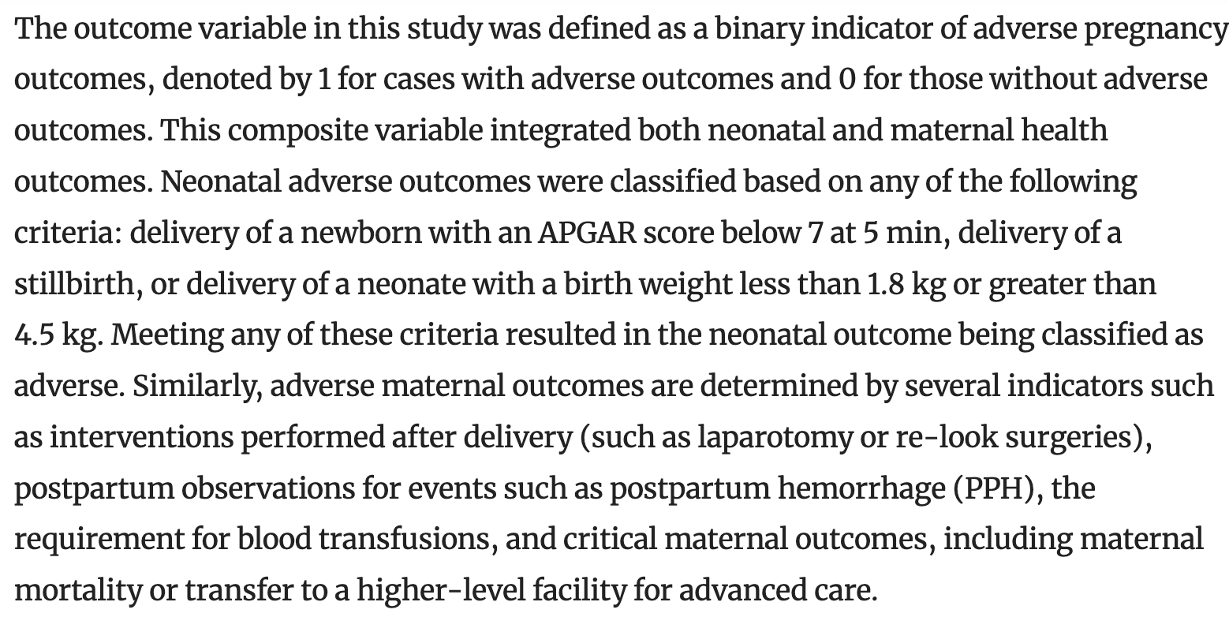

* Many things being predicted with the same indicator, especially with a binary target that loses nuance, such as the extent of the adverse circumstance (scale)

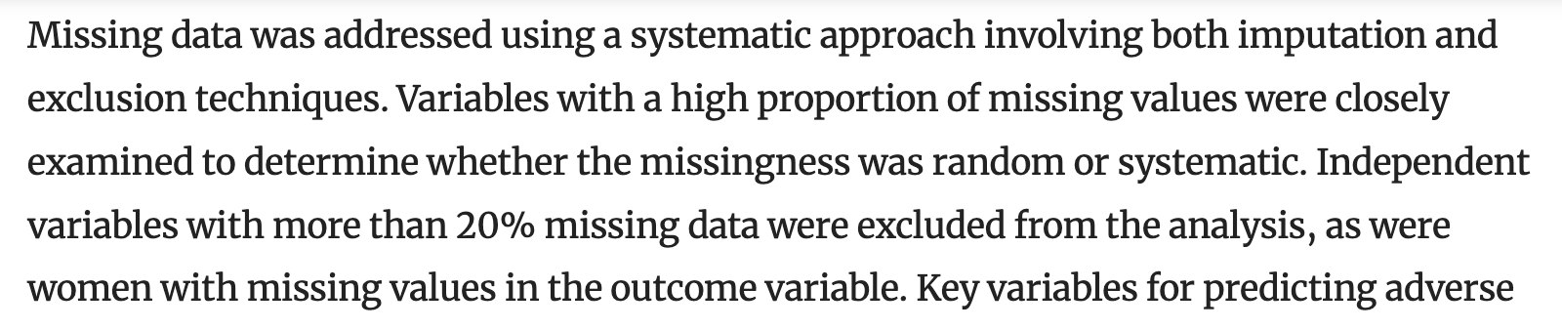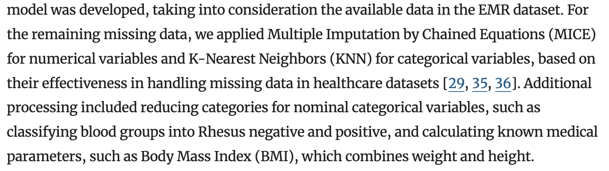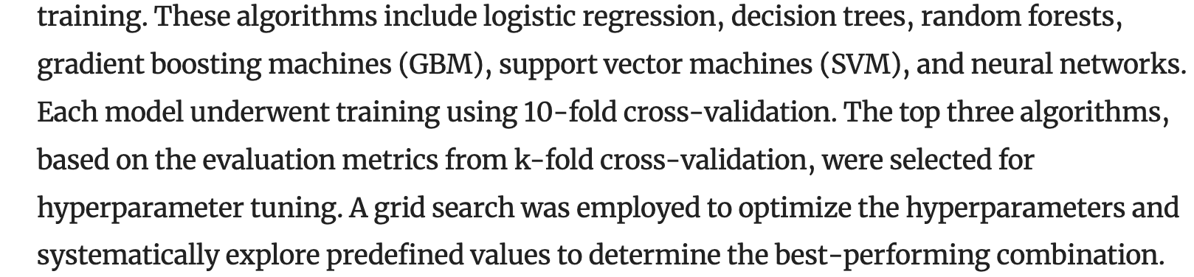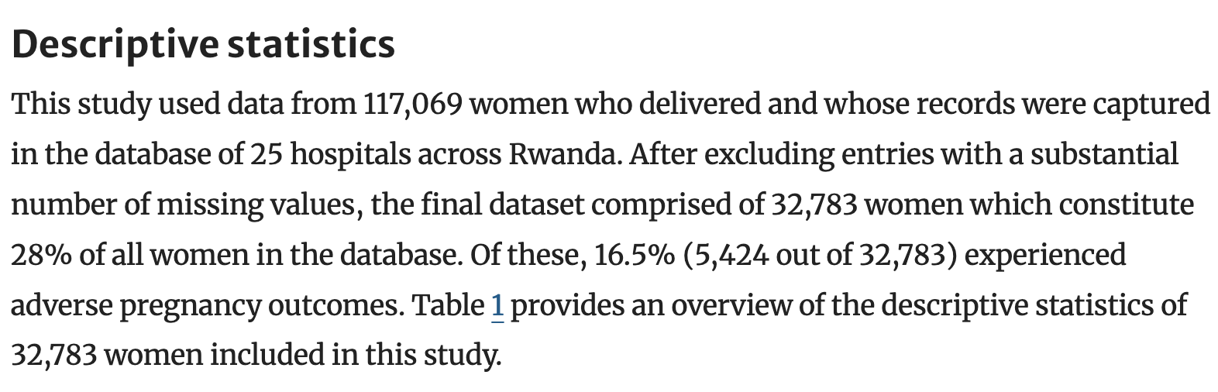

* Again, not super comprehensive

Use this study for information about various contributing factors, as it discusses which factors were associated with worse outcomes in strong detail

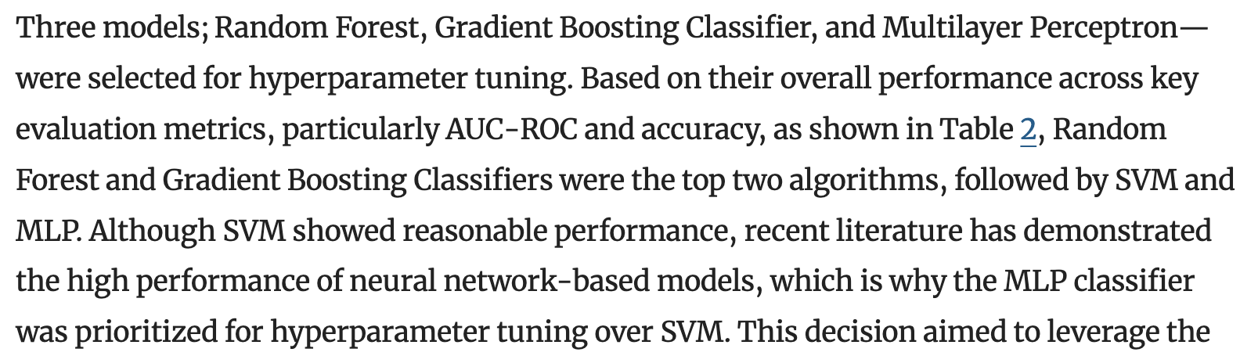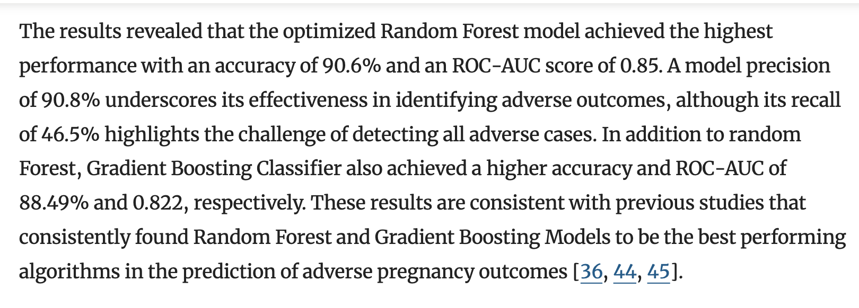

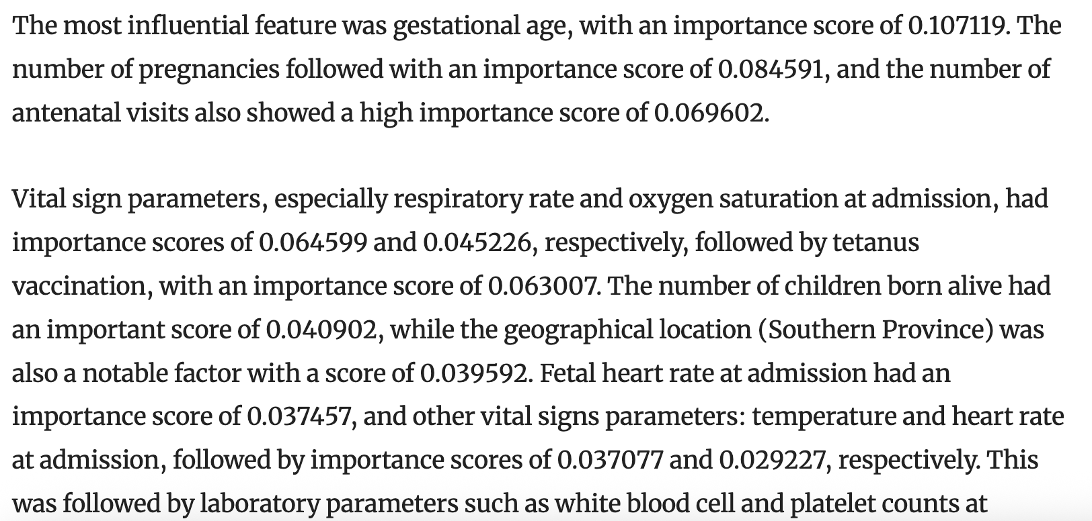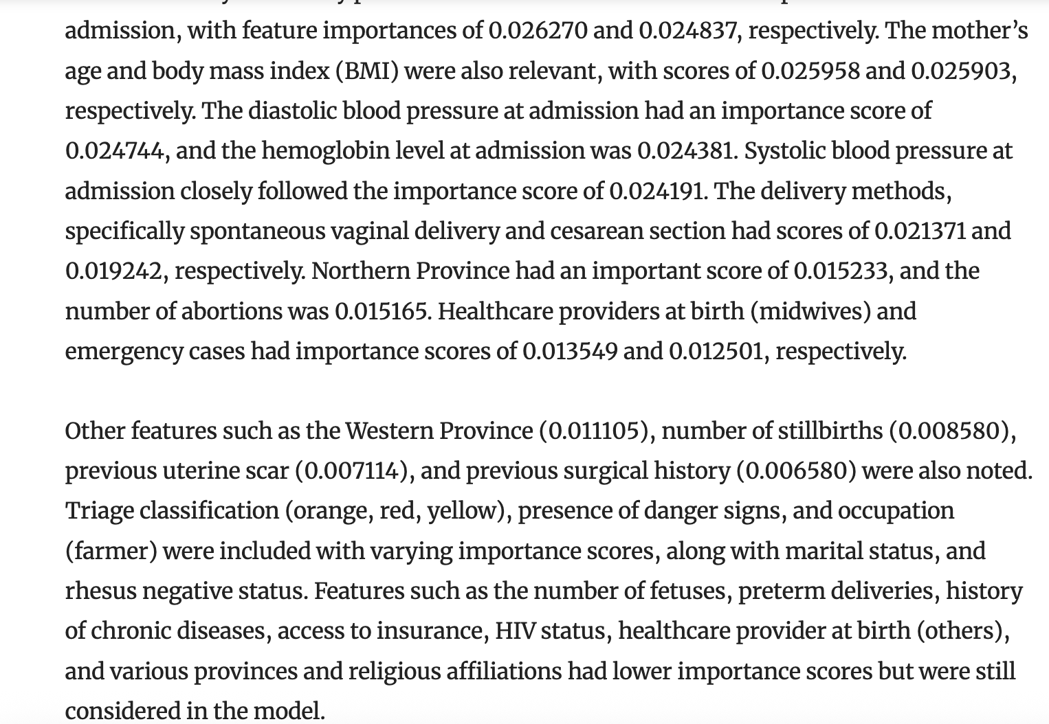

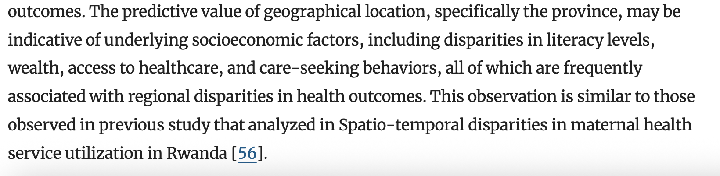

## Pregnancy Risk Prediction – Low Resource Settings

<https://www.mdpi.com/2673-9992/25/1/13>

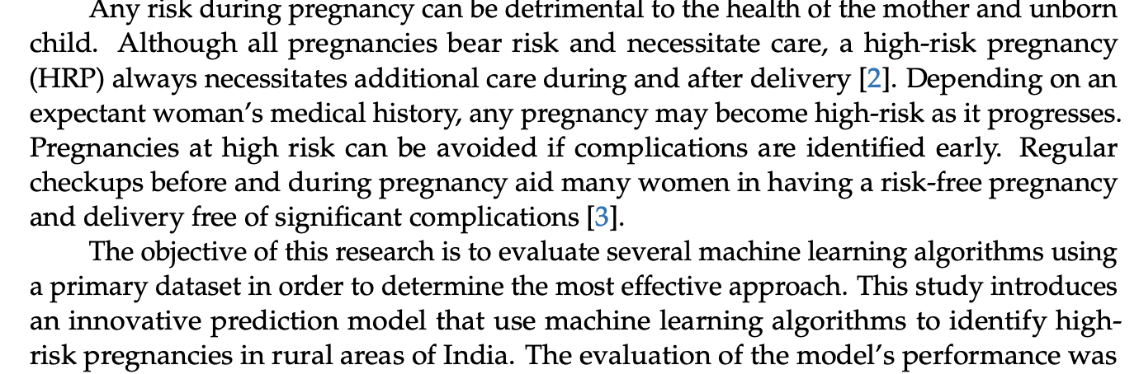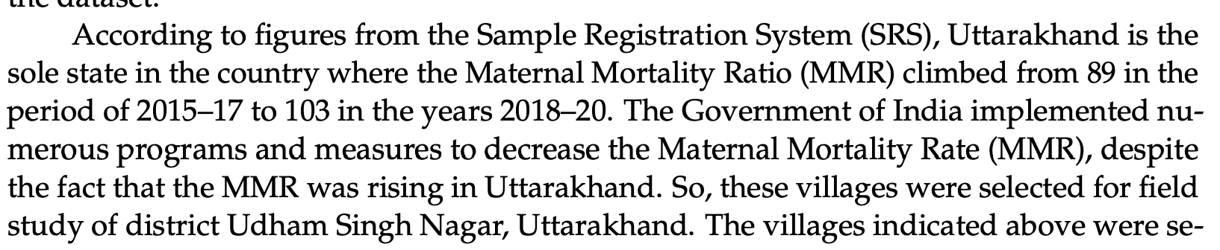

‘The collected data consist of a total of 837 rows and 13 columns.’

13 features chosen via consultation with medical practitioners, including age, history of pregnancies, and vital signs to predict high or low risk classification

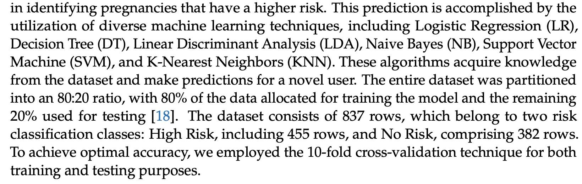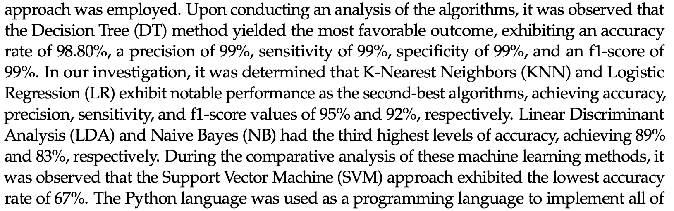

## Blockchain and ML for Maternal Health Monitoring + Prediction

<https://ieeexplore.ieee.org/stamp/stamp.jsp?tp=&arnumber=10090997&utm_source=scopus&getft_integrator=scopus&tag=1>

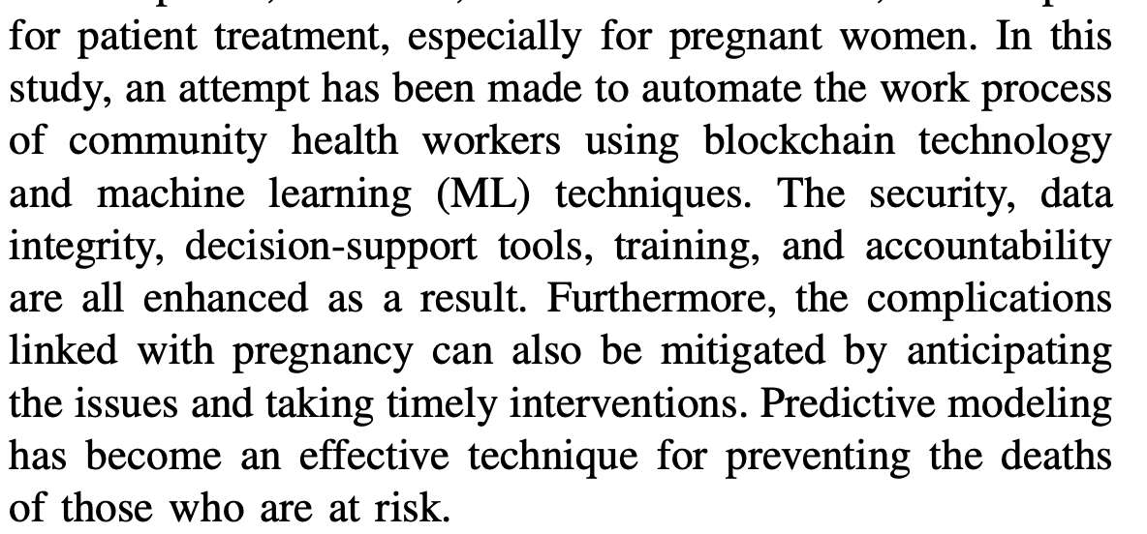

Blockchain technology’s purpose is to “decentralize the data storage, making it difficult for one entity to control or possess it”

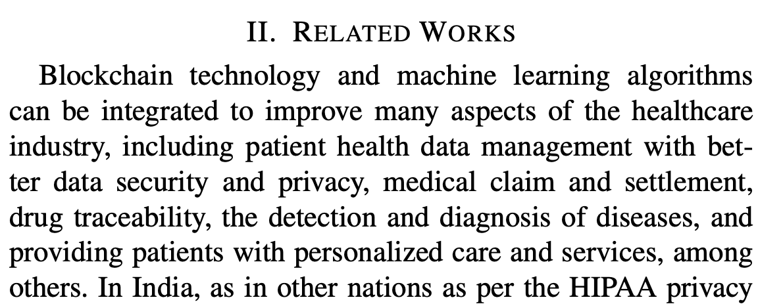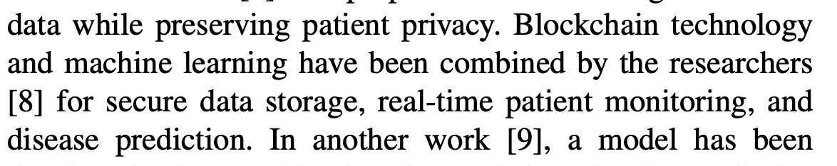

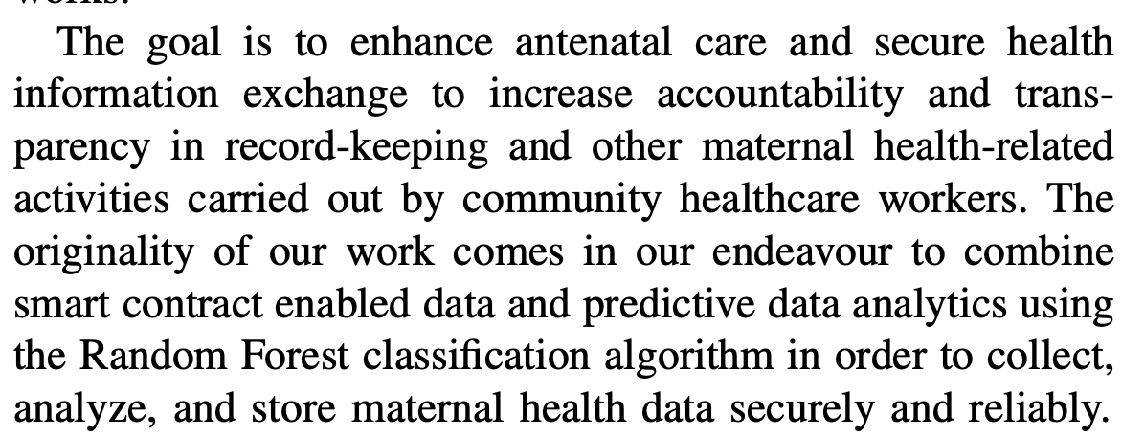 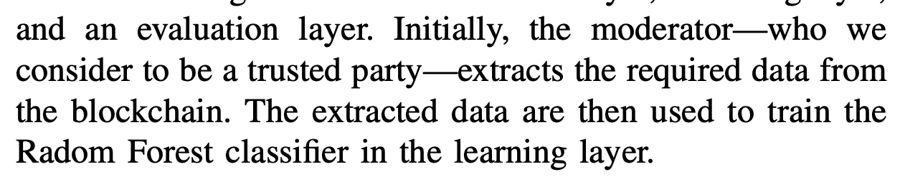

* This is also trained with the Kaggle dataset
  + Shows my study will expand testing of these algorithms on a new dataset

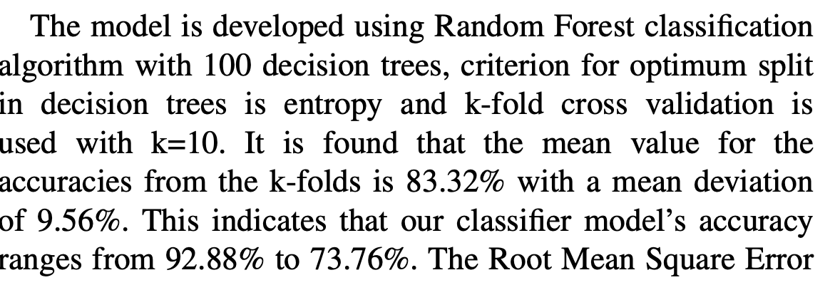 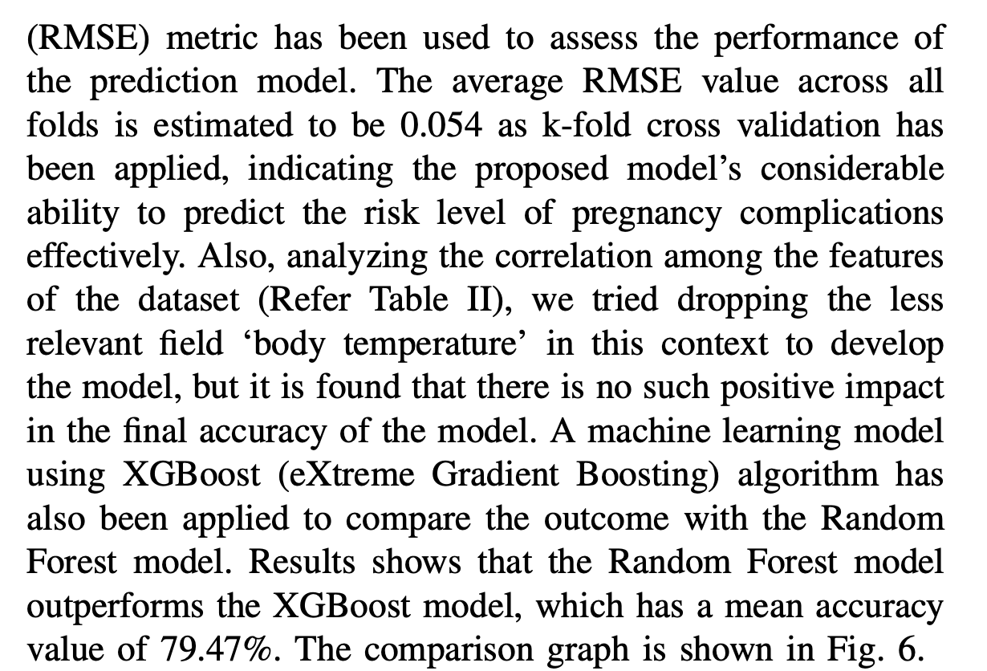

## Maternal Health Risk Classifier

<https://journals.nipes.org/index.php/njstr/article/view/1165/1094>

Classification based model called ‘Safe Motherhood Predictor’ that predicted whether a specific patient’s pregnancy posed a low, medium or high-risk to maternal health based on age, systolic blood pressure, diastolic blood pressure, blood sugar, body temperature, and heart rate. It tested the following classifiers: Random Forest, Decision Tree, Random Forest, Gradient Boosted Decision Tree, Extreme Gradient Boosting (XGB), Support Vector Classifier, Multilayer Perceptron, and Gaussian Naïve Bayes. The authors also combined these base estimators into a single stacking ensemble model. This study found that the ensemble model had the highest classification accuracy (91.21%), followed by the Random Forest (84.30% validation accuracy) and XGB (82.13% validation accuracy) models. No missing data.

## Comparative Analysis of ML Tree Based Methods for Predicting Maternal Health Risks

<https://www.sciencedirect.com/science/article/pii/S1877050924030370?pes=vor&utm_source=scopus&getft_integrator=scopus>

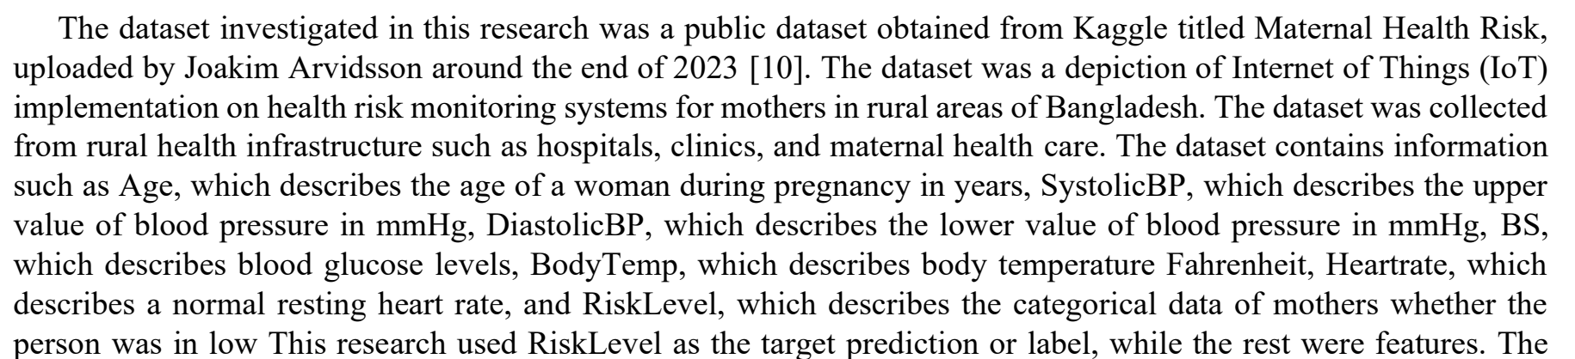

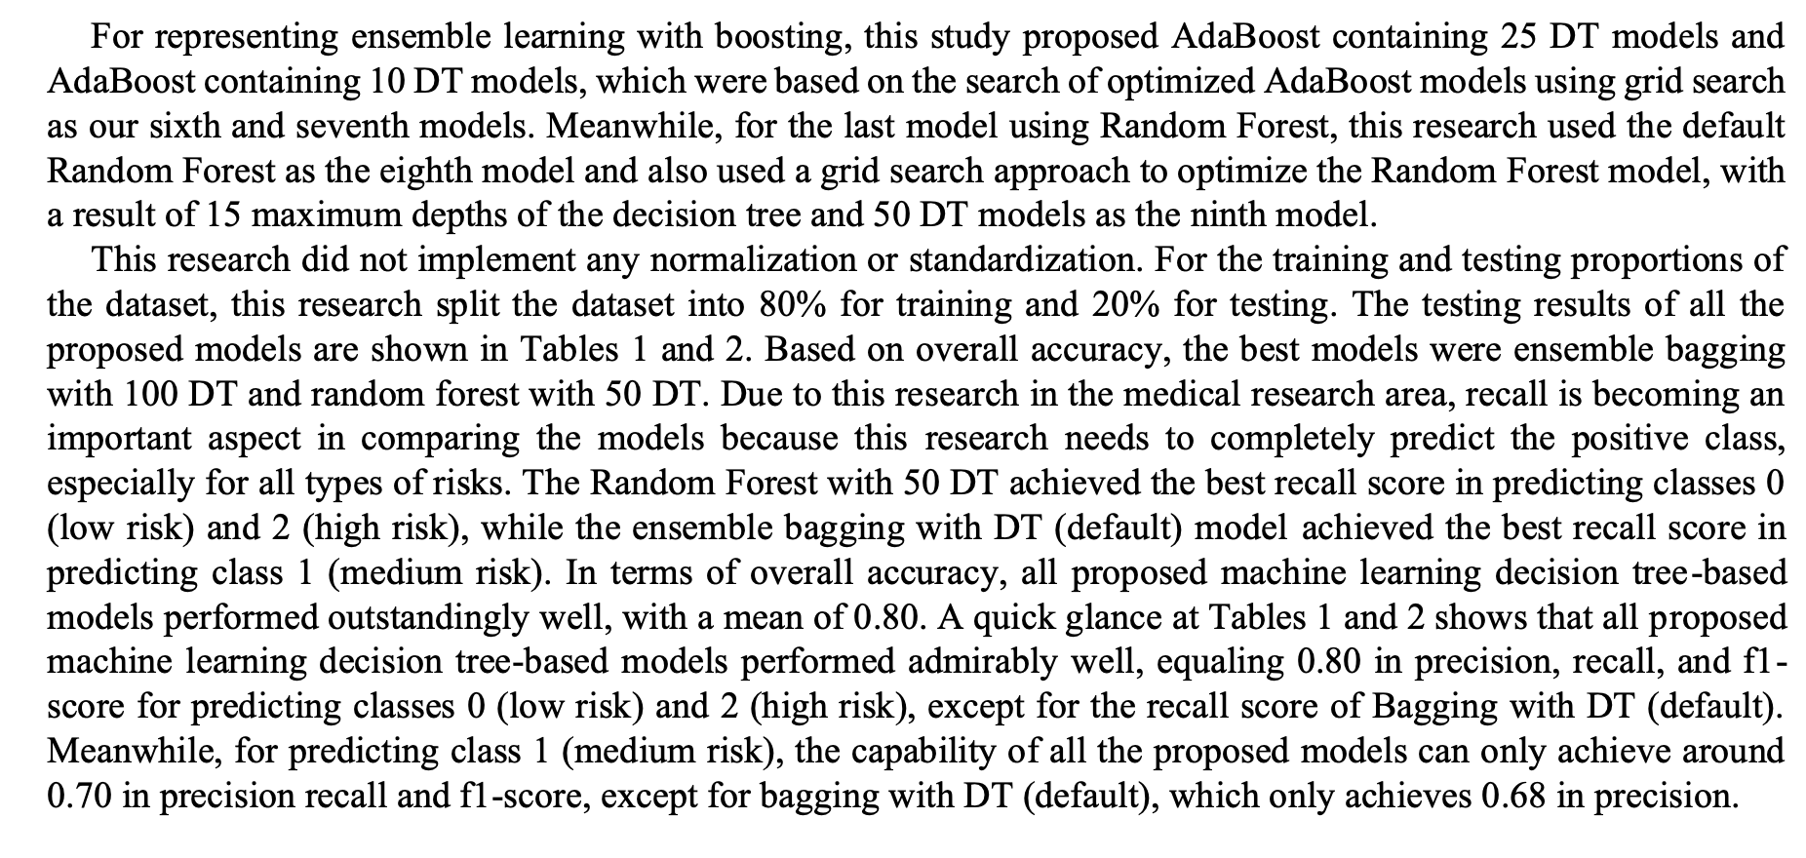

# Ensemble Models – Case Studies

## Hybrid Boosting Ensemble – Maternal Mortality Prediction

<https://www.sciencedirect.com/science/article/pii/S2352648322000599?via%3Dihub>

 

Replaced missing values with mean, 6 features and 1 target (age, blood pressure (diastolic and systolic), body temperature, blood sugar, heart rate, target = risk level)

- same dataset as used for those Kaggle studies?

- study does not say how the base estaimators (catboost and xgboost) were combined



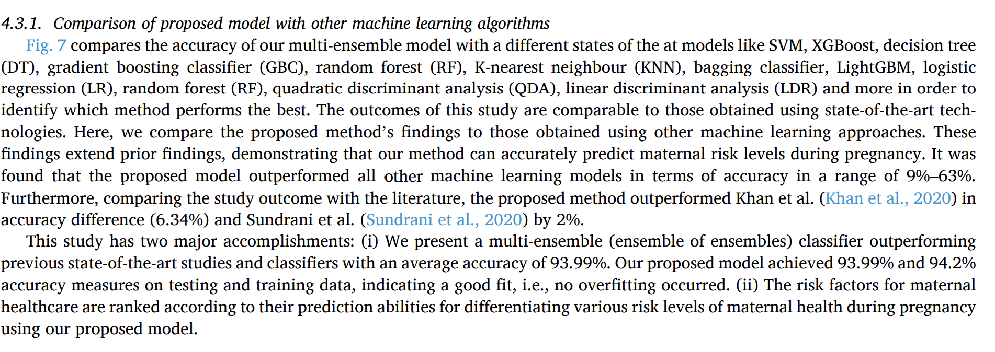

## Maternal Health Risk from Pregnancy

<https://www.nature.com/articles/s41598-024-71934-x#Abs1>

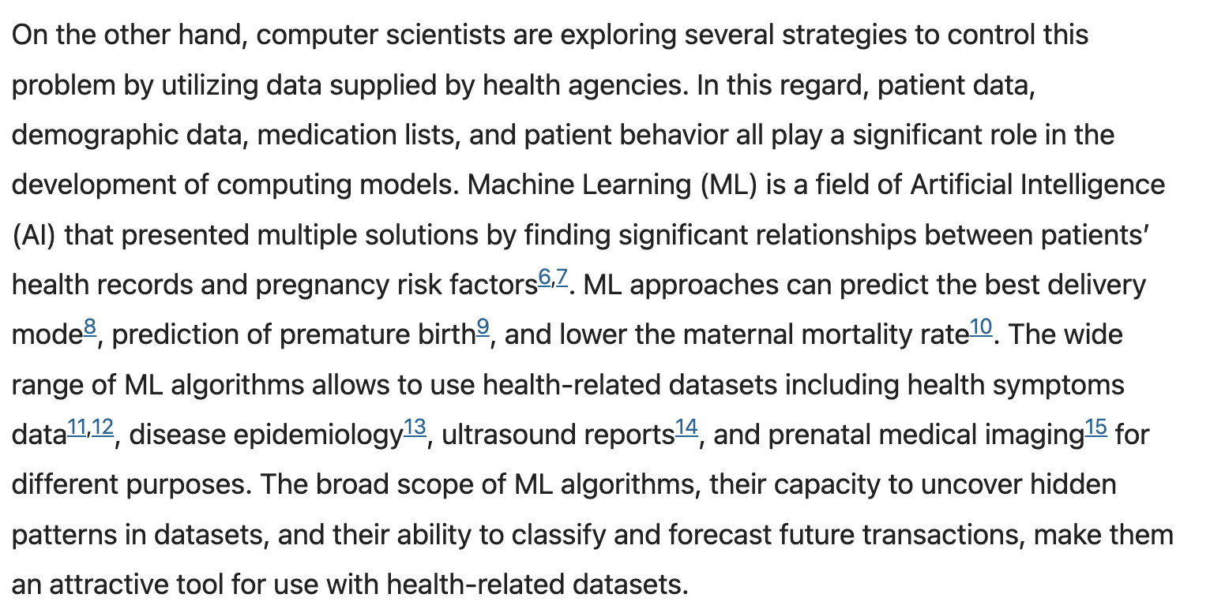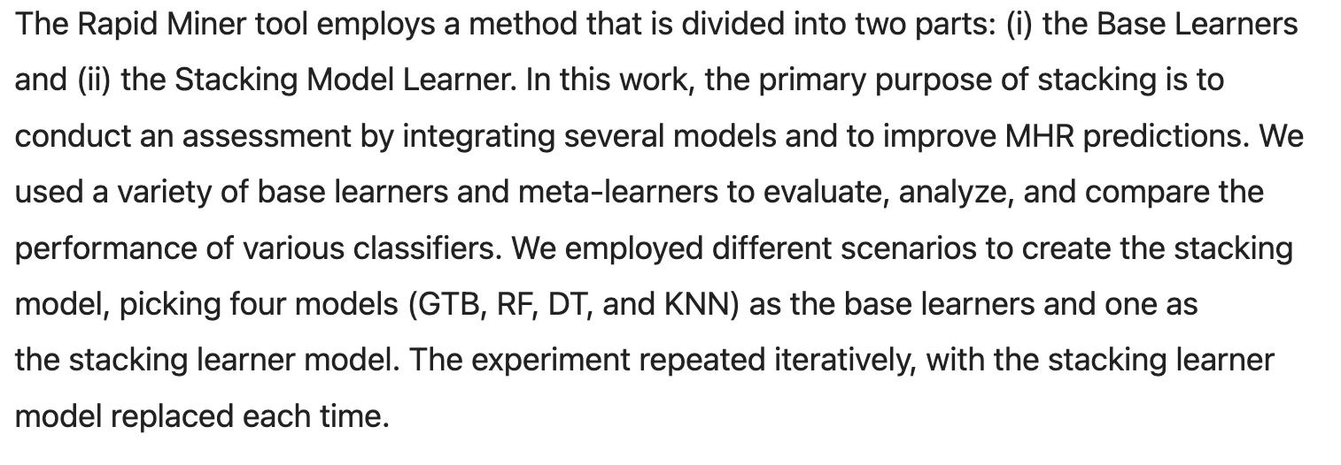

Used open dataset from several hospitals located in Bangladesh

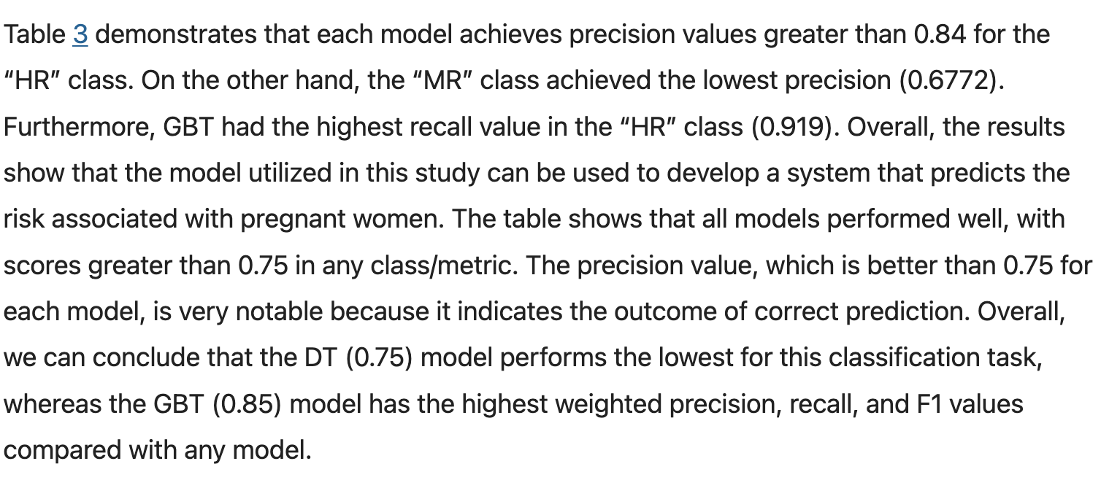 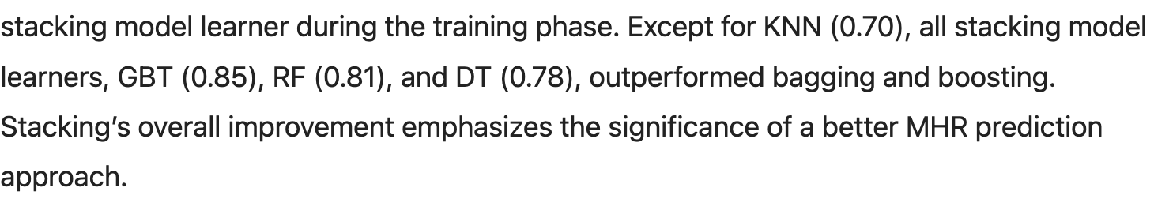 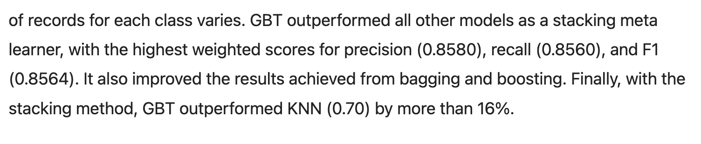 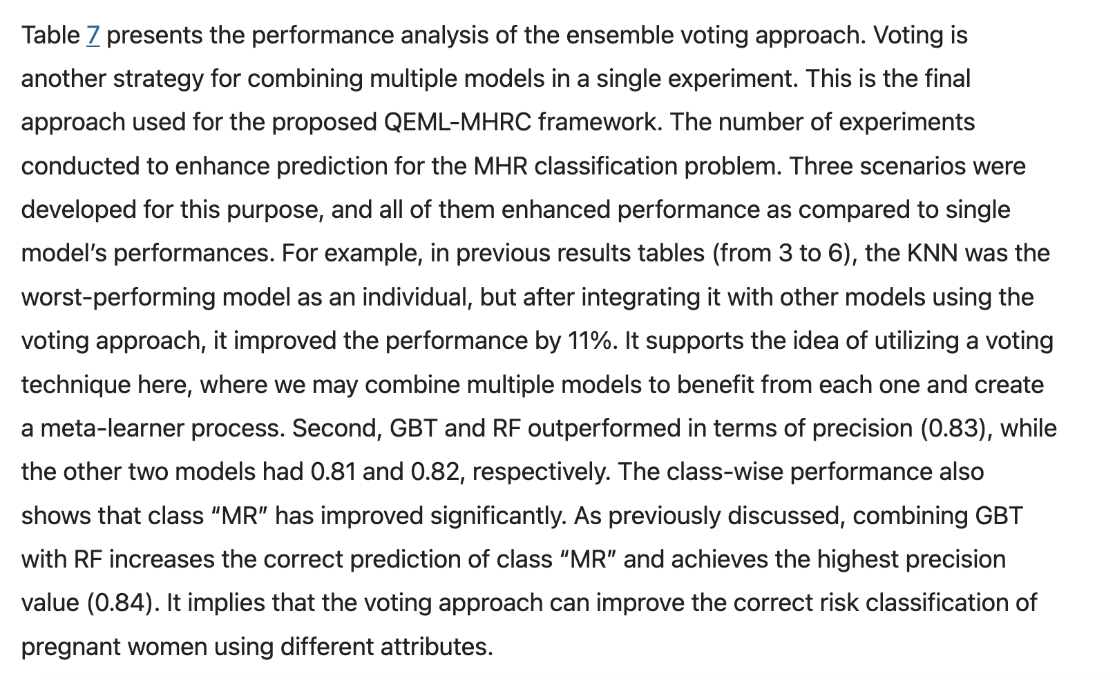 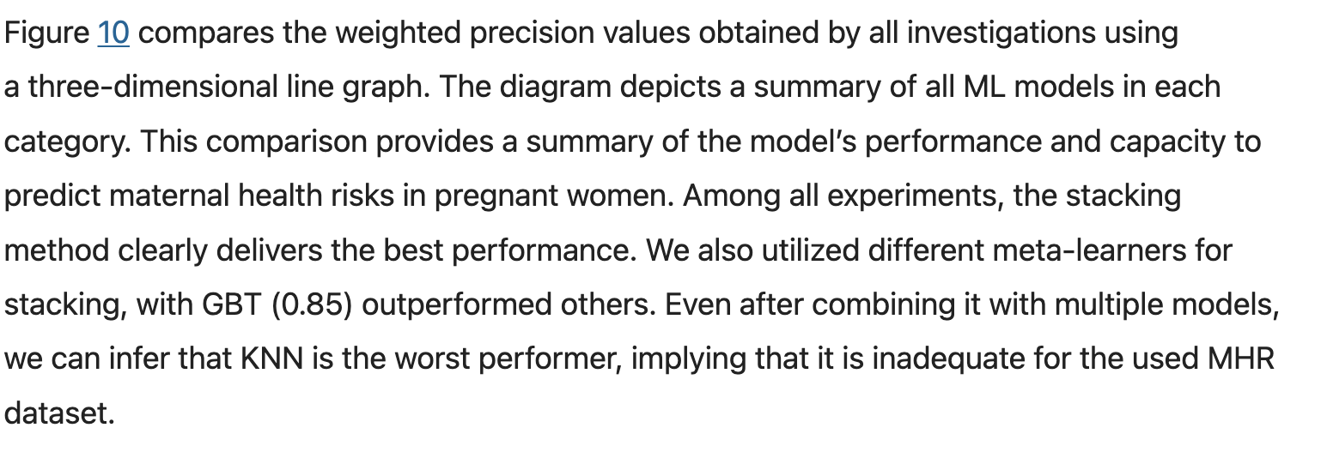

* Justify not using KNN

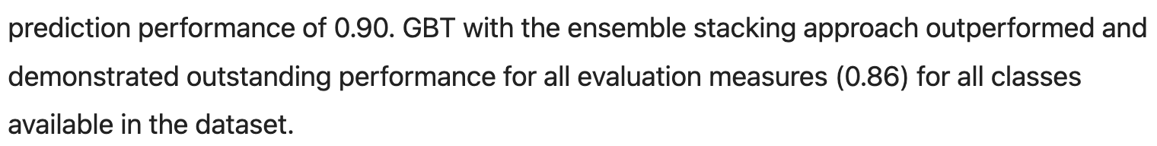

## Stacking based model – disease outbreak prediction

<https://www.mdpi.com/2227-7390/10/10/1714>

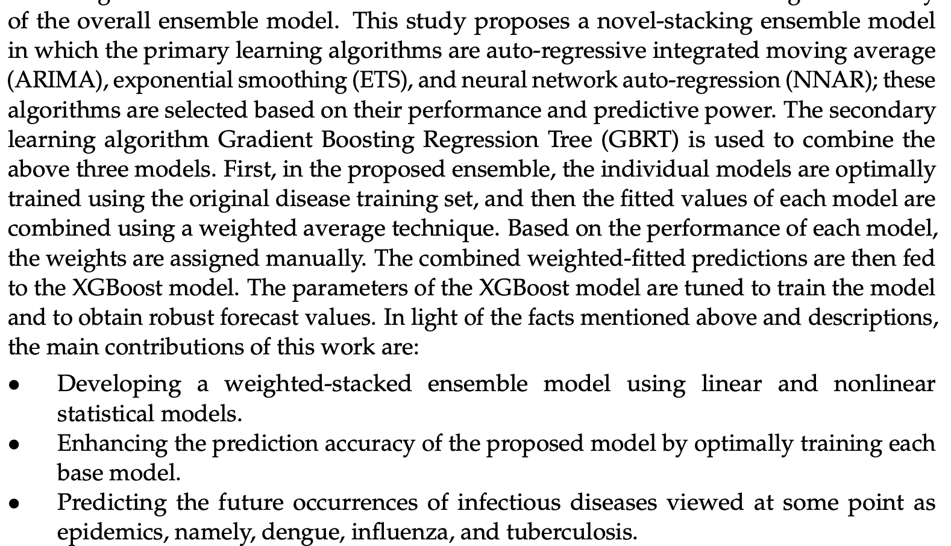

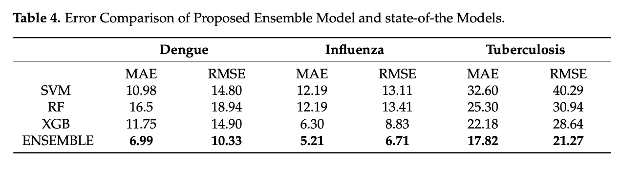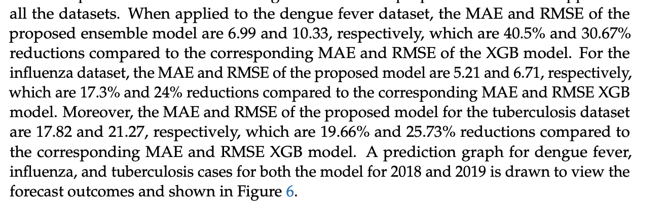

## Birth data classifier (C-section or not)

<https://www.tandfonline.com/doi/epdf/10.1080/08839514.2022.2158273?src=getftr&utm_source=scopus&getft_integrator=scopus>

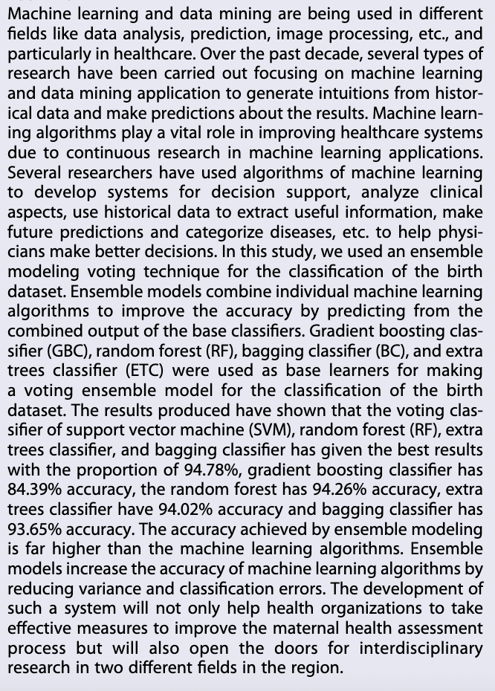

## Ensemble – Burden of Disease Prediction

<https://academic.oup.com/ije/article/49/6/2065/5625112?login=true>

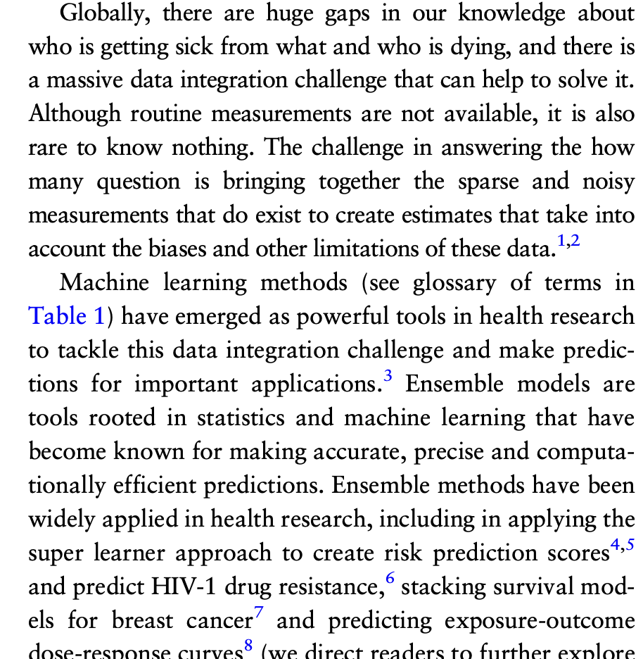 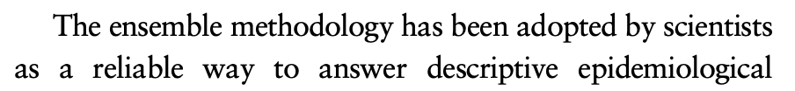 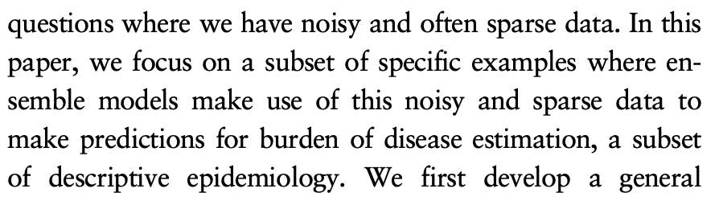 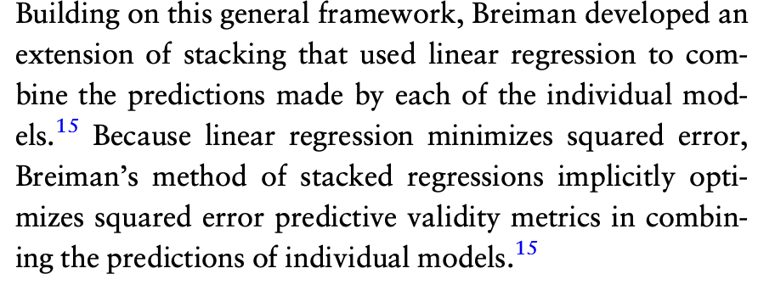

* For use of linear regression ensemble-r in my study (potentially paired with MLP)

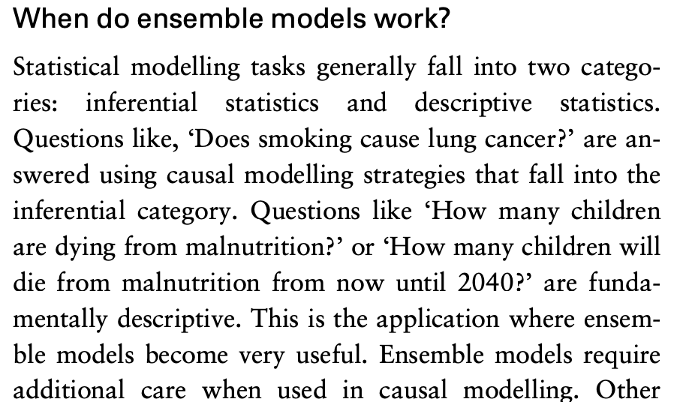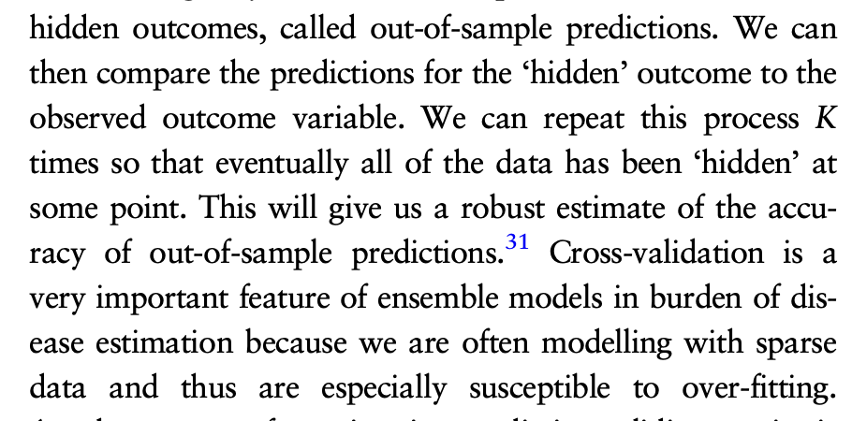

* Perfect for my study’s needs

Combines component prediction models based on relative performance in RMSE metric, and used weighted linear combination to do so (in later example)

## Ensemble – Disease Prediction

<https://pmc.ncbi.nlm.nih.gov/articles/PMC10298658/>

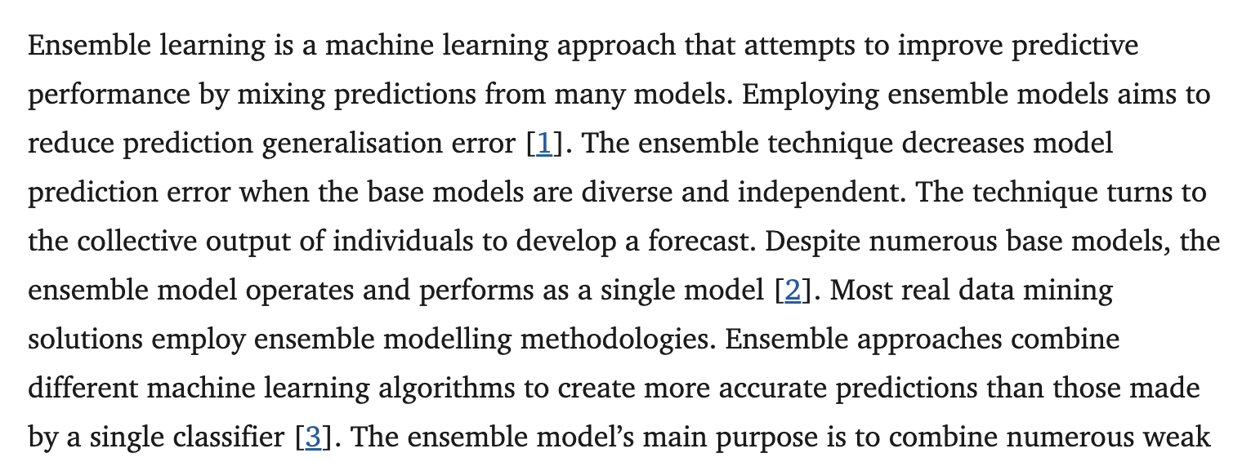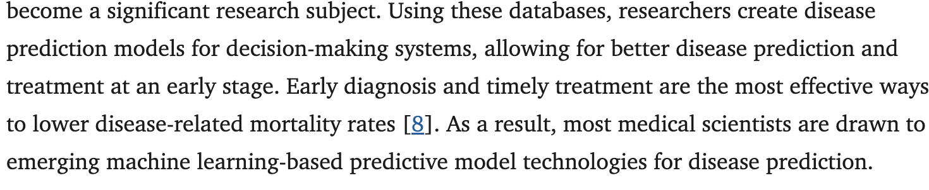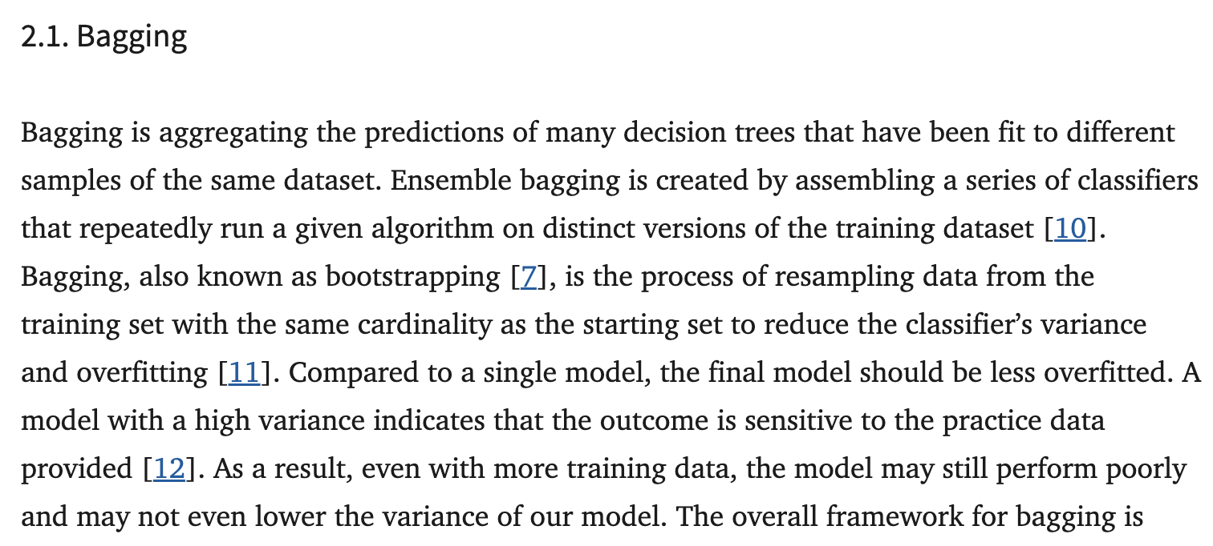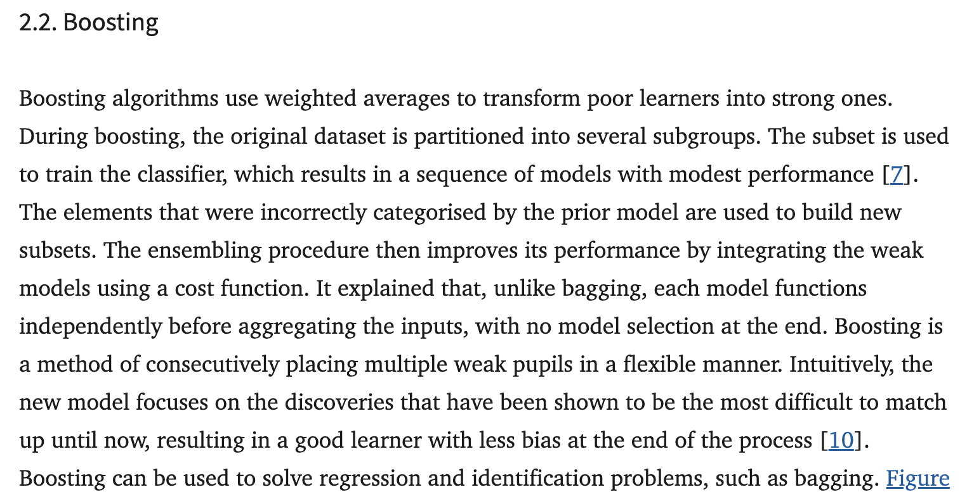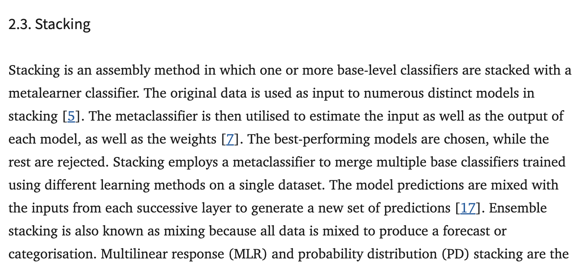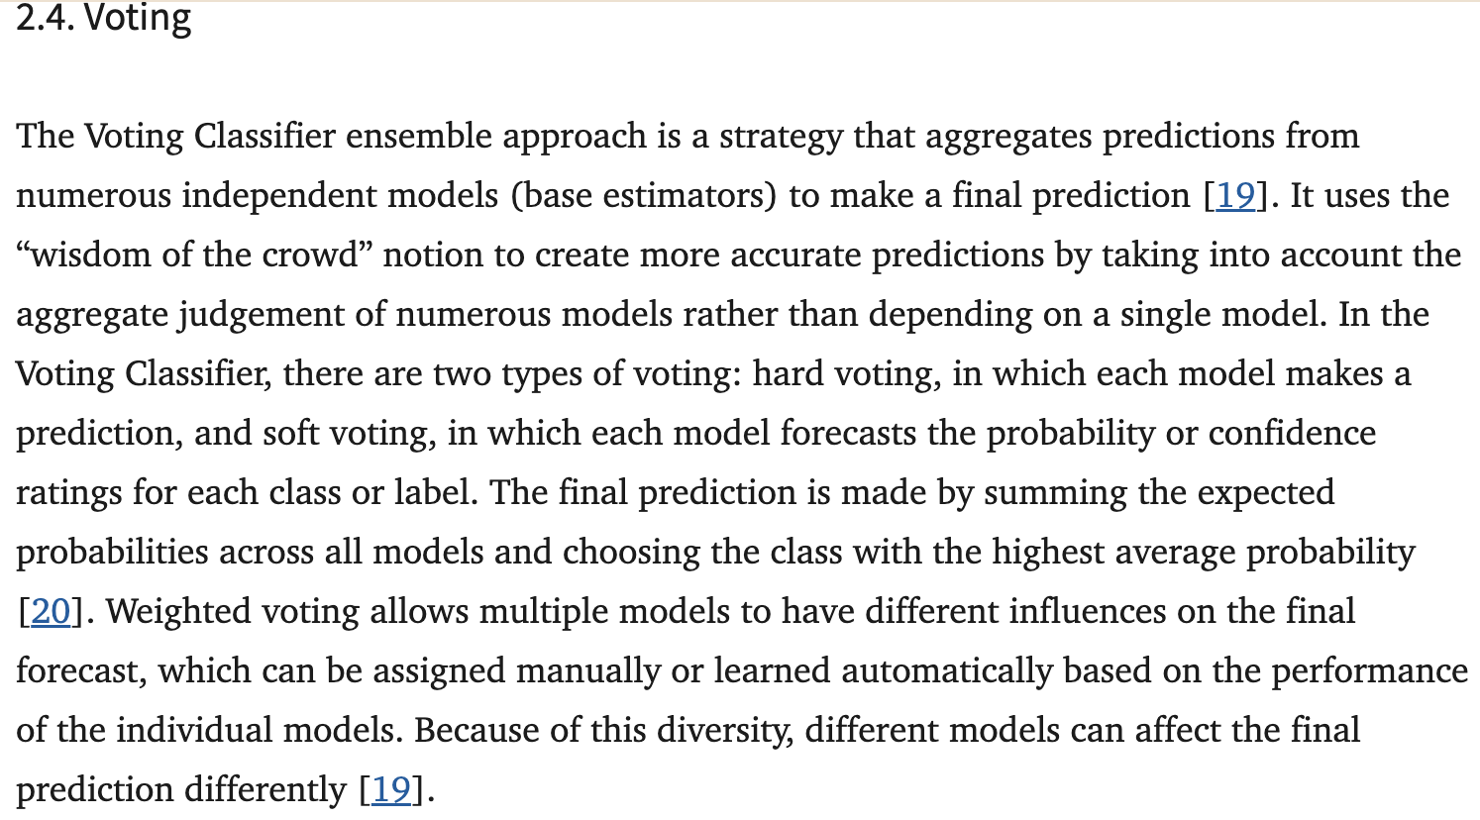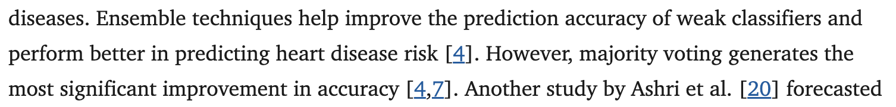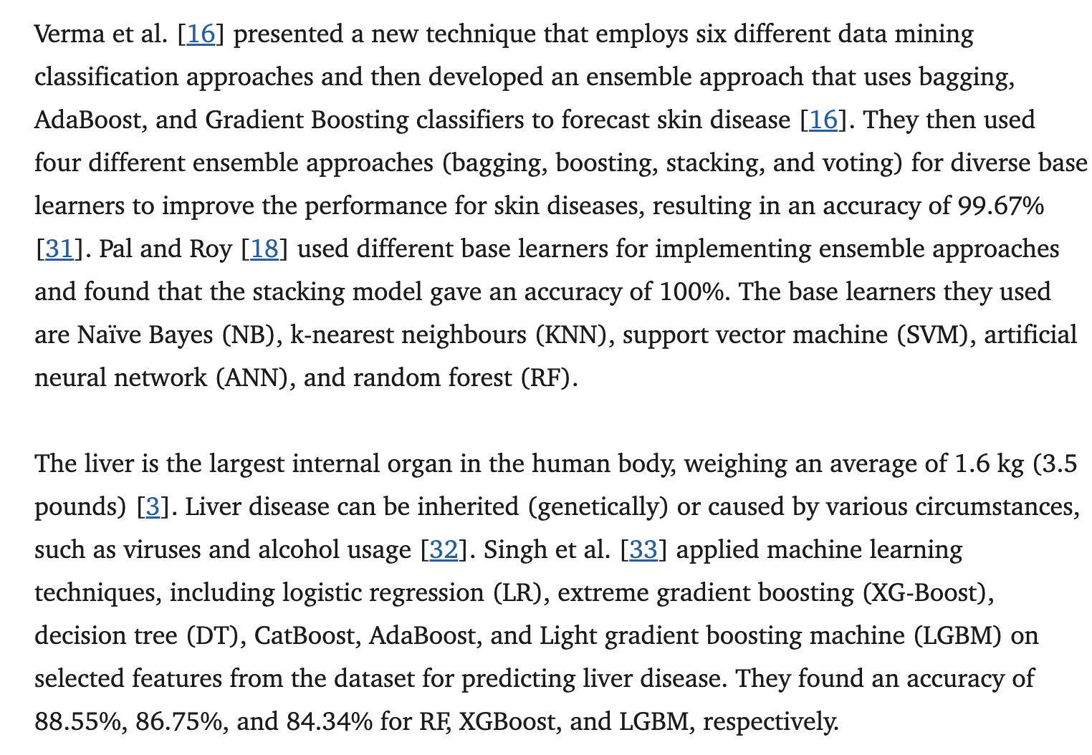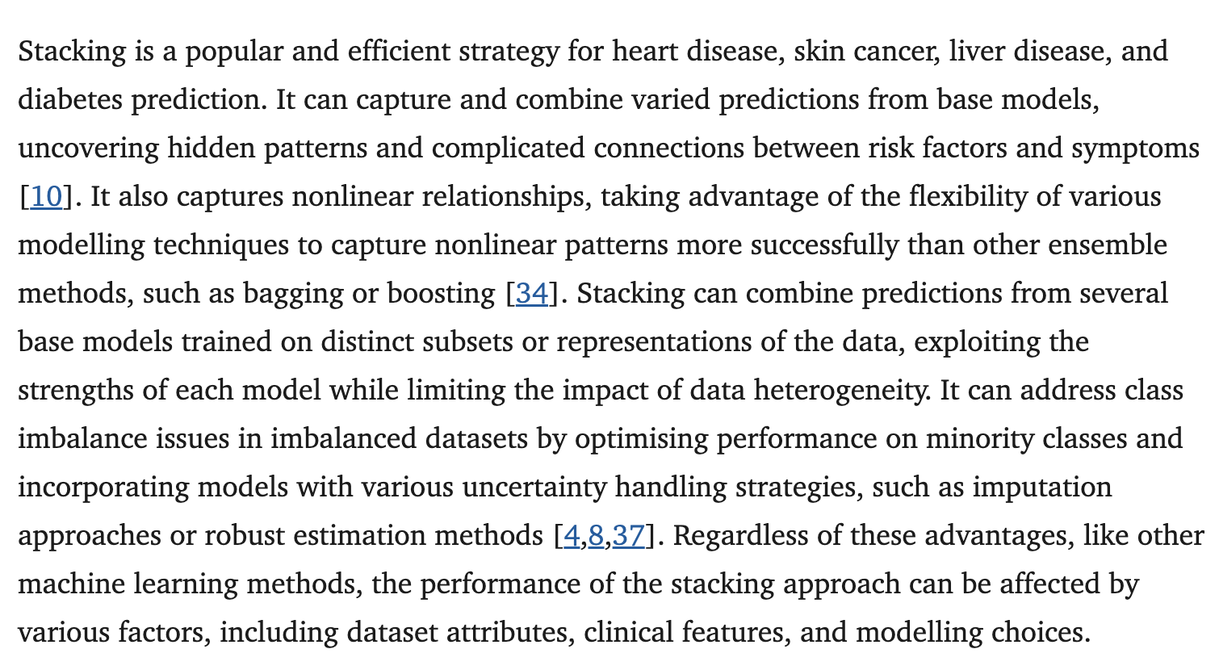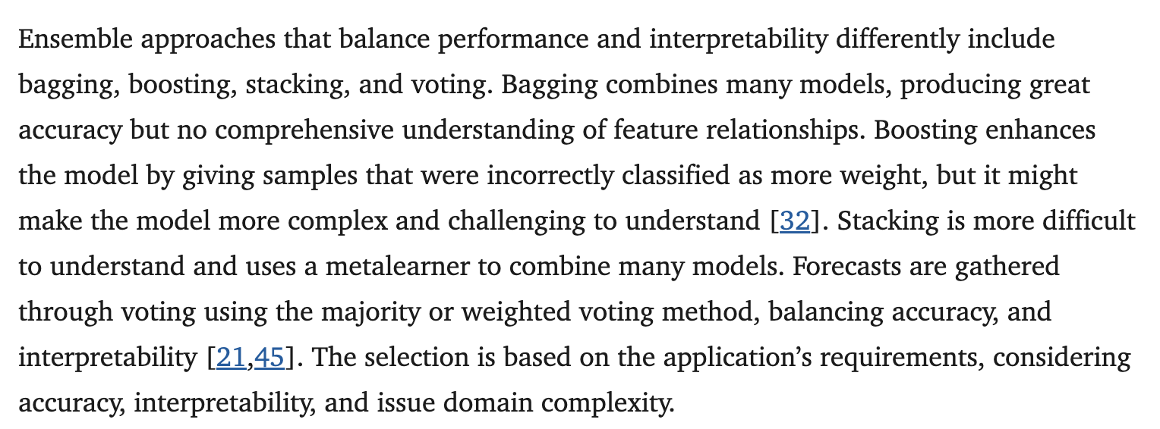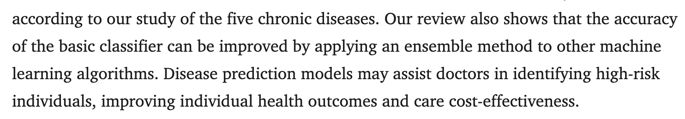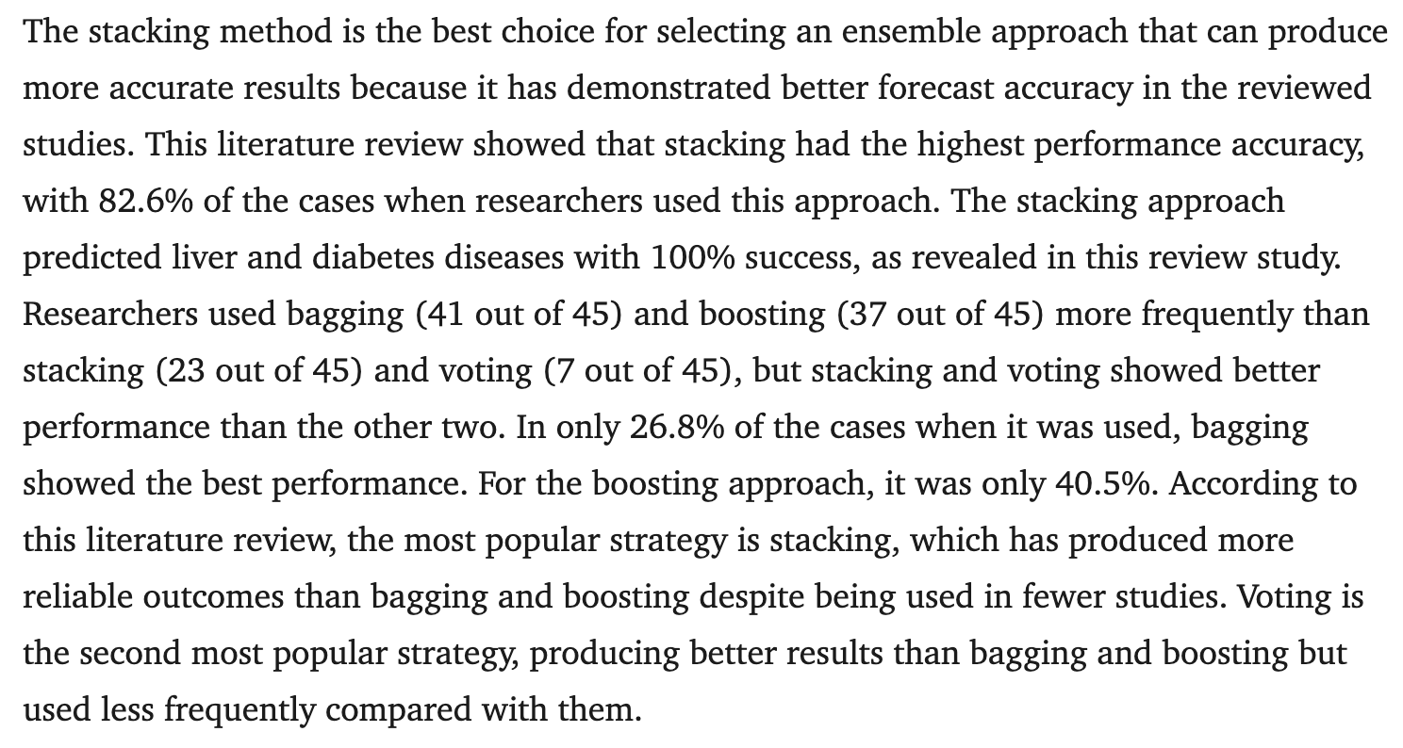

# DL Techniques

<https://link.springer.com/article/10.1007/S10462-023-10466-8#Sec44>

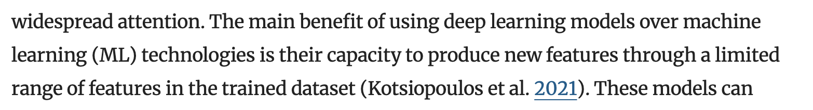

* Do not really need this given the number of features already being supplied to the model

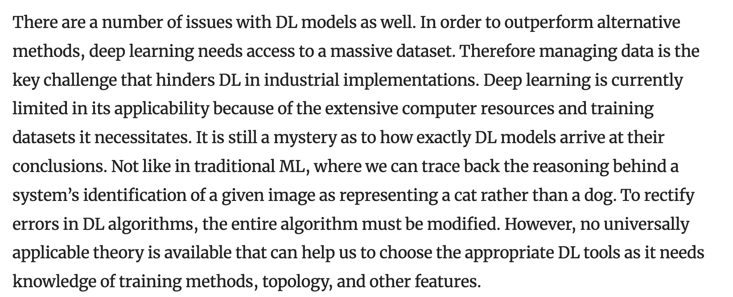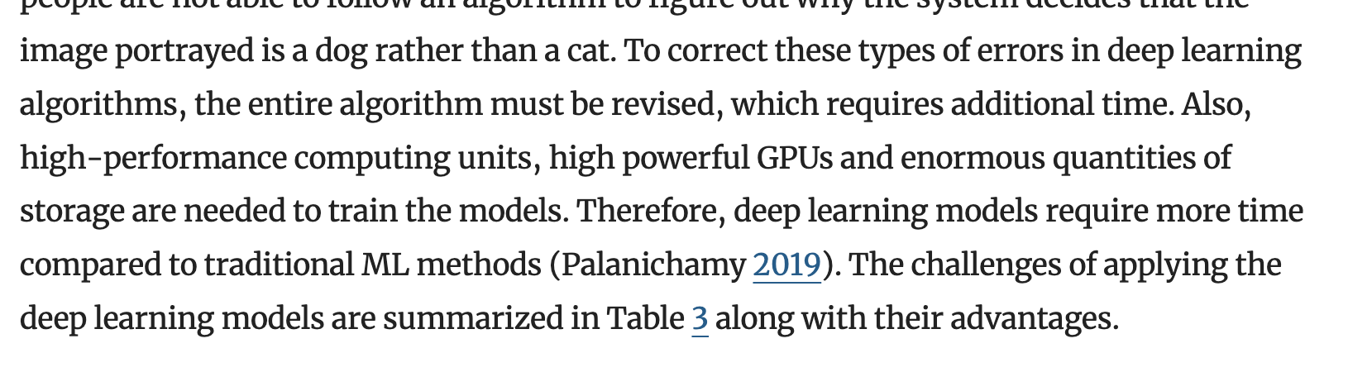

* Why I did not choose it:
  + Could not do feature predictive power analysis
  + Want interpretability to be able to shape policy
  + Hard to identify errors
  + Lots of data needed, while at the moment only have per country per year (not necessary and does not justify added computational resources need to train the model)